Student Perceptions on Effective Strategies to Reduce Bullying

Giovanni Cicero, Gerardo Gutierrez, Mike Laurella, Jose Lopez, Roseann Lovato, Tracy Medrano, Tiffany Angel Ruiz, and Juan Escamilla

California State University, San Bernardino
EDUC-607: Introduction to Educational Research
Enrique G. Murillo, Jr., Ph. D.
November 16, 2017

Table of Contents
Abstract………………………………………………….……………………….………….3
Introduction…………………………………………………….……………….….. ………4
Review of Related Literature…………………………………………………..…... ………4
Research Questions, Hypothesis, or Foreshadowing Problems…………….…..….. ………6
Significance of the Proposed Study…………………….…………….……………………. 7
Design and Methodology………………………………….……...…...................………… 8
Instrumentation/Data Collection………………………………………………….………... 8
Data Treatment Procedures……………………………………………………..…………..9
Presentation Findings……………………………………………………………..………... 9
Limitations of Design…………………………………………………...…………………. 12
Recommendations for Further Research…………..…………………...…………………...13
Conclusion……… ………………………………..…………………...…………………....15
Appendix……………………………………………………………………………………17
References……………………………………….……………………………..…………... 22

Abstract
Over the years bullying has become a major issue that affects millions of students each day. Parents and teachers are very concerned, however, they are not really aware of how extreme the issue of bullying has become because they aren’t always around to see it or they are not made aware of it immediately. Research has found that nearly 30% of our youth, nationwide has either been a part of or a victim to bullying. This statistic has led to a substantial rise in research to investigate the effects of bullying on a short-term and long-term basis. Due to this research, schools across the nation have been working vigorously to create and implement anti-bullying programs. Bullying is also considered a major public health concern; due to the rise in suicide rates amongst our youth (Boyle, 2017).
This study focused on the student’s perception of effective strategies that would reduce bullying in school. Currently, school board administrators, staff and faculty work together to develop and implement rules and regulations to assist with minimizing or eliminating bullying in school, however, they fail to include the perspectives of the children themselves. The children can offer a greater perspective on the problem and provide valuable solutions to the problem as they are the ones currently experiencing the bullying and they are aware of the current bullying practices that are taking place in schools all over the nation. This study sought to determine the effectiveness of including the student’s perspective in creating a training program which will educate students at a young age on bullying to promote a bully-free school or prevent it altogether. Our findings support this statement and further research will need to be conducted to find the long-term success.

Introduction
Bullying has long been considered a rite of passage of sorts. At one time, students were concerned by a bully ruling the sandbox or stealing someone's lunch money but as time has gone on bullying has become more dangerous. One tragic incident occurred on January 24, 2017, when eight-year-old Gabriel Taye committed suicide after a bullying incident at school (Jorgensen & Chavez, 2017). According to a study, bully victims are between 2 to 9 times more likely to consider suicide than non-victims (Rigby & Slee, 2008). Due to that statistic, school districts across the United States have launched strategies to help provide students with a safe school environment where children feel valued, respected and protected.
School Districts have enacted disciplinary exclusionary and punitive strategies, like zero tolerance policies, to help prevent bullying in schools. Exclusionary discipline is the act or practice of using negative or punitive measures in attempting to correct unwanted behavior. Examples of exclusionary discipline include suspension or expulsion for bullying incidences. However, exclusionary discipline policies have not gone without criticism. Researchers of school discipline look at exclusionary and punitive approaches as having limited value (Osher, Bear, Sprague, & Doyle, 2010). Researchers suggest that disciplinary problems, such as bullying, are often left unresolved in schools, resulting in the increase or continuation of student bullying (Osher, Bear, Sprague, & Doyle, 2010).
Review of Related Literature
In preparation for this study, the researchers studied several different peer-reviewed academic articles on the topic of school bullying. With school bullying being such a broad topic, the researchers felt that it was essential to look at variables such as aggression and conflict. The researchers also believed that it was necessary to investigate how schools and communities intervene under different variables such as age, social relations, and power. The articles have provided a glimpse not only the magnitude of the problem but also the difficulties that have arisen from policies that adults have implemented.
One of the dynamics that was considered in the early stages of this investigation was the broad topic of bullying. The researchers felt it was essential to define bullying. One of the articles that was very helpful in doing so was, “What Educators Need to Know about Bullying Behaviors” by Sandra Graham. In the article, Graham presents six myths that cloud our understanding of bullying behavior in schools and prevent us from addressing the issue effectively (p. 66). The article was beneficial in instructing Educators who want to better understand the dynamics of bullying. Graham writes that educators will need to learn that the problems of victims and bullies aren’t the same (p. 68). Interventions for bullies don’t need to focus on self-esteem; rather, bullies need to learn strategies to control their anger and their tendency to blame others for their problems. Victims, on the other hand, need interventions that help them develop more positive self-views, and that teach them not to blame themselves for the harassment (Graham, 2010).
The researchers also reviewed studies that researched the student experience in bullying in Thornberg, et al’s article, “Older Teenagers’ Explanations of Bullying,” the general purpose of Thornberg, et al’s study was to explore how older teenagers explain why bullying takes place at school. In addition, the study tried to determine whether there were any differences in explaining bullying due to gender (Thornberg, Rosenqvist, & Johansson, 2012). The findings provided insights into older teenagers’ understanding of why bullying occurs in school. The study also identified some gender differences, but also some mixed findings regarding gender differences, in comparison with previous research with younger participants. The implications for practitioners overall suggests getting teenagers involved by providing a “student voice” and seriously listen to their perspectives on bullying.
Yet another article that was reviewed on student perceptions of bullying policies was “A Qualitative Exploration of An Experiential Education Bully Prevention Curriculum” by Battey and Ebbeck. The purpose of this study was to determine the effectiveness of an anti-bullying program, “The Bullying Prevention Challenge” (Battey & Ebbeck, 2013). A group of students were given the classes and then took part in a focus group to see if the information in the courses remained with the students. Based on this study, students were able to remember aspects of the anti-bullying program via focus groups with their peers.
The information that was provided to the researchers from these, and other articles, was instrumental in developing the questions for this study. Many questions were answered, and more questions were raised as a result of our inquiry. The researchers felt that they needed to take this information a bit further in order to understand how to combat the bullying phenomenon.
Research Question(s), Hypothesis, or Foreshadowed Problems
Due to the complex nature of our research, there had to be an incorporation of both qualitative and quantitative methods to accurately gauge and interpret the data. Simply using one method or approach would not prove one to be superior over the other and would severely handicap our findings. For the quantitative approach, the research team designed a survey with eleven questions that would allow the students to provide imperative information about how bullying is perceived from the witness perspective and from the intervention perspective. By allowing the students to express what they see and how they feel, allows the researches to gain insight into their world and identify the strategies the students believe would be successful in reducing bullying in their school.
The survey places the students in the driver seat, and the survey revolves around two focal questions: Bystander actions take when witnessing bullying and helpful ways to prevent bullying. The data retrieved for the quantitative survey effectively answered our research question because the questions were direct in nature which allowed the students to solely focus on the concepts or ideas about bullying and the students were given complete anonymity, so they would not be identified as bully or a victim, allowing them to express their opinions freely. A foreshadowed problem or concern is whether or not the students’ strategies, given a trial run, will be proven effective in reducing bullying and further research will need to be conducted in that area.
Significance of the Proposed Study
The overall significance of this proposed study is to obtain student insights and assessments on what they feel is necessary to establish effective strategies to decrease bullying instances. The hope of the applied research is to engage student views and opinions which can help ensure their investment in reducing bullying (Erwin, 2004). The insights in this study will also provide educators and policymakers a glimpse on what the students consider to be successful policies. In turn, educators and policymakers can also see what policies students feel are not working so that improvements can be made to existing policies. The researchers of this study understand that this approach is more progressive than the traditional approach, but the researchers of this study feel that the best population to ask about what youth bullying are the youths themselves. The belief that youth oriented evaluation will work stems from the assumption that students are capable of making their own decisions and “meaningful contributions” when given the chance (Duke, Sollie, & Silva, 2016).

Design and Methodology
Mixed methods comprised of survey research were applied to this study. Both qualitative and quantitative data were collected throughout the study. The survey data was collected at the beginning of the inquiry. A survey responded to by a convenience sampling of third grade students were collected and analyzed to answer the research question. “What are student perceptions on effective strategies to reduce bullying?” The study occurred, and student data were collected during the fall of 2017. The study was conducted in a large-sized elementary school located in Desert Hot Springs, California. The school is one of few in the Palm Springs Unified School District that provides universal, school-wide behavioral support structures and professional development for instructional staff, such as Positive Behavior Interventions and Supports and anti-bullying policies. The participants were 32 third grade students. Participants’ ages ranged from eight to nine. Of the 32 students, 16 were female and 16 were male.
Instrumentation/Data Collection
A bullying perception survey was adapted from several journal articles covering the topic. Our survey targets attitudes and perceptions toward bullying and bullying prevention. The survey contains 15 items that assess an individual’s perceptions of bullying across two main factors: (a) actions taken when witnessing bullying, and (b) helpful ways to prevent bullying. In addition, open-ended questions like, “What do teachers do when they see bullying?” are included in the survey to voice other concerns that may arise. The survey includes ordinal response choices. Sample items include, “When I see bullying at school, I do nothing,” and “Would it be helpful to have stricter rules on bullying?” Responses to items are given on a Likert Scale from 0 (definitely not/not helpful) to 4 (definitely yes/very helpful). The survey was revised several times and aimed for high school level participants. Due to logistics and timing concerns, the researchers decided to shift to third grade level participants, resulting in another revision. The questions were revised in a way that would be clear and comprehensible to participants of this age group. The original high school survey was to be completed by paper. The final version was completed online through a google form, where participants completed the survey with their Chromebooks. The results were analyzed by the members of the research group after the raw data was generated into a Google shared Excel spreadsheet.
Data Treatment Procedures
The data were collected from third grade students attending an elementary school in Desert Hot Springs, California. As per district approval, participants received a letter prior to the administration of the survey that allowed parents to opt out of the survey if they did not want their student to participate in the current study. This study involved a random sampling, by which students were asked to complete the survey. This study explored student perceptions of bullying. Thirty-two students with access to Chromebooks were given a Google form link to complete the survey. They received oral instructions to complete the survey and were allowed to ask clarifying questions, if needed. They were informed that the data would be used to help improve the general knowledge base regarding bullying and bullying prevention. The survey was administered during classes on a day in October 2017. Participation in the study was voluntary and no incentive was offered.
Presentation of Findings
Quantitative Analysis. 65.6% of the participants reported that there is a bullying problem at their school. In addition, 65.6% of the participants reported that there should be a bully prevention program at the school.
To gain insight on student perceptions on effective strategies to reduce bullying, students were asked what actions are taken when witnessing bullying. 71.9% of the participants said they would take action when witnessing bullying. 71.9% of the participants said they would tell an adult. 62.5% of the participants would talk to the victim. 43.8% of the participants said they would talk to the bully.
To gain insight on student perceptions on effective strategies to reduce bullying, students were asked to share helpful ways to prevent bullying. 75% of the students said it would be “very helpful” to have stricter rules on bullying. 75% also said that anti-bullying assemblies would be “very helpful.” 75% said it would be “very helpful” if teachers were taught how to help reduce bullying at school. 71.9% said it would be “very helpful” to have anti-bullying lessons taught in the classroom. 59.4% said it would be “very helpful” if parents worked with the school to help reduce bullying at school.
Student Perceptions on Bullying Survey
Definitely No/Not Helpful ○ ○ ○ ○ ○ Definitely Yes/Very Helpful
0 1 2 3 4
 | Mean | Median | Mode
Should there be a bully prevention program at your school? | 3.1875 | 4 | 4
Bystander actions taken when witnessing bullying | Mean | Median | Mode
When I see bullying at school, I do nothing. | 0 | 0 | 0
When I see bullying at school, I talk with the bully. | 2.53125 | 3 | 4
When I see bullying at school, I talk with the person who got bullied. | 3.34375 | 4 | 4
When I see bullying at school, I tell an adult. | 3.28125 | 4 | 4
Helpful ways to prevent bullying | Mean | Median | Mode
Would it be helpful to have stricter rules on bullying? | 3.5625 | 4 | 4
Would it be helpful to have anti-bully assemblies? | 3.375 | 4 | 4
Would it be helpful to have bystanders stand up against bullies? | 3.9375 | 4 | 4
Would it be helpful to have classroom anti-bully lessons? | 3.4375 | 4 | 4
Would it be helpful if teachers were taught how to help reduce bullying at school? | 3.5 | 4 | 4
Would it be helpful if parents worked with the school to help reduce bullying at school? | 3.28125 | 4 | 4

Qualitative Analysis. The descriptive data revealed that when participants were asked, “What do teachers do when they see bullying?” Three actions emerged from the question: (a) teachers’ stop the bullying, (b) teachers document the bullying, and (c) participants have not witnessed bullying.
53% replied that they would stop the bullying, but not elaborating on what stopping meant. 40% replied that teachers document the bullying with a “write up,” a behavior notice sent to the bully, which is sent home and later returned signed by a parent or guardian. 15% replied that they have not witnessed bullying. Some of the responses had a combination of the three categorized actions.
When asked, “Are there any other things you would do when you see bullying at school? The majority of participant responses had no additional actions they would take when seeing bullying at school. Most repeated actions from the survey statements. A small sample of participants suggested victims of bullying be removed from the bullying in progress, by playing with them or taking them somewhere else.
When asked, “Are there any other helpful bully prevention ideas you can think of to reduce bullying at your school?” The majority of participant responses had no additional helpful bully prevention ideas to reduce bullying at school. A small sample of participants suggested that their school counselor visit all classrooms more frequently and teach anti-bully lessons. One participant even suggested to have the school counselor work directly with a group of bullies instead of the victims of bullying.
The findings from this study indicate that schools may benefit from increased professional development for teachers and administrators on bullying prevention. The findings also indicate that schools may benefit from increased personal development for students and parents on bullying prevention. This study also indicates that both students and teachers are taking action, by stopping bullying. Students are witnessing teachers documenting the bullying with behavior notices sent home. The novel bully prevention idea presented by a small sample of participants was to have the school counselor more involved with all students.
Limitations of the Design
Although this study provided a glimpse into student perceptions on effective strategies to reduce bullying, a few weaknesses warrant discussion. The limitation of this study was the constraints of time. Since the study had to be completed to meet specific deadlines, the researchers used a small convenience sampling. The population of the participants is small (32 students), which may not represent the majority of the students at the school. To generalize the results for larger groups, the study should have involved more participants at different grade levels.

Recommendations for Further Research
In this research report to find out what “Student Perceptions on Effective Strategies to Reduce Bullying,” there were several journal articles read and researched. Also, a third grade class of students were given a survey of bully related questions to be answered. The information that was provided to the researchers from these, and other articles, was instrumental in developing the questions for this study. Many questions were answered, and more questions were raised as a result of our inquiry. The researchers felt that they needed to take this information a bit further in order to understand how to combat the bullying phenomenon.
It would be recommended that from the survey given to the 3rd graders on bullying that it would be important to follow up with discussion with the students with the results of the survey. The survey not only gets the student opinions and what they think about bullying, but it is an excellent opportunity to introduce the students to information on the subject and to talk about it.
Although elementary school children don’t have the experience or maturity level of adults, they certainly can think. Inviting students to think through alternatives and consequences, both positive and negative can heighten their awareness of possibilities. (Telljohann SK, Symons CW, Pateman B. Health Education: Elementary and Middle School Applications. 4th ed. New York: McGraw-Hill; 2004, p. 203)
From the findings of this study, it is recommended that schools may benefit from increased personal development for students and in turn, parents on bullying prevention. Also, that schools may benefit from increased professional development for teachers and administrators on bullying prevention. This study also indicates that both students and teachers are taking action, by stopping bullying. Students are witnessing teachers documenting the bullying with behavior notices sent home. The latter is highly recommended so to stop bullying behavior before a serious altercation takes place where administration and even law enforcement authorities must enter in to deal with the situation.
Further, it is recommended that teachers familiarize themselves with the school district and school’s “Coordinated School Health and Safety Policy to Preventing and Managing Bullying.” Although it would take another research report on a “Coordinated School Health and Safety Approach on Bullying”, the researchers feel it is important to give some insight to what we are talking about and to emphasize the significance and importance of it along with this study.
Typical school district’s “Coordinated School Health and Safety” policy
(Telljohann SK, Symons CW, Pateman B. Health Education: Elementary and Middle School Applications. 4th Ed. New York: McGraw-Hill; 2004, P. 289)
Recommendations for professional members of the school community:
- Treat all staff and students fairly and with respect.
- Come to a consensus about a definition of bullying which is “a person who is habitually cruel to smaller or weaker people and to others.”
- Encourage students to come forward when they or someone they know is being bullied. Reinforce that disclosing bullying is a courageous act that helps maintain a safe environment where everyone can learn.
- When bullying is observed, immediately bring it to a stop. Follow the school’s policy for management of bullying with consistency.
- Collaborate to improve supervision at times in locations where bullying is likely to occur (recess, lunch, in the gym, hallways transitions, and buses).
Recommendations for administrators:
- Work on creating a safe and caring school where relationships between among students and staff are supportive and are civil and where an ethic of nonviolent conflict resolution is the norm.
- Reinforce all adults in the school for modeling civility and respect.
- Create a school-wide code of conduct that describes in concrete terms how students should and should not treat each other.
Recommendations for school counselors and other mental health providers:
- Offer direct and indirect support for students who have been the target of bullying.
- Do not have aggressors and victims work together in a mediated counseling context.
- Provide support and referrals to teachers to implement evidence-based bullying prevention strategies in their classrooms.
Recommendations for school nurses:
- Be on the alert for overt and subtle signs of bullying (patterns of absences, complaints, of non-specific aliments, poorly explained wounds).
Recommendations for school resource officers:
- Communicate to students and staff that any behavior intended to make someone feel unsafe is unacceptable and will not be allowed.
Recommendations to teachers:
- Work with students to develop classroom codes of behavior that communicate respect to all.
- Enforce classroom codes of conduct with consistency.
- Create developmentally and culturally appropriate instructional activities focused on preventing bullying.
- Following a bullying incident, do not use peer mediation or ask the aggressor and the target to meet and talk things out.

Conclusion
In this study, we extracted third grade students with a range of 8 to 9-year old’s who were asked to complete a survey. A convenience sampling of third grade students were collected and analyzed to answer the research question: “What are student perceptions on effective strategies to reduce bullying?” The study was conducted in a large-sized elementary school located in Desert Hot Springs, California. Student data were collected during the Fall Quarter of 2017. In conclusion having a high-quality school district anti-bullying policy is not sufficient to reduce bullying and protect bullying-involved young people. Future studies examining policy implementation will inform best practices in bullying prevention. Our findings indicate that if we educate students at a young age regarding bullying, we can further promote a bully-free school.
This study and its reporters feel that the third-grade student’s survey is effective to the extent that it gathers the opinion of the third graders on what they think and know about bullying. Also, the survey which was done very well utilizing statistical technology is instrumental in determining the awareness of bullying, and imparting information to help prevent bullying. From journal articles it is shown if a young person is taught with an awareness of what bad behavior is; they will have the potential of having a better educated, healthier and safer experience in school. Through the use of information surveys, interviews, instruction, information quizzes, engagement, and intervention; much is learned from the students. Every student’s perception and experience on the subject is important and this is where the reducing of bullying begins.
The high-quality school district anti-bullying policy which is part of the all-inclusive Coordinated School Health and Safety Policy has its codes and recommendations. The guidelines for health and safety in school districts are in place. However, it is the implementation of these health and safety standards by students, teachers, and administrators that make it work. Our findings indicate that it is important to teach young age children behavior that is healthy and proper, and what is not healthy and not proper such as bullying. The students will learn early on what it is and will have a better perception of how to deal with it. By having a heads up to eliminate bullying, the students will be better prepared not to let themselves be harassed or to become a victim. Students will better know what options there are available to them and/or how to be. Even potential bullies will have an understanding of what they did not know before about themselves, their behavior, and come to know what it is to be out of line. It is an opportunity for them to use the information to hopefully help them to a better path in their behavior and in their education.
Asking and answering questions, students will be better informed and will have better opportunity to know that they have a better path in an environment that is positive, more secure, productive, and healthy as they obtain their valuable education. The findings from this research report indicate that if we educate students at a young age regarding bullying, we can further promote bully-free schools.

Appendix: Survey Responses
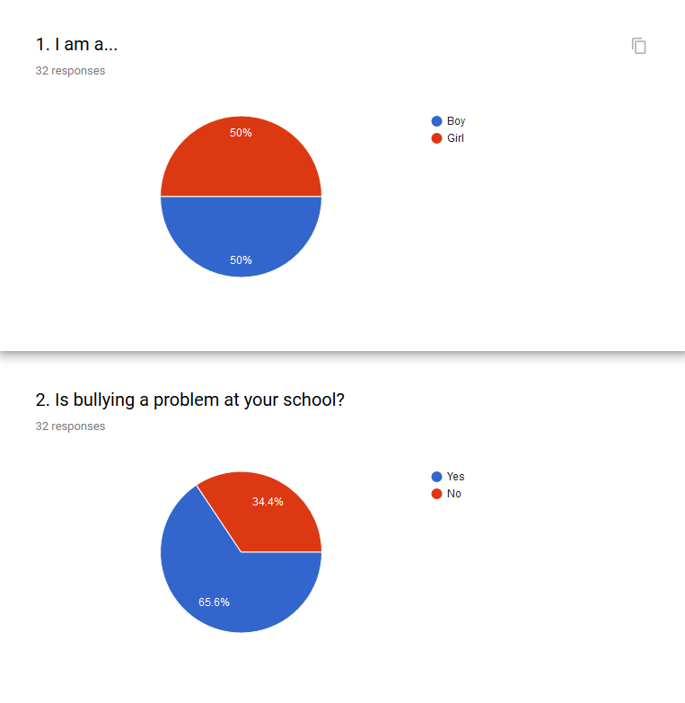
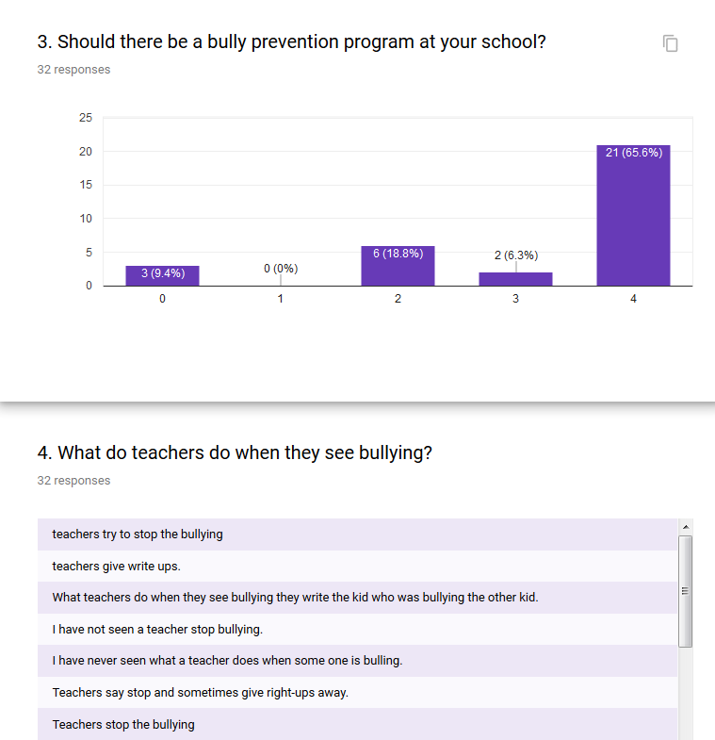
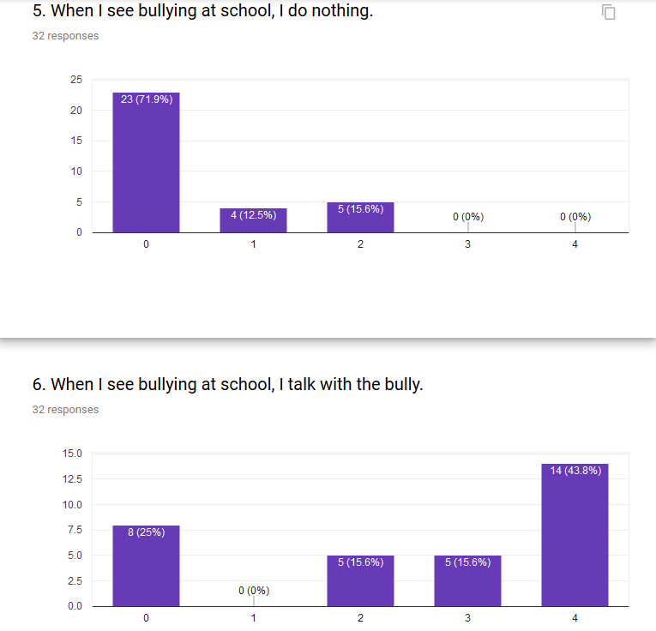
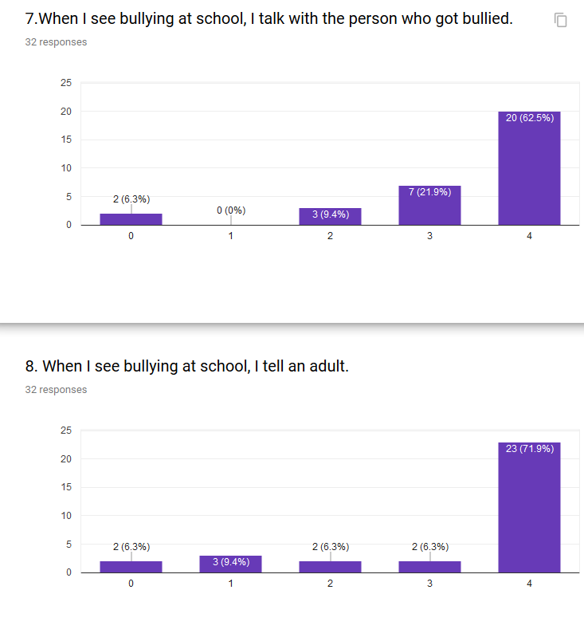
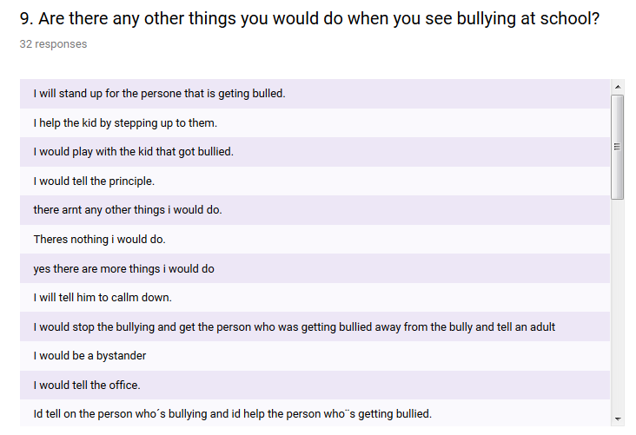
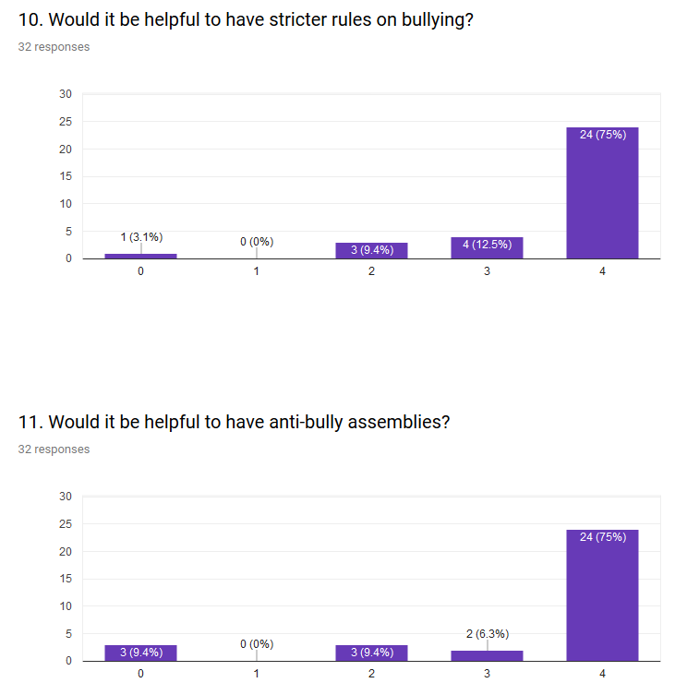
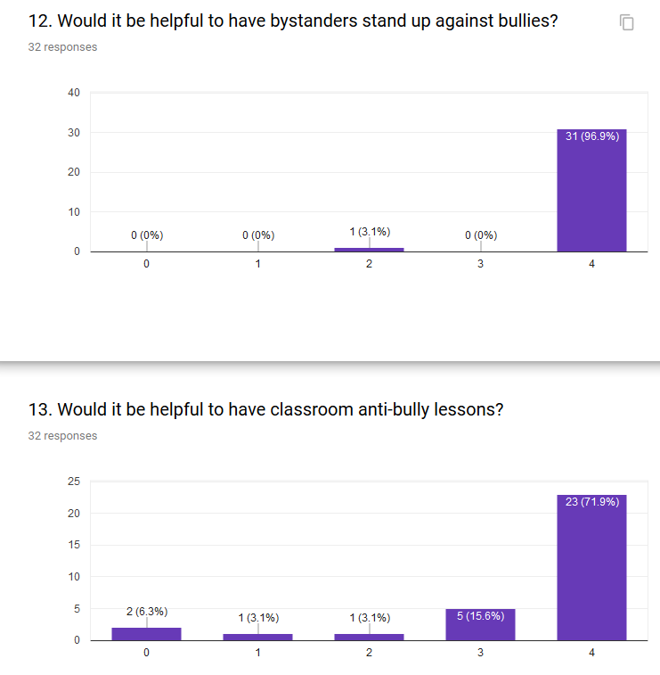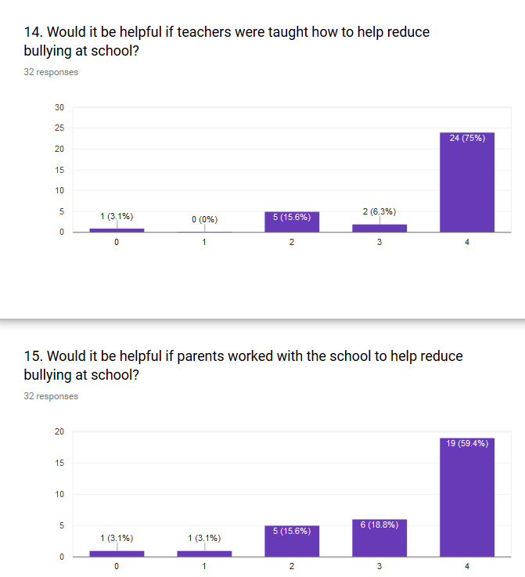

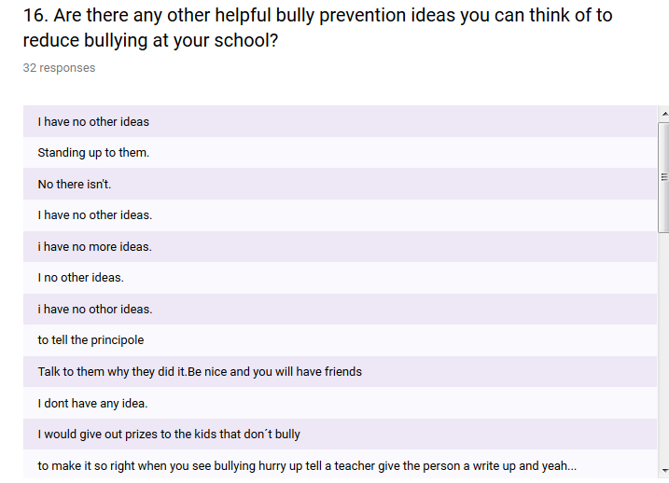

References
Battey, G. J. L. & Ebbeck, V. (2013). A Qualitative Exploration of an Experiential Education Bully Prevention Curriculum. Journal of Experiential Education, 36(3).
Boyle, D. (2017). New study shows bullying in schools is down, feelings of safety are up. Phys Org. retrieved 11 November 2017 from https://phys.org/news/2017-05-bullying-schools-safety.html
Cabot Yerxa Elementary School. Retrieved from https://www.greatschools.org/california/desert-hot-springs/25030-Cabot-Yerxa-Elementary-School/
Duke, A., Sollie, D., & Silva, K. (2016). Using Youth Participatory Evaluation to Improve a Bullying Prevention Program. Journal of Extension, 54(4)
Erwin, J. (2004). The classroom of choice: Giving students what they need and getting what you want. Alexandria, VA: Association for Supervision & Curriculum Development.
Graham, S. (2010). What Educators Need to Know about Bullying Behaviors. Kappan, 92(1), 66-69.
Jorgensen, S. & Chavez, N. (2017, May 16). Video shows bully incident days before 8-year-old took his life. Retrieved from http://www.cnn.com/2017/05/13/health/ohio-boy-suicide-bullying/index.html
Osher, D., Bear, G., Sprague, J., & Doyle, W. (2010). How Can We Improve School Discipline? Educational Researcher, 39(1):48-58.
Rigby, K. & Slee, P. (2008). Interventions to reduce bullying. International Journal of Adolescent Medicine and Health, 20(2):165-83.
Telljohann SK, Symons CW, Pateman B. Health Education: Elementary and Middle School Applications. 4th ed. New York: McGraw-Hill; 2004, p. 203
Thornberg, R., Rosenqvist, R., & Johansson, P. (2012). Older Teenagers’ Explanations of Bullying. Child and Youth Care Forum, 41(4), 327-342. http://dx.doi.org/10.1007/s10566-012-9171-0

