EDUC607 Education Research Report
Discovering How Mobile Phones Impact Student Learning and Social Behaviors

Mikko Li
Wafaa Alharbi
Chun Yi Huang
Ashton Reynosa
Samirah Bahkali
Hsieh Heng Tsai
Kristin Champion
California State University, San Bernardino

Abstract
Cell phone use such as texting and using social media has become the norm within college classrooms and during school related activities. Many college students are overly attached and highly dependent on their cell phone when they should be focusing on their schoolwork or homework. This research paper examines the affect cell phone use has on student learning and social behaviors. It discovered that students are using their phones when they should be focused on class and that they continue to do so without fear of the consequences. A survey questionnaire was given to 81 college students within the Southern California area, which examined how often students used their phone. The results of the survey questionnaire concluded that college students use their cell phones during class/studying and realize that it hinders their progress in learning but that they will continue to do so regardless. The phenomena known as cell phone obsession is impacting college students learning as well as their social behaviors.

Introduction
With the rapid evolution of science and technology, the use of cell phones has been increasing in the world. According to CTIA (2011), "recent statistics from December 2011 show that there are 311.6 million mobile phone subscribers in the United States which indicates a penetration rate of 104% for mobile phones across the country" (Salehan & Negahban, 2013, p.1). More recently, data from CITA report (2013) showed the number of mobile users reaching up to 326.4 million phone subscribers in December 2012. Cell phones have become important assets for human beings and are utilized in many ways such as to search the internet, call or text family and friends, listen to music, and watch movies. According to the report by Adkins’s research report for the Ambient Insight (2008) explored that the US market for mobile learning products and services is growing at a five-year compound annual growth rate (CAGR) of 21.7% and revenues reached $538 million in 2007. The data indicated that the demand is relatively immune from the recession. The findings of the report indicated that the largest demand throughout the forecast period is for custom development services, content conversion, and media services and that the healthcare sector accounts for 20% of the total US market for mobile learning.
Statement of the Problem
Several problems such as physical and mental health have manifested because of the over use of cell phones. Many people are addicted to their cell phones and it affects their social life, academic, and professional performance (Griffiths, 2013). For example, according to Rainie’s investigative report in May 2013 for the Pew Research Center’s Internet & American Life Project (2013), Rainie (2013) stated that the ownership of cell phones is increasing from 65% to 91% from the period of 2004 to 2013 in the United States (Rainie, 2013). The report also indicated that the highest percentage (97%) of cell phone ownership is the group of people between the ages of 18 to 34. Please refer to the following demographics for the comparison.
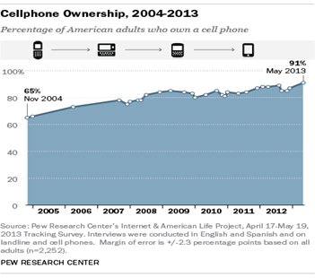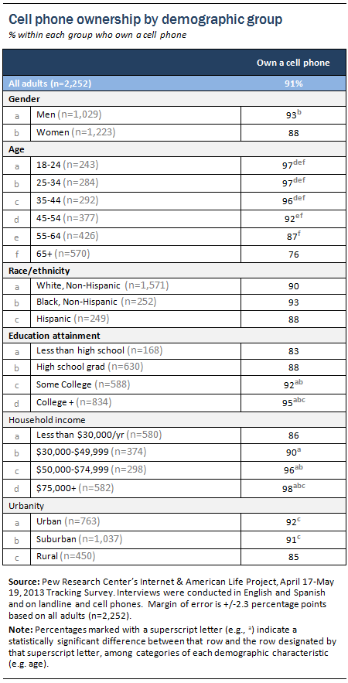
In another example, the Sun newspaper conducted a U.S. survey of 2,000 college students. It reported that, "85 percent of the students constantly checked their mobile phones for the time, and that 75 percent slept beside it" (Griffiths, 2013, p.1). Waal and Morland (1999) defined addiction in the following way, "addiction is characterized by repetitive acts with a total negative sum of consequences" (Salehan & Negahban, 2013, p.4).
Purpose of Study
The purpose of this research is to identify in what ways cell phones distract college students studies in the classroom and outside of the classroom. This research project is interested in examining whether or not cell phones are a distraction to students and to examine whether or not students identify how reliant they are on their cell phones. Does the average college student pay more attention to his/her cell phone, when they should be paying attention to class? Do college students use their cell phones as study aides (ex. Listening to music while studying for an exam)? Do students realize how often they use their cell phone during school/class related activities? In addition, this research looks to examine how cell phones affect student learning and the relationship students have with their cell phones?
Hypothesis and Foreshadowed Problems
The hypothesized deduction made is that the majority of college students do use their
cellular phones during school related activities such as texting/surfing the internet during class time, listening to music while studying, using social media during class time as well during studying or doing homework, etc. This hypothesis came to be because it was noticed that the majority of students on campus own a “smartphone” and have admitted to using their phone during school related activities. An anticipation made is that the survey will support the hypothesis in that it will find that many students will admit to using their phone while in school or while studying. Another hypothesis made, is finding out that students will admit to being overly attached to their phone as if it were a part of their own anatomy. Although there is anticipation that the survey will support the hypothesis that students do use their phone during school related activities and that it is a distraction to their learning, there is a foreshadowed consensus that these students do not see their attachment to their phones as a problem or that they are even concerned about it.
Before research was conducted, problems that might occur were discussed. Foreshadowed problems were discussed and include problems such as; a small scale sample may not depict an accurate portrayal of all college students, due to the survey having qualitative and quantitative aspects, it may lead to more questions, and college students may alter their answers because they may not want to sound too dependent on their cell phone. Based on what is being sampled, which is a small group of college students from three Cal State University campuses (CSUSB, CSU Poly, CSU Fullerton), there may not be a lot of material gained, however it is enough to answer the research questions. The survey used asks multiple choice questions as well as self-answer questions. This set of data collection may lead to a discovery of more questions, however that the survey is a decent data collecting tool that will lead to answers. Although this survey is a decent data collecting tool it is still vulnerable for error, and error can be that one of the participants taking the survey may alter their answers. This may be unlikely but it is still a possibility.
Significance of the study
The methodology used to address the research questions consists of mixed methods. The significance of the study is that the research project used primary data in the form of surveys to analyze and identify concrete patterns concerning the implications of cell phone use among college students. More importantly, the significance of the research project is that it documents what students perceptions are on cell phone use. The study reveals the impacts and aspects of social behavior associated with cell phones. First, the research study is to investigate if there is a statistical significance that proves a cell phone behavior impacts student learning. The collected data results indicate a significant relationship and impact on student learning. This significance is based on the results from a couple questions in the survey. For example one of question is asking whether they feel the cell phone will disturb their studies and 75% of college students did feel the cell phone (i.e. incoming call or text messaging) does in fact disturb their study. The other research questions explore whether the cell phone impacts students social life and behavior. The survey was distributed to 81 students at CSU San Bernardino, CSU Fullerton, and Cal Poly Pomona in May, 2014. According to the questionnaire findings, this research study provides significant results.
Literature Review
The reviewed literature on the implications of cell phone use exposes the learning consequences of using this form of technology in the classroom and M-Learning. In addition, there are multiple scholars who argue that there is a correlation between cell phone use in the class room and bad academic performance. The interesting aspect on cell phone use is that people who overly use it may have been using it to fill a void in their lives. The literature points to loneliness, issues of detachment, and a sense of wanting to belong to a community as reasons why people overly use their cell phones. Nevertheless, cell phones have serious health and safety issues when used while driving. Lastly, the literature exposes significant percentage rates in terms on how drivers can be dangerously affected by cell phones while driving.
Cell Phone Obsession and Student Learning
Lee (2012) described that the addiction to “Smartphones” can be described as “wanting to be in constant communication with people even though there is no real need for communication” (Sarwar & Soomro, 2013, p. 220). The issue with cell phone obsession arises when there are other more important tasks (i.e. class, meetings, etc.) to be completed. According to Tindell and Bohlander’s finding (2012), there was significant amount of students (i.e. 97%) using text messages in the classroom before the class began. In addition, these scholars explored that a significant number of these students text during instruction and the researchers found that students think the instructor will not find out when texting occurs. Cell phone use (i.e. texting) in the classroom may have severe learning implications (Tindell & Bohlander, 2012). In another study, Pottharst (2010) shared “one story about a student in the class receiving a message from his girlfriend. After checking it and going back to class, the student found himself lost and did not know what was going on in the lecture” (Ali, Papikie, & Medivitt, 2012, p. 225). The researchers found these events to be a common occurrence amongst students who are preoccupied with cell phones. These scholars document the negative learning consequences of cell phone use in the classroom from a qualitative perspective. Through their interviews, the audience is able to get the rich details of how easily cell phone use occurs without the student being aware of his/her consequences. From the literature, it seems that when the student realizes the important points being made in the classroom, the pupil is already behind in the lesson plan.
The literature indicates that teachers and even schools are aware of the over use of cell phones in the classroom and they have been attentive in helping students minimize cell phone use to improve learning outcomes. For example, Bugeja (2007) found that after the teacher started a policy banning cell phones in the classroom, grades improved. In addition, Bugeja (2007) stated that the teacher attributed the lower grades to the distractions caused by using the cell phones (as cited in Ali, Papakie, & Mcdevitt, 2012). In another study, Obringer and Coffey (2007) mentioned that there are many schools have implemented policies to restrict cell phone use by students and teachers (as cited in Tessier, 2013). Moreover, Sarwar and Soomro (2013) claimed that this type of cell phone communication amongst students in the classroom is not needed and if not monitored at an early stage could have significant implications. On the contrary, Traxler (2007) and other advocates of mobile learning defined mobile learning as wireless and digital devices and technologies, generally produced for the public, used by a learner as he or she participates in higher education. Moreover, Mcconatha and Praul (2008) claimed that the Mobile Learning (M-Learning) is a relatively new tool in the pedagogical arsenal to support students and teachers as they navigate the options available in the expanding world of distance learning. M-Learning is learning accomplished with the use of small, portable computing devices. From reviewing the research from different scholars could understand that M-learning is convenient in that it is accessible from virtually anywhere. M-learners typically view content and/or lessons in small, manageable formats that can be utilized when laptop or fixed station computers are unavailable. It is currently being used in a variety of educational, governmental and industrial settings.
Text Messaging
Text messaging is an important communication function of cell phones. Scholars, Skierkowski, and Wood (2012) argued that, “on the basis of casual observation, it would appear that mobile phones have permeated almost every facet of interpersonal interaction in an apparent melding of humanity and technology” (p.744). In addition, Skierkowski and Wood (2012) also highlight that text messaging is a type of technology that connects or works as a social bridge for the individual and enables virtual communication despite distance or geography. Kim, Kim, Park and Rice (2007) also research the importance of text messaging for adolescents from a quantitative perspective, and the results of this study identify that text messaging, instant messaging, and cell phones are unique media for students, and have a tendency to be used in emphasizing intimacy social ties among this group (as cited in Skierkowski & Wood , 2012).
Conti-Ramsden, Durkin, and Simkin (2010) expanded on text messaging behaviors and have identified several key aspects which are particularly appealing to young people. Conti-Ramsden, Durkin, and Simkin (2010) claimed that text messaging occurs because of convenience, affordability, and control over the context of communication, speed of relating information, and autonomy from parental supervision (as cited in Skierkowski & Wood , 2012) . Skierkowski and Wood (2012) stated that the research from Conti-Ramsden, Durkin, and Simkin advance some of the reasons (i.e. including positive perceptions and social incentives) of a disproportionate rate of text messaging within adolescents. Despite these findings, it is important to perform more research on cell phone use as these adolescents will become tomorrow’s labor force.
Loneliness
Another theme within the literature on cell phone use deals with the idea of students feeling the need to use their cell phones because they feel lonely. According to a definition advanced by Weiss (1973), he claimed that “loneliness arises from the lack of social relationships that can satisfy particular wants of affection and belonging” (Reid & Reid, 2007, p. 425). Green, Richardson and Logo (2001) were even more specific on their interpretation of loneliness and state that it is more likely to arise from a lack of intimate contact than from a general lack of social interaction (as cited in Reid, & Reid, 2007). However, cell phone use is part of human daily interaction. Reid and Reid (2007) expanded on the idea of loneliness and cell phone use and claimed that:
“While an SMS exchange might ameliorate the experience of loneliness, we expect the intimacy needs of lonely people to be satisfied more directly by a vocally expressive, real-time voice call. Lonely cell phone users are less likely therefore to associate SMS with their sociability needs, and instead will show a generalized preference for talking over texting on their cell phones.” (p. 425)
Reid and Reid’s study (2007) consists of using a methodology that uses online surveys. Reid and Reid (2005) reveal that "cell phone owners declaring a generalized preference for texting on their cell phones were both lonelier and more anxious than those who preferred talking" (Reid , & Reid, 2007, p. 425). Therefore, based on the literature, it seems that students who over use their cell phones during class time may be dealing with issues of loneliness, attachment, and a sense of belonging.
Using Cell Phones While Driving
Cell phone use while driving (CPUWD) is an important public-health concern and this issue has been communicated via the media in recent years. It is extremely dangerous to drive while using the cell phone. For example, according to the National Highway Traffic Safety Administration (NHTSA, 2010), there was 995 fatalities and 24,000 injuries were believed to be caused by cell phone use as the source of distraction (as cited in Weller, Shackleford, Dieckmann, & Slovic, 2013). Synovate (2009) stated that “in order to understand what cell phones mean to people, one research study found that 25% of individuals reported that they would rather lose their wallet than their phone, and 75% said they never leave their home without their phone” (Shackleford, Dieckmann, & Slovic, 2013, p. 380). Synovate’s study (2009) suggested considerable cell phone attachment. Moreover Weller, Shacklefod, Dieckman and Slovie (2012) claimed that “Furthermore a strong attachment to cell phones may be especially important for young drivers” (p. 382). For instance, Walsh, White, and Young (2009) reported that 16- to 24 year-olds have a strong sense of connection to their phones (as cited in Weller, Shacklefod, Dieckman, & Slovie, 2013). As found in other studies from Walsh, White, and Young (2009) highlight that these participants expressed that the cell phone enhanced feelings of belonging with others. This sentiment is also echoed in Geser’s (2006) qualitative analysis of teens, which observed that the phone represents a way to be connected with social networks and gain autonomy from parents (as cited in Weller, Shackleford, Dieckmann, & Slovic, 2013). In addition, Caird, Scialfa, Ho and Smiley (2004) found out that cell phone conversations have negative effects on reaction time, lane keeping, car-following ability, and speed control while driving (as cited in Champagne, & Francescutti , 2013). Young and Regan (2007) argued that distracted drivers do not perform well on driving tasks such as checking mirrors (as cited in Lee, Champagne, & Francescutti, 2013). In a large quantitative research project conducted by Hosking, Young and Regan (2009), the study found “there is a 23.2 % increase in crashing or near-crash risk when text messaging compared with driving without any distractions” (Lee, Champagne, & Francescutti, p. 724). Reed and Robbins (2013) simulated experiments show that “drivers who text message while driving display poorer car control, ability, and lateral lane control” (Lee, Champagne, & Francescutti, 2013, p. 724). Hosking, Young and Regan (2009) found that “ those who text while they drive spend 400% more time with their eyes off the road when compared with undistracted drivers” (Lee, Champagne, & Francescutti, 2013, p. 724).
The reviewed literature on the implications of cell phone use exposes the learning consequences of using this form of technology in the classroom. In addition, there are multiple scholars who argue that there is a correlation between cell phone use in the class room and bad academic performance. The interesting aspect on cell phone use is that people who overly use it may have been using it to fill a void in their lives. The literature points to loneliness, issues of detachment, and a sense of wanting to belong to a community as reasons why people overly use their cell phones. Nevertheless, cell phones have serious health and safety issues when used while driving. Lastly, the literature exposes significant percentage rates in terms on how drivers can be dangerously affected by cell phones while driving.
Definition of Key Terms
For the purposes of this paper, several key definitions were used. The first term used is mobile technology. This definition helps to identify that the use of technology has transferred from being in a set location to being able to move with people in their pockets. According to Humphreys (2008) defined mobile technology is an important communication channel that facilitates social connections (as cited in Salehan & Negahban, 2013). Salehan and Negahban, (2013) also stated that when mobile technology is applied to mobile phones then it can provide wireless communication from anywhere but also provides social networking such as calling, texting or using mobile internet.
Another term used is mobile phone addiction. This definition helps to identify the growing epidemic of students and people becoming overly reliant and obsessed with having their cell phones with them. Salehan and Negahban (2013) declared that mobile phone addiction is associated with different factors such as personal habits and loneliness (Toda et al., 2008; Park, 2005). Park (2005) claimed that ritualistic motives can define the mobile phone addiction better than instrumental motives, also can be characterized by symptoms like feeling uncomfortable and irritated when mobile phone is not accessible (as cited in Salehan & Negahban, 2013). Lu et al., (2011) also defended the mobile addiction is also associated with high depression, social extroversion, anxiety, insomnia and psychological distress (as cited in Salehan & Negahban, 2013).
A key term used for this study is social networking. This definition is needed in order to examine why students would be in desperate need to constantly have their cell phones on them. Salehan and Negahban (2013) described social networking as a services not only are changing human communication and interaction patterns, they also have the potential to create intense interactions and influence their members’ lives even though those interactions may be limited within the online context (Cheung & Lee, 2010; Clemons, 2009; Humphreys, 2008). In addition, Boyd and Ellison (2008) defined the social networking services as web-based services that allow individuals to (1) construct a public or semi-public profile within a bounded system, (2) articulate a list of other users with whom they share a connection, and (3) view and traverse their list of connections and those made by others within the system (as cited in Salehan & Negahban, 2013). Two scholars, Ganley and Lampe (2009), declared that social networks are structure of relationships among individuals which can offer socioeconomic benefits to their participants (as cited in Salehan & Negahban, 2013)
The key term m-learning or "mobile learning” has different meanings for different communities, covering a range of use scenarios including e-learning, educational technology and distance education, that focuses on learning with mobile devices. There are so many defined terms from different scholars. Crompton (2013) defined mobile learning as defined as "learning across multiple contexts, through social and content interactions, using personal electronic devices. In other words, mobile learning can with the use of mobile devices, learners can learn anywhere and at any time, including traditional learning environments such as classrooms as well as in workplaces, at home, community locations and in transit (Crompton, 2013).
Traxler (2007) and other advocates of mobile learning defined mobile learning as wireless and digital devices and technologies, generally produced for the public, used by a learner as he or she participates in higher education. Moreover, Mcconatha and Praul (2008) claimed that the Mobile Learning (M-Learning) is a relatively new tool in the pedagogical arsenal to support students and teachers as they navigate the options available in the expanding world of distance learning. M-Learning is learning accomplished with the use of small, portable computing devices.
Methodology and Research Design
According to McMillan and Schumacher (2010), there are three type of research methods; quantitative, qualitative and mixed methods. The term of qualitative research is descriptive and thematic analysis. This type of research design is best for “How?” and “Why?” type of questions (McMillan & Schumacher, 2010). The term of quantitative research is descriptive and inferential statistics. This type of research design is best for “What?” questions (McMillan & Schumacher, 2010).
The methodology used to address the research questions in this study consists of mixed methods. The methodology consists of finding primary evidence and data to analyze the patterns of cell phone use with the goal of being able to generate a quantitative graph that illustrates our results. Questionnaires were designed and administered to 81 college students. The questionnaire included 27 questions in a “yes or no” or “multiple choice” format to generate quantitative information. In addition, the survey used three open-ended questions designed to get descriptive and qualitative information, which we can analyze to determine the social meaning of cell phone use amongst students. Lastly, the mixed approach used peer-reviewed articles to situate the research within other established patterns on cell phone use and the implications associated with this type of technology. The questionnaire was distributed to 81 students at CSU San Bernardino, CSU Fullerton, and Cal Poly Pomona. The responses consisted of 70 students (86.42%) and it included 9 surveys (11.11%) that were incomplete. Sixty one students (75.31%) completed the entire survey.
Research Questions
This research explores how cell phones will bring an undetermined impact to student learning, including their studying, behavior, and social life. The research questions involve the following:
RQ1: What is the average number of college students that own cell phones? Is it
greater than the average number of ownership amongst Americans?
RQ2: What is the average college student’s daily time on his/her cell phone
compared to the average American?
RQ3: a) Do cell phones affect student learning? Do students realize how often they
use their cell phone during school/class related activities?
b) How do cell phones affect student’s behavior & life?
RQ4: What do cell phones mean to students?
Data Collection and Analysis
The total amount of surveys that went out were 81 questionnaires. However, there were 70 students who returned the questionnaire but only 61 students fully completed all aspects of the survey. Therefore, the data analysis is based on these 61 students who finished all components of the survey. The following analysis is based on their answer for RQ1 (i.e. How many cell phones do you have now?) The question is designed to examine if the cell phone subscriber ownership of college students is greater than the overall population in the USA. The following is a quantitative figure of the data collection:
How many cell phones do you have now?
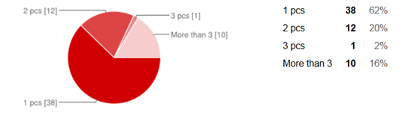
According to the figure, the following results were found:
- 100% of the surveyors (college students) own a cell phone, and 38% college students own more than mobile phones.
- Based on the statistical method: statistical independent-measures test method, the average subscriber ownership among these surveys (college students) owns an average of 1.72 piece cell phones.
According to Pew Research Center’s Internet & American Life Project report (April 2013) the average cell phone US adult (between 18 to 44 years old) subscriber owns 0.97 piece cell phone. Therefore, the data collected from RQ1 demonstrates statistically significant results. Here is the demographic comparison between college students and US Adults subscribers (age between 18 to 34):
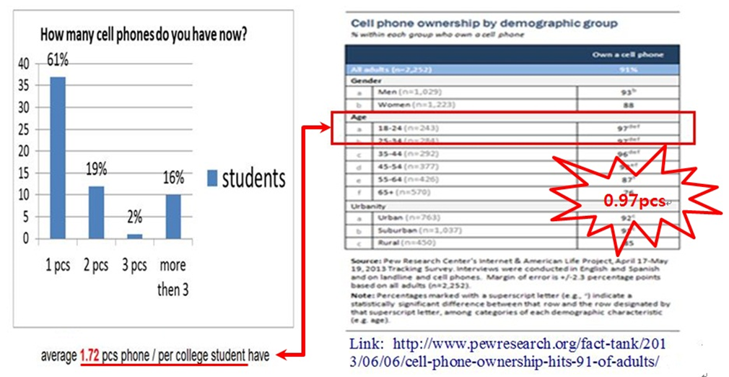
Statistical method: statistical independent-measures test Link: http://www.pewresearch.org/fact-tank/2013/06/06/cell-phone-ownership-hits-91-of-adults/
Statistical method: statistical independent-measures test Link: http://www.pewresearch.org/fact-tank/2013/06/06/cell-phone-ownership-hits-91-of-adults/
Data Analysis : ( Statistical mode: statistical significance test)
- Data collection
Sample Data:
。1.72 pcs phone / per college student
。 Source: Based on these 61 students who finished all components of the survey.
Population (USA Adults ): According to Pew Research Center’s Internet &
American Life Project report (April 2013)
。Mean 0.97 pcs phone / per person
- Testing Method : The independent-measures t test.
3) Texting result
P=0.0000019< 0.05, so support RQ1
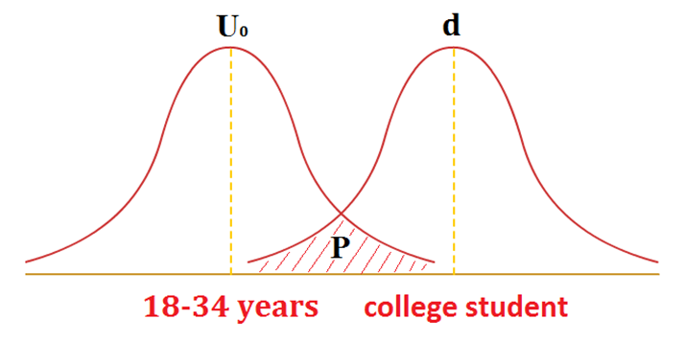
Conclusion: The average amounts of college students surveyed do indeed own cell phones and in fact many own more than one cell phone. This is significant because it shows that the number of cell phone ownership amongst college students is greater than the overall population in the USA.
For RQ2: What is the average college student’s daily time on his/her cell phone compared to the average American? The idea is to examine whether the average college student’s daily hours on his/her cellphone is greater than what the average American spends on his or her mobile phone. The data collection is based on 61 usable surveyors’ responses to analyze what are the hourly daily average college students use their phones. The following graph indicates the amount of daily hours students spend using their cell phones:
What kind of activity do you do with your cell phone every day?
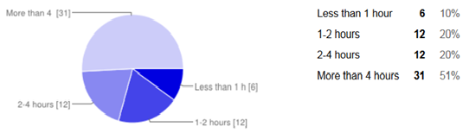
The next part of the data collection is to compare whether or not student cell phone use is greater than the average American’s. The testing method is based on statistical independent-measures test method (one-tailed testing). The result indicates that the average usage is 2.97 hours per day from college students. This 2.97 hours usage is higher than average American daily usage 2.34 hours (as cited in www.eMarketer.com, 2013) therefore there is significant proof that college students use their cell phone longer than the rest of American’s. The daily cell phone use between college students and the average American is shown in following:
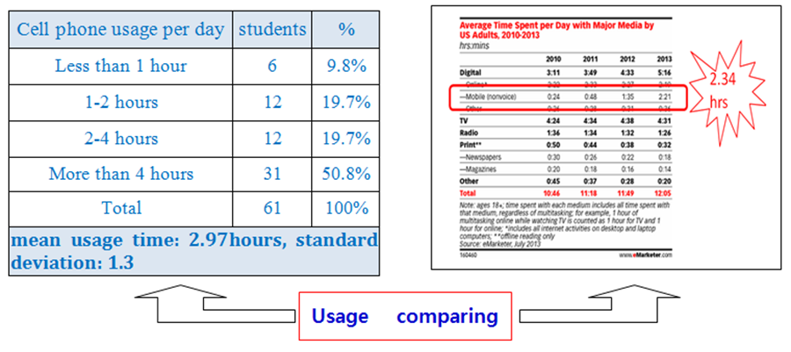
Here are the steps in the analysis and the testing results which are based on a statistical independent-measures test (one-tailed testing) formula:
- Step one Data collection :
Average cell phone usage: 2.34 hours / per day by US adults
Average cell phone usage from surveys: 2.97 hours / per day by college students
Standard deviation: 1.3 hours
- Assumptions:
The project employed statistical methods to prove that college students use of cell
phones (i.e. total time measured in hrs) were significantly greater than adults in USA.
Based on Uo= 2.34, U=2.97, α=0.05
。 If U≤ Uo, Ho is right.
Therefore, there are no significant differences between students and adults.
。 If U> Uo, H1 is right.
This result will support that college student’s daily phone usage was significantly
greater than adults in the USA.
- Calculating format and demographic :
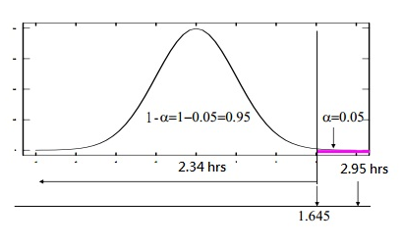
- Result from data analysis

Z=3.78>1.645, so support H1

- Conclusion:
The results indicate that the college student cell phone use is higher than the average adult in USA. Therefore, the data collected from RQ2 demonstrates statistically significant results. Moreover, through a statistical analyzed method, the data demonstrates cell phone obsession of college students is greater than adults in the USA.
For the RQ3-a: How does the use of cell phones affect student learning? Do students realize how often they use their cell phone during school/class related activities?
This research question was conducted by questionnaires to examine how cell phone affects students' learning. According to the data collection, the results found 69 % of college students use their cell phones in the classroom and 75% of college students think that cell phones do disrupt their studying. Over half of the college students are prone to using their phone when they take classes. The participants recognize that cell phone use in the classroom has negative influences on learning. These results for RQ3 are represented in the following graphs:
9. Do you use your phone when you are in the class?
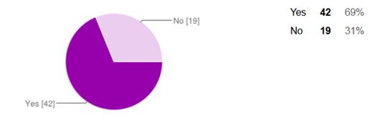
13. Do you think your cell phone usage disturbs your studying?

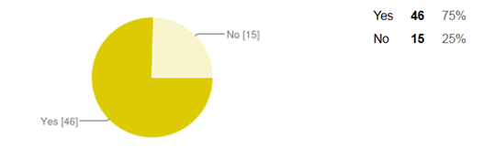
RQ3-b: How do cell phones affect student’s behavior & life?
From the survey’s data, it was found that 51% of college students spend time with cell phones more than four hours per day and only six college students spend less than one hour with a cell phone. The data indicates that 66% of college students use cell phones even when they have a meal, 92% of college students check their cell phone before they go to sleep, and 82% of college students use their cell phone when they wake up in the morning. These results demonstrate cell phone dependency and perhaps addiction.

4. How many times do you spend with your cell phone every day?
8. Do you use your phone when you are eating meal?

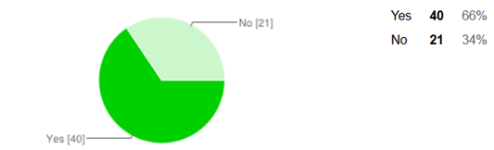
7. Do you use your phone before you go to sleep?

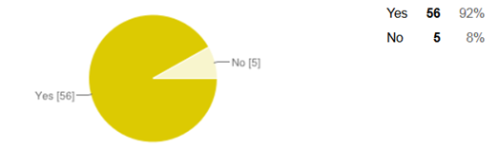
14. Do you look at your cellphone before you roll out of bed in the morning?

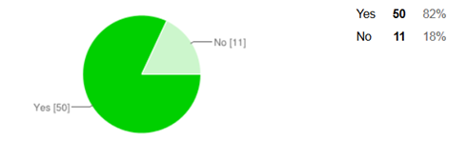
In addition, college students carry their cell phones all day as if the cell phone is a part of their body. Also, the research found a serious pattern in that 69% of college students answered that they feel depressed if they lost their cell phone. According to the research, 77% of college students responded that they do not feel lonely when they use cell phone while 62% of college students have texted, emailed, or searched the web with their cell phone when driving. These results demonstrated remarkably that cell phone affects students' life and behavior. The results of the study support the idea that the overuse of cell phones may cause many issues (i.e. loneliness and depression) and in some cases (i.e. while driving) may cause bodily harm including death. This form of technology (i.e. cell phones) if not correctly regulated may become a very serious problem in our society. The following graphs demonstrate the behavior and life style impacts of cell phone use amongst students:
10. Do you feel depressed if you don't have your cell phone for just one day?

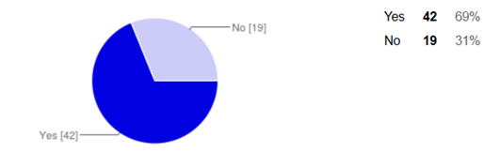

16. If you’re in a public place by yourself, do you look at your smartphone to not feel lonely?
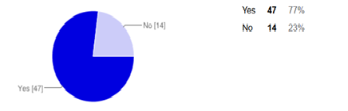

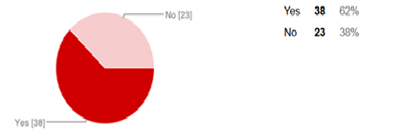
18. Have you ever texted, e-mailed, or searched the web with your phone while you are driving?
These results demonstrate cell phone dependency and perhaps addiction
RQ4: What do cell phones mean to students?
The format of the research study involves a questionnaire survey because due to time constraints there is not enough time for face-to-face interviews. Therefore the survey questionnaire consists of 27 questions and the research project utilizes a mixed quantitative and qualitative research methods. The first twenty-four questions reflect a quantitative research approach. The last three survey questions were framed in an open ended way to collect qualitative responses from the participants which reflects the qualitative research approach method. According to Mertler (2012), “qualitative data are usually through observation, interviews, or journals or through access to existing files or record collection” (p.151). The three open questions include: What circumstances do you feel using a cell phone is appropriate ? What does mean to you cell phone ? Please describe your experience. These three open- ended questions are able to explore the participant’s open responses rather than force the participant into a single all-encompassing answer. After finishing the data collection, the next step is to code and distinguish the findings into distinct categories. Strauss and Corbin (1998) suggested the following types of coding “open coding, axial coding, and selective coding” (as cited in Mertler, p. 160). Through a comprehensive consideration, this cell phone obsession research study is using both open coding and axial coding. The first step is to sweep through the data and tag (by circling or highlighting) or label parts of the text selection. An example of this method is to circle the word or phrase that describes the behavior of the college students’ responses. Eventually a large number of codes can be found and they need to be sorted into some sort of order or into groups. Axial coding involves of determining relationships between the open codes. Moreover, Strauss and Corbin (1998) explained that “two common types of axial coding are Non-hierarchical or Hierarchical” (as cited in Mertler, p. 164). This cell phone obsession research project used Non-hierarchical type because that is kind of flat coding more clearly to find the key points than hierarchical coding (tree coding) in this RQ4: What do cell phones mean to students? Here are the results of coding
Part I - Open coding

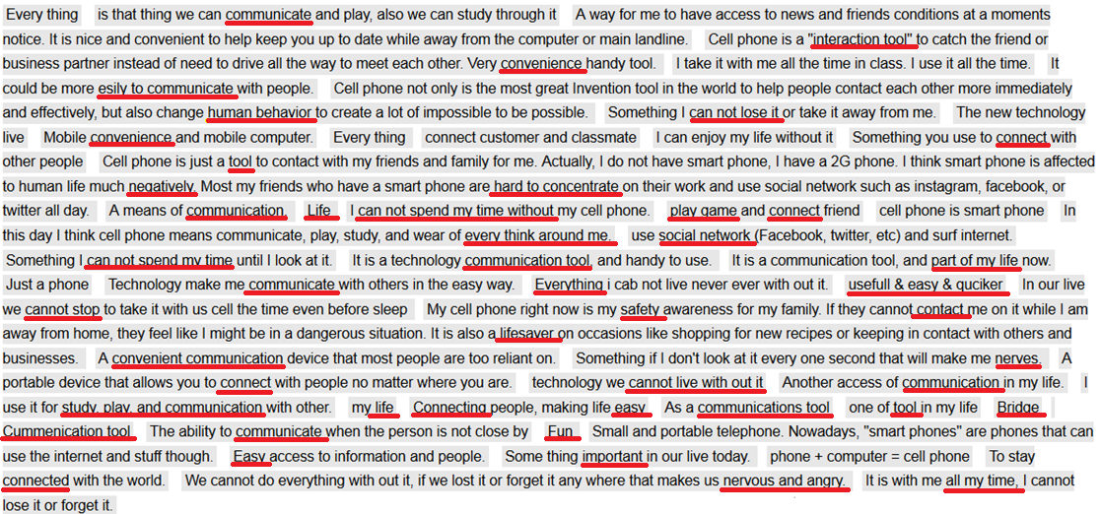

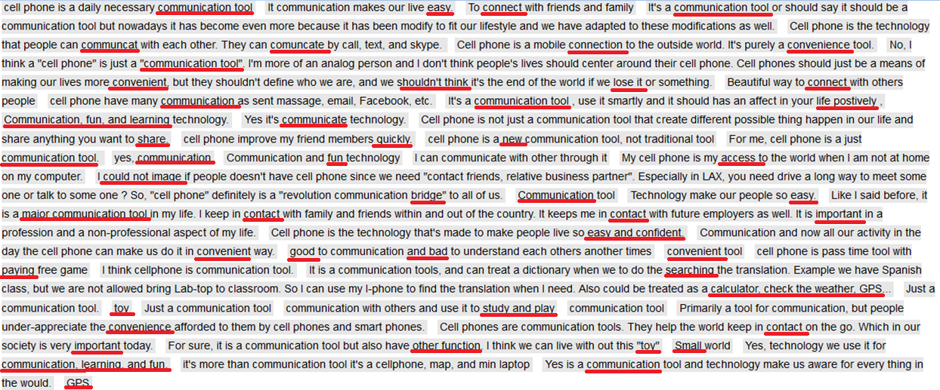

Part II-Axial coding (Additional analysis of RQ4: What do cell phones mean to students?)

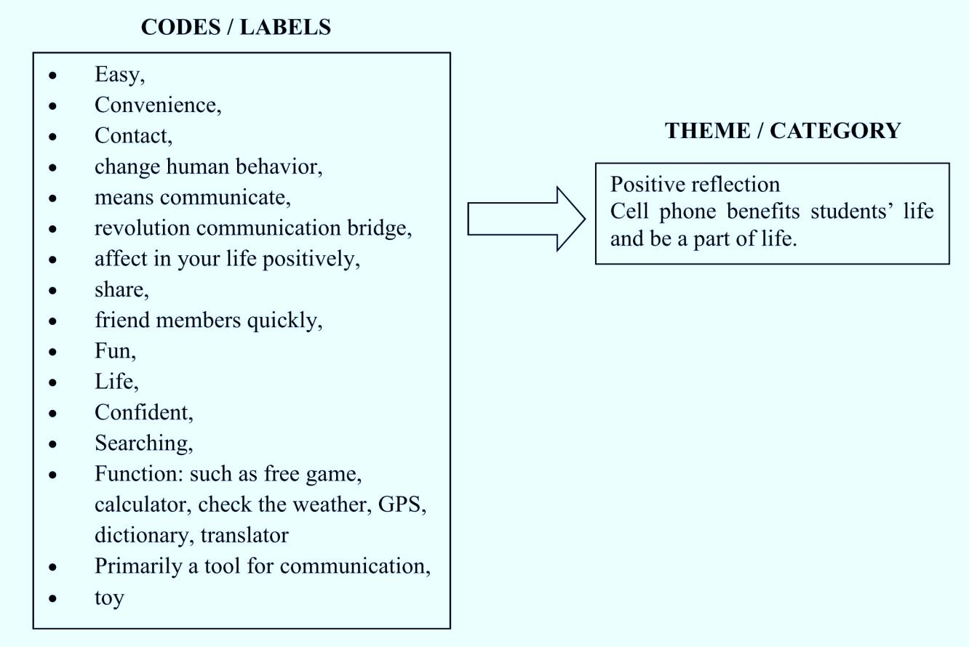
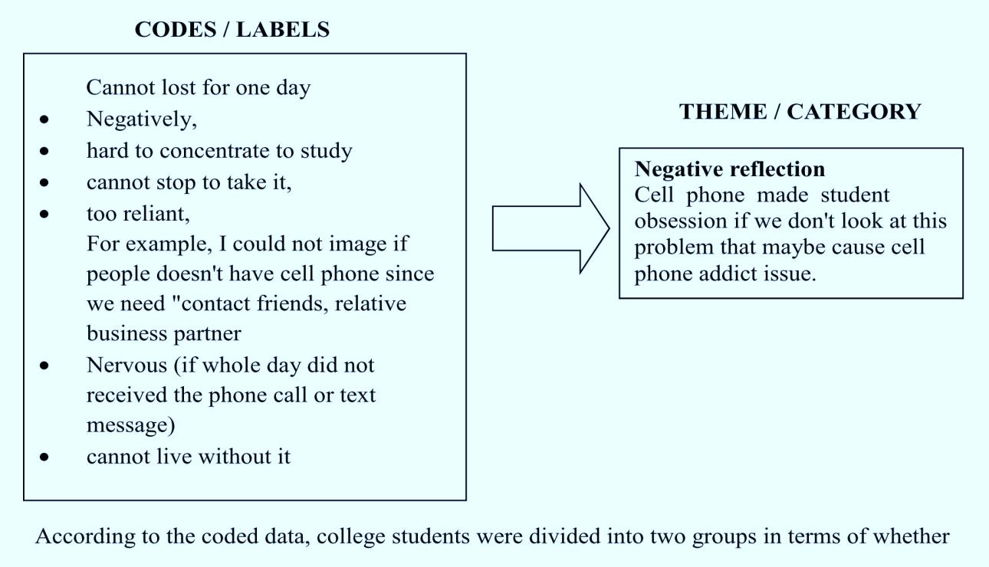

According to the coded data, college students were divided into two groups in terms of whether cell phones have positive and negative reflections. The positive reflection group considered that the cell phone is part of their life, a primary communication tool, a searching information tool, learning supplement (i.e. translations, tutoring), and a form of entertainment. The negative reflection group was concerned that cell phones disturb their learning and make people over rely on them and cause anxiety and nervousness when they do not receive a phone message from their friends. No matter if the cell phone usage is positive or negative, cell phones have significant meaning to college students. There is no doubt that technology can deliver information with ease to human beings and they provide people with a comfortable lifestyle and convenient mode of communication. However, the overuse of cell phones could cause several problems in society.
Limitations of the Design

There were a handful of limitations to this study. For example, the small scale sample of students surveyed may not depict an accurate portrayal of all college students. The students used in this project are all residents of Southern California. Additionally, the students surveyed may not have answered honestly out of fear of sounding too dependent on their cell phones.
Results and discussion
The purpose of this research is to identify cell phone obsession issues and the impacts to college students on their learning, social lifestyle, and behavior and to figure out in what way college students rely on their cell phones and of course to explore problems of overuse. First, the research study is to investigate if there is statistical significance that proves a cell phone’s behavior impact on student’s learning. From the collecting data results, there is an indication of a significant relationship and impact of cell phones on student learning. This significance is based on the results from a couple questions in the survey. For example, Question 13 asks whether the person feels the cell phone will disturb their studies. 75% of college students reported that their cell phone (i.e. incoming call or text messaging) does in fact disturb their study. The other findings (i.e. question 9) indicate that 69% of the students use their cell phones in the classroom. Other research questions (i.e. questions 14, 7, 10, 8, 19, 16, 18) explore what the cell phone impact is on student’s social life and behavior. According to the questionnaire findings, this research study proves significant. Examples of the survey questions are: How many cell phones do you own? How many hours do you spend on the cell phone per day? The results show the average subscriber ownership and average daily usage of a cell phone.
The data collection and analysis shows that the average college student’s (age of 18-34) cell phone subscriber ownership average is 172%. This is much higher than the average American (age of 18-44) 96.67%. The other finding is on average use. The collected data demonstrates that average college students spend 2.97 hours on their cell phones. It is important to demonstrate what cell phones mean to the students. The other interesting finding from the survey shows that more than 66% of students use cell phones when they are eating and more than 82% of students check the cell phone before they sleep and wake up from bed. In addition, 77% students feel lonely if they do not use cell phones during the whole day, 69% feel depressed if they lose their phone, and 77% of college students use their cell phone if they are by themselves in public area. Thus, the finding from the research data analysis proves significant in terms of how college students rely on the cell phone in their social life and how cell phones influence social behavior. The last research question of the survey is a short answer question and asks, “what does the cell phone mean to you?” This qualitative research question brings out a lot of interesting ideals. For example, some students stated that their cell phone is a primary communication tool, social tool, information search tool, entertainment and supplemental study tool (i.e. dictionary, research for the project). On the other hand, others responded that cell phone not only makes people heavily reliable and nervous, but that it also disturbs students' learning. Technology has brought a plethora of advantages in human society. However, the overusing and underusing of technology is an issue today because it causes abnormal behavior and makes slow reasoning of human ability.

Discussion Possible Problems
Since the research topic focuses on the cell phone impact on college student learning and social behavior, the results are significant and need to be discussed. There is no doubt that technology can deliver information with ease to human beings. It also provides people with a comfortable life and convenient communication. However, the overuse (i.e driving while texting, texting in the classroom) of cell phones can cause several problems (i.e. accidents, negative academic impacts) for society. It seems students are becoming less attentive to the opportunities of face to face social interaction. Also, people are choosing more brief forms of communication and rarely take the time to develop personal and deep conversations.

Conclusions & Recommendations
Recommendations for Further Research
A specific topic which coincides with this research is to examine why college students’ continue to use their cell phones in class and during school related activities. Though students know and agree that over-using cell phones has a negative impact on their learning and their social behaviors, they still choose to. Along with figuring out why so many students use their phones, regardless of the impact it has on their schooling and social life, one may examine when this behavior begins in life. Discovering when and why this “cell phone obsession” occurs can lead to answers on how to make students less reliable on their phones so they can truly experience everything that college and life has to offer
Further evaluation may be done by using the same type of data collecting tool and administering it to younger students, perhaps in the middle school and high school levels. More questions may be needed that ask why students use their cell phones so much. Another research tool would be to design an observational study to look at why students are so dependent on their phones. Understanding student behavior is a key issue as to why they continue to use a device even when they know it may be detrimental to their studies.
Conclusion
The methodology the research project used to address the research questions is mixed methods. For example, the methodology consists of finding primary evidence and data to analyze the patterns of cell phone use with the goal of being able to generate a quantitative graph that illustrates our results. In addition, the survey uses three open-ended questions designed to get descriptive and qualitative information, which we can analyze to determine the social meaning of cell phone use among students. Lastly, our mixed approach uses peer-reviewed articles to situate our research within the gaps and limitations of the field. The survey was distributed to 81 students at CSU San Bernardino, CSU Fullerton, and Cal Poly Pomona. According to survey results, it is proved that cell phone subscriber ownership of college students is greater than the overall population in the United States and the average college student daily hours on cell phone is greater than average American adults. Also, this research project found that college students heavily rely on cell phone use not only in class but also in their daily life such as when college students has a meal, before going to bed and after waking up. In addition, results show that cell phone causes social behavior such as loneliness, depression, and using cell phones while driving is dangerous. In the qualitative responses, some college students regard cell phones as helpful to their life; other college students state that cell phones affect college students' life in many ways. Through these results, this research found that heavy reliance on cell phone could bring many disadvantages to college students. The research topic is focuses on the exploration of how cell phones impact student learning and social behavior. To fully understand the results, a deeper conversation needs to occur.
Lastly, the study uses the results to find useful solutions in reducing negative influences and enhancing the positive aspects of controlling cell phone use. There is no doubt that cell phones are a form of great technology that make our lives easier and help us communicate. However, people should not rely on them continuously for entertainment or loneliness. The study provides some recommendations to help solve college students’ issues with cell phone obsession.

Appendix
* Required
Name *
What is your gender? O Female O Male
Are you a college student? *
o Yes
o No
How old are you? *
o 10-20 years
o 21-30 years
o 31-40 years
o Others
1. If you are college student now, what is your education status?
o Freshmen
o Sophomore
o Junior
o Senior
o Others
2. What kind of technology do you use most frequently?
o Cell phone
o Laptop
o Ipad / tablet computer
o Computer
3. What kinds of cell phone do you use?
o I-phone
o Android phones
o Blackberry
o Window phone
o Others
4. How much times do you spend with your cell phone per day?
o Less than 1 hour
o 1-2 hours
o 2-4 hours
o More than 4 hours
5. What kind of activity do you do with your cell phone every day?
o Social network (Facebook, twitter, line, etc)
o Listening to music
o Playing game
o Searching the internet
o Watching movie / TV show
o Only phone call or texting
o Others
6. How many cell phones do you have now?
o 1 pcs
o 2 pcs
o 3 pcs
o More than 3
7. Do you use your phone before you get sleep?
o Yes o No
8. Do you use your phone when you are eating meal?
o Yes o No
9. Do you use your phone when you are in class?
o Yes o No
10. Do you feel depressed if you don't have your cell phone for just one day?
o Yes o No
11. Do you feel uncomfortable with talking to people face to face and instead prefer to talk with them on
your cell phone?
o Yes o No
12. Can you memorize your friends' phone number?
o Yes o No
13. Do you think your cell phone usage disturbs your studying?
o Yes o No
14. Do you look at your smartphone before you roll out of bed in the morning?
o Yes o No
15. Do you get excited when your smartphone rings or get notifications?
o Yes o No
16. If you’re in a public place by yourself, do you look at your smartphone to not feel lonely?
o Yes o No
17. Have you heard your smartphone ringing or felt it vibrating in your pocket when it was really nothing?
o Yes o No
18. Have you ever texted, e-mailed, or searched the web with your phone while you are driving?
o Yes o No
19. Do you feel lonely if your smartphone doesn’t ring for several hours?
o Yes o No
20. If your smartphone rings in the middle of personal business, have you ever taken it out to see what
it is?
o Yes o No
21. Do you have a name for your cell phone?
o Yes o No
22. Have you ever sent an e-mail, Tweet, or Facebook message from your smartphone when there was
a computer in the same room you could have sent it from?
o Yes o No
23. Is it painful for you to live without your smartphone?
o Yes o No
24. Which is more familiar to you :
o Talking with phone o Talking with people by face-to-face
25. Under what circumstances do you feel using a cellphone is appropriate?
26. What is the most important aspect of your cell phone, to you personally?

27. Does your cell phone have a negative or positive impact on your life? Why or

References
Ali, A. I., Papakie, M. R., & Mcdevitt, T. (2012). Dealing with the distractions of cell phone misues/use in the classroom -A case example. Competition Forum, 10(2), 220-230.
Bugeja, M.J. (2007). Distractions in the wireless classroom. Chronicle of Higher
Education, 53(21), C1-C4.
Conti-Ramsden, G., Durkin, K., & Simkin, Zoe. (2010). Language and social factors in the use of cell phone technology by adolescents with and without speciﬁc language impairment (SLI). Journal of Speech, Language, and Hearing Research, 53, 196–208.
Crompton, H. (2013). A historical overview of mobile learning: Toward learner-centered education. In Berge, Z. L., & Muilenburg, L. Y. (Eds.), Handbook of mobile learning (pp. 3-14). Florence, KY: Routledge.
CTIA-The Wireless Association (2013). Wireless Quick FactsYear-End Figures. Retrieved from http://www.ctia.org/advocacy/research/index.cfm/aid/10323
eMarketer (2013). Average Time Spent per day with Major Media by USA Adults, 2010-2013. Retrieved from http://www.emarketer.com/
Griffiths, M. D. (2013). Adolescent mobile phone addiction: A cause for concern?. Education and Health, 31(3), 76-78.
Hosking, S. G., Young, K. L., & Regan, M. A. (2009). The effects of text messaging on young drivers. Human Factors, 51, 582–592.
Kim, H., Kim, G. J., Park, H. W., & Rice, R. E. (2007). Conﬁgurations of relationships in
different media: Ftf, email, instant messenger, mobile phone, and SMS. Journal of Computer-Mediated Communication, 12, 1183–1207.
Lee, C. S. (2012) Smartphone addiction: disease or obsession? http://www.koreatimes.co.kr/www/news/opinon/2012/11/298_117506.html
Lee, V. K., Champagne, C. R., & Francescutti, L. H. (2013). Fatal distraction: Cell phone use while driving. Canadian Family Physician Medicin De Famille Canadien, 59(7),
723-725.
Mcconatha, D., & Praul, M. (2008). Mobile learning in higher education: An empirical assessment of a new educational tool. The Turkish Online Journal of Educational Technology, 7(3), 1-7.
McMillan, J.H., & Schumacher, S. (2010). Research in education: Evidence-based inquiry (7th ed.). New Jersey: Pearson.
Mertler, C. A. (2012). Action research: Improving schools and empowering educators (3rd ed.). Thousand Oaks, CA: SAGE
Rainie, L. (2013). Cell phone ownership hits 91% of adults. Pew Research Center’s Internet & American Life Project. Retrieved from http://www.pewresearch.org/fact- tank/2013/06/06/cell-phone-ownership-hits-91-of-adults/
Reed, N., & Robbins, R. (2008). The effect of text messaging on driver behavior: A
simulator study. Transport Research Laboratory, 367.
Reid, D. J., & Reid, F. J. M. (2005). Textmates and text circles: Insights into the
Socialecology of SMS text messaging. In: Hamill, L., Lasen, A. (eds.), Mobile world:
past, present and future. London: Springer-Ver- lag, 105–118.
Reid, D. J., & Reid, F. J. M. (2007). Text or talk? Social anxiety, loneliness, and divergent preferences for cell phone use. Cyber Psychology & Behavior, 10(3), 424-435.
Salehan, M., & Negahban, A. (2013). Social networking on smartphones: When mobile
phones become addictive. Computers in Human Behavior, 29(6), 2632-2639.
Sarwar, M., & Soomro, T. R. (2013). Impact of smartphone's on society. European Journal of Scientific Research, 98(2), 216-226.
Skierkowski, D., & Wood, R. M. (2012). To text or not to text? The importance of text messaging among college-aged youth. Computers in Human Behavior, 28(2), 744-
756.
Strauss, A., & Corbin, J. (1998). Basics of qualitative research: Techniques and procedures
for developing grounded theory. Thousand Oaks: Sage Publications.
Tessier, J. (2013). Student impressions of academic cell phone use in the classroom. Journal
of College Science Teaching, 43(1), 25-49.
Tindell, D. R., & Bohlander, R. W. (2012). The use and abuse of cell phones and text
messaging in the classroom: A survey of college students. College Teaching, 60(1), 1-
9.
Traxler, J. (2007). Defining, discussing and evaluating mobile learning: The moving finger writes and having written. The International Review in Open and Distance Learning, 8, 1-13.
Young K. L., & Regan M., A. (2007). Distracted driving. College of Road Safety, 379-
405.
Walsh, S. P., White, K. M., & Young, R. M. (2009). The phone connection: A qualitative exploration of how belongingness and social identiﬁcation relate to mobile phone use amongst Australian youth. Journal of Community and Applied Social Psychology, 19, 225–240.
Weller, J. , Shackleford, C. , Dieckmann, N. , & Slovic, P. (2013). Possession attachment predicts cell phone use while driving. Health Psychology : Official Journal of the Division of Health Psychology, American Psychological Association, 32(4), 379-387.

