Do Reward Systems Improve Student Performance?

Arwa Albah, Steven Ramirez, Jeanette Ojeda, Gloria Inzunza, Brenda Machuca, & Kaleena Smith

California State University San Bernardino

Fall 2018

Abstract
A challenge that educators face is how to manage classroom behavior and engagement of their students. This is a quantitative report discussing the effects of reward systems (homework pass, early lunch, and extra points, etc.) on student behavior and achievement in the classroom. The research was conducted through a survey given to 39 educators ranging from TK to eighth grade. Their years of teaching experience ranged from 2 to 41 years; where 15 years of teaching experience was the average. Findings revealed that 87% of these educators believe that reward systems are necessary to improve student behavior and achievement. 94% of these educators will continue to use reward systems to help with classroom management. Future research implications include focusing on core subject reward systems to see if there is a discrepancy between multiple subject and single subject data.

Do Rewards Systems Improve Student Performance
Introduction:(Arwa)

This project’s main purpose is to establish if reward systems improve student performance. The project will research if the above is true. Literature review from various scholars indicates that reward systems are a solution to poor performance. Other scholars believe that rewarding the best students encourages the rest of the students to work harder. This improved performance is attributed to students aiming for the reward and not necessarily improving because they made a decision on their own. The reward system in this case is the sole reason for student improvement. This project seeks to find out if the claims are true by researching on the performance of k-8 students who were offered a reward system as an incentive and another class that did not have the same incentive. The k-8 classes will have to share the same teacher and mathematics will be the subject of study when collecting performance data. The project will employ the use of a quantitative method of research to collect data. Data will be analysed and results will be plotted on bar charts. The project makes the assumption that the classes are well balanced in terms of student performance and that the teacher is an excellent instructor. Another assumption is that the boys and girls in the two classes are well represented in similar ratios. The final assumption is that the teacher interacts with the two classes in the exact way so that no class is at a greater advantage than the other.
Literature Review:

Improving students’ intrinsic motivation in piano learning: Expert teacher voices
According to Cheng and Southcott (48), in as much as numerous students learn to play the piano, some students end up lacking the motivation to continue learning. This is because many students learn how to play the piano for extrinsic reasons. As such, the two scholars examined the understandings and reasons behind student motivation based on the guidance of expert piano teachers who have formulated strategies to improve the students’ intrinsic motivation to only start learning how to play the piano, but continue learning.
Cheng and Southcott (50) employed qualitative, constructivist and empirical approaches in their research. These approaches are suitable to their research since the study takes the form of a small scale phenomenological case study involving three expert and experienced teachers who share their knowledge and learning processes and philosophies with the authors regarding student engagement and motivation. For instance, constructivism implies that knowledge is the outcome of interactions between individuals which Cheng and Southcott (50) aim to achieve by interacting with the teachers. The empirical aspect of the research compares and contrasts the numerical outcomes of the case study to the existing literature in the same field of study.
As revealed in the research, the case study generated various findings thematically in connection to the students’ motivation in piano learning such as interviewing parents and students before beginning teaching, modeling enthusiasm, professionalism and enjoyment, selecting appropriate repertoire, providing performance opportunities, being vivid about what
and how one teaches, individualizing teaching and learning, managing student and parent expectations and espousing students in their choices to continue learning or stopping. Cheng and Southcott (55) are of the opinion that a healthy combination of these factors is crucial to improving students’ intrinsic motivation in piano leaning. Nonetheless, they conclude that underpinning these factors is the belief that students who enjoy leaning and playing the piano tend to develop stronger inherent motivation to play so as to please themselves. When a student enjoys what he or she is doing, then he or she will be motivated to continue performing the task. Thus, the challenge lies in teachers using extrinsic motivational strategies that make the lessons enjoyable so as to improve the student’s intrinsic motivation in piano learning.
According to Chwen and Hu (1), the utilization of rewards in education settings as a means of improving motivation in students is a controversial issue. The authors highlight the findings of previous studies on rewards that denote that the impacts of rewards in education settings are mostly contingent on the reward expectancy, they types of rewards used, the attributions made for getting the reward and the reward contingency. This means that immense emphasis is placed on the reward by the students when deciding whether to work hard and attain better results or not. Notwithstanding, Chwen and Hu (1) conducted a research to explore the predictive model of rewards so as to identify the reward predictors for motivating students to read.
Chwen and Hu (3) employed empirical and qualitative approaches in their study. These approaches proved to be suitable to their study since the research involved participants answering questionnaires and their responses analyzed on a students’ reading motivation scale so as to reflect intrinsic reading motivation and extrinsic reading motivation evinced by the students. The authors also made use of a longitudinal design in their research procedure so as to determine pre and post-reward leaning motivation of the students.
From a longitudinal perspective, the findings of the research revealed that the reward attribution and reward type are two influential processes when it comes to students’ reading motivation. These processes not only predicted the intrinsic reading motivation but also the
extrinsic reading motivation in that intangible effort and reward attribution improved both students’ intrinsic and extrinsic reading motivation, but luck attribution impacted students’ intrinsic reading motivation adversely. In addition, Chwen and Hu (6) found that the expectancy of rewards and reward contingency were not capable of predicting any form of reading motivation. As such, the authors recommend that rewards should be intangible rather than tangible to maintain students’ focus on improving their reading rather than just putting effort for the purpose of getting a reward. Moreover, Chwen and Hu (6) also suggest that parents and teachers need to be aware of the attributions students make for getting rewards so that they are not for irrelevant purposes.
The purpose of this quantitative study was to record the positive impacts of personal goal setting and to see if this improved students’ performance on high stakes testing. The specific question that was asked was “How could I (the researcher) instill intrinsic motivation in all of my students now, so that they make the proper learning preparations necessary for academic success on the upcoming achievement test?” This study involved a third-grade class with 18 students. The study did not talk about the socioeconomic status of these 18 students. The purpose of this study was to record the positive impacts of personal goal setting and to see if this improved students’ performance on high stakes testing. Overall in this study the teacher concluded that she was happy with the results of her students. She noticed higher participation and individual motivation of her students. The teacher followed the students and had her students make their own goals and to journal what they were achieving on their weekly tests. She noticed that they were actively discussing during their journaling why they did or did not meet their goals. She noticed that many of her students applauded and gave high fives to their peers when they reached their goals. That overall there was an increase in test scores especially with her lower achieving students. Future implication is that the author would like to see more research performed that involved students making and monitoring their own goals. The cautions that this author gave when conducting this research is for teachers to monitor and make sure that the students are setting realistic and attainable goals. The students should be the guiding force of creating these goals so that they are taking ownership, but they need to make sure that the goals are realistic. (Smithson)
I always understood the importance of goal setting as an adult, however I never really thought of having my students make and monitor their own goals. As educators we tend to set things up for our students to follow and set goals and expectations for them. After reading this article, I realize the importance of students setting and monitoring the goals that they themselves created so that they are taking ownership and reflecting on what they did or did not do to attain these goals. This article showed that when this classroom of third graders did this, that there was higher motivation and participation in the learning process. Therefore, reward systems that we researched in our study focused on extrinsic motivation, but this article focused more on an intrinsic motivation to engage and impact student achievement.
(ONE-LitReviewBM)

Classroom management is an essential part of ensuring that students have a stable learning environment that encourages learning and harvests creativity. Dr. Ruth Payne found that rewards and reprimands assist with classroom management when it relates to social behavior. “These systems are based on behaviorist principles of reinforcement and punishment as motivators for changing patterns in behavior” (Payne, 2015). Payne’s 2015 study was done using a large data collection that was composed of students who attended secondary school of years 7 – 12 (6th grade – 12th grade) in the United Kingdom with over 11000 enrolled students. Payne was able to collect the response of over 3000 students who completed the survey, asking them about their thoughts on rewards and reprimands. Even though all the responses were taken into consideration, only the survey responses from students in year 7 and 11 (6th grade and 10th grade) were used to compare data and obtain findings. The study consisted of three separate questionnaires with 18 different scenarios. The student in years 7 and 11 were then separated in five different groups and asked to answer the questions consisting of 18 different scenarios. The addition of sub groups in the study allowed Payne to take a closer look into the student responses. According to his finding, the reward that was most effective over all age groups was “contact with home” which is when the teacher contacted a student’s parent or guardian to give them a positive report on the student’s overall progress at school. Students whose teacher contacted home were motivated to behave well, work harder, and this also improved the relationship between the teacher and the student.
The sanctions in place at the secondary school that was studied are; being made to miss a break, formal report, not being allowed to participate in a school trip, and contact with home. “Being made to miss a break has the highest overall score for disliking the teacher (56%) and it is the only punishment that causes pupils to dislike the teacher more than if they are not allowed on the school trip” (Payne, 2015). This also did not motivate the student to behave well or to work hard in class. The punishment that had the most positive effect on student behavior was “being put on a report (Q18), which is not a formal part of the school behavior policy” (Payne, 2015) but has the most responses for motivating student to behave well in class. The findings also show that students in year 10 respond better to reprimands when these are given to the students in a private setting. Public reprimand in front of peers causes students to shut down, and does not improve the behavior.
Over all Payne conclude that even though rewards and sanctions are beneficial to teachers to manage social behavior in class, these do not have a significant impact in motivating students to work hard or encourage learning. The best way to build positive relationships with students is to contact home and give positive and negative reports relating to students’ progress and behavior in class, as well as give private reprimands when reprimands are needed.
(TWO-LitReviewBM)
As new teachers enter the classroom for the first time as credentialed instructors, they come in fully prepared academically and with some hands-on experience in classroom management. However, for many, their first day of work will also be the first day they will be alone with a group of students, having to teach lessons, engage students, and manage classroom behavior. In the study “Classroom motivation: Strategies of first-year teachers” conducted by Timothy J. Newby, 30 first-year elementary school teachers were observed during a 16-week period in 50 minutes segments. “The purpose of this study was to investigate the quantity of motivational strategies implemented, the types most frequently used, and the relationship between strategy use and student behavior in the classrooms of first-year teachers” (Newby, 1991).
During the observations the trained observer took notes on all events that occurred in the classroom focusing on; presentation of information, instructional games played, use of posters, media, drawings, and overhead projections. During the observation the observer also focused on student behavior. Off task students were the focus during that observation segment, as well as the techniques used by the new teacher to redirect them and get them back on track. The observers then finalized their notes and submitted to principal investigator within 24 hours. The notes had to be written in narrative form and “each narrative was individually reviewed, and motivational strategies were identified” (Newby, 1991). The identified strategies were then rated and classified into highlighted strategy based on the ARCS strategies (strategies focusing on redirecting students with Attention, Relevance, Confidence-building, Satisfaction).
According to Newby’s findings, the strategies that were frequently used were the satisfaction strategies. These strategies used an extrinsic approach when rewarding and punishing students. This approach motivates students to increase their efforts to obtain the desired objective. To increase on-task behavior relevance strategies were the most helpful. When students understood why lessons were important and how they provide the foundation for other lessons, students were then motivated and open to receiving the new information.
Newby concluded that the different ARCS motivational strategies used by first-year elementary school teacher assist with classroom management. Rewards and sanctions help by motivating students to work hard to obtain their end goal and to stay on task. Newby did add that “additional empirical research is needed to compare the direct application of extrinsic motivators with those of a more intrinsic nature on the amount of task effort” (Newby, 1991). This is because the data collected was that of only first-year teachers. The author recommends including teachers with a variety of levels of teaching experience for future studies.
This study gives valuable insight to what strategies work best to motivate students to stay on task and to work hard to achieve their desired goals. This is especially useful information to new teachers who even after having some hands on experience managing classrooms, are still transitioning to new positions where they are the only ones in charge of classroom management as well as presenting new lessons in an almost daily basis.
Research Question (BM)
Now to redirect our focus to our research question, “do reward systems improve student performance when focusing on students between the grades of transitional kindergarten through eighth grade?” We believe that the data collected via surveys, will allow us to confirm our hypothesis and determine if reward systems help improve student performance in the classroom. We predict that the data collected will reflect a positive outcome.
When determining a focus on grade level for this research, our group had to determine which grade levels to focus on, the group as a whole determined that focusing on the TK-8th grades would benefit the educational community the most.
Some complications that were predicted in this research project were; how to address survey answers from teachers who only taught students with special needs and how many surveys would we have to collect to get clear and credible results. Our group came to terms and decided that surveys from teachers who taught only special education students would not be used and to collect a minimum of 30 surveys.
Definitions of Terms (BM)
For this study the following key terms are defined;
- Motivation: the general desire or willingness of someone (students) to do something.
- Ethnographic Study: is one that comes from ethnographic research, a qualitative method where researchers completely immerse themselves in the lives, culture, or situation they are studying. They are often lengthy studies.
- Extrinsic Orientation: is demonstrated when a student increases motivation and effort to obtain a desired item.
- Intrinsic Orientation: participation in the task is considered, not as a means, but rather as desired end.
- Rewards: a thing or action given in recognition of one's (students) effort, or achievement.
- Sanctions: Measures taken consequently for not obeying or braking rules.
- Constructivist Approaches: a moralistic behavior approach to learning with the belief that learning is an active process rather than acquired process.
- Empirical Approaches: It is a way of gaining knowledge by means of direct and indirect observation or experience.

2. Review of Related Literature (GLORIA)
Develop this section according to the natural divisions that you found in the reviewed literature: trends, schools of thought, clusters of attributes, or methodologies. Organize headings and sub-headings to represent these various divisions. The literature review should imply (but not necessarily state) reasons why the problem should be studied. Use a concise, summary style, peppered with paraphrased material, salient references, and perhaps a few quotes. If you quote an author who uses special emphasis (underlined phrases, etc.), use the following phrase in the internal citation: emphasis in original. Whenever appropriate, identify gaps in the literature.

There are many ways that teachers use motivators in different contexts to help students in their classroom. One way to help students is by controlling their behaviors. When behaviors are controlled it motivates students to learn. If student behaviors are kept at a minimum the learning environment is one where a student is absorbing more information regarding the lesson. “The main role of the teacher is to guide and lead the students in the teaching-learning process” (Kubat & Dedebali, 2018, p.111). This specific study does not use direct motivators; however, they do set up the classroom management in order to motivate students and create an ambiance that promotes learning. “Students are affected positively when using classroom management in terms of motivation to draw attention at the beginning of the lesson” (Kubat & Dedebali, 2018, p.114).
The study of Kubat and Dedebali (2018) Opinions of Science Teachers for Classroom Management states that different things should be done in the classroom to promote student learning. Even though specific motivators are not being used, the environment and the context of the environment is being used. Students should always feel comfortable in class and a cozy environment should be provided. A democratic environment is emphasized, “such as giving equal rights to everyone, distributing tasks, and listening to a class while a student is speaking” (Kubat & Dedebali, 2018, p.113).
Seating plans also affect classroom management and the U-shaped seating plan allows face-to-face interaction between students & student, students and teacher. Everyone gets to look at each other and be equals; thus, promoting the democratic environment. Most students are active in participation when seated in this manner.
When problem behaviors do arise oral warnings should be issued to maintain classroom management. “In order to understand the reason why the student has this undesirable behavior in this subject, the teacher should interview the student exhibiting the undesirable behavior at the end of the lesson and be much more effective in removing the problem” (Kubat & Dedebali, 2018, p.115). If the problem is not corrected then teachers must punish to correct unwanted behaviors in the class management process.
“Classroom management is undeniably essential for the motivation of the students in the learning environment. (Kubat & Dedebali, 2018, p.115). Students need their environment set up to manage the classroom and thus serving to help motivating students. When students are motivated classroom and learning flow well.
Other teachers play games with their classroom to help motivate their students. The Good Behavior Game is a game that teachers use to motivate students to behave in their
classroom. The Good Behavior Game has been termed as a “behavioral vaccine”. Donalson, Vollmer, Krous, Downs and Berard (2011) researched An Evaluation of the Good Behavior Game in Kindergarten Classrooms. This study has been done with people in grades first through fifth. This study was a replica with a major change in it being that it would be done with kindergartners.
The Good Behavior Game divides the class in half where each half will compete against each other by behaving the best. Each team gets a point marked against them if they do anything the teacher has asked them not to do for example get out of their seats, talk without raising their hands, etc. The teams are distributed as evenly as the teacher can make them. The team with the least amount of points marked against them wins. The prize for example may be extra recess time. This game is a great motivator to help control the classroom which leads to more learning time in the class.
The five kindergarten teachers who participated in the study with a total of 98 students implemented the Good Behavior Game in their classrooms. Studies show that “during baseline, relatively high and stable levels of disruptive behavior were observed in all classrooms” (Donaldson, Vollmer, Krous, Downs & Berard, 2011, p.607). After the Good Behavior Game was implemented in the classroom “disruptive behavior decreased in all classrooms” (Donaldson, Vollmer, Krous, Downs & Berard, 2011, p.607). Even though the study was not conducted at a one hundred percent fidelity there was a significant drop in disruptive behaviors.
From the Good Behavior Game, one can learn that it helps motivate students to control disruptive behaviors which in turn leads to students learning more in the classroom due to the fact that the teacher does not need to stop as much to control students disrupting the class. It is a good game to implement in the classroom which is also a great motivator. Ultimately classroom management is the goal for all teachers and having students behave is what leads to more learning time.
Design & Methodolgy
The study examined the effect of reward systems on student performance. The experiment used both male and female teaching ranging from K-8 grade and we collected survey that had ten questions we created. As each group member received an answer from the educators, it was written down and put into a google thought where it was charted and calculated into a pie chart.
Limitations of the Design

Our study did have limitation. The survey had to be made to target our selected focus group. Since the contributors to this research each have different roles in the education system, we each had to find a point in common. Our focus group was changed to transitional kindergarten to eighth grade, when originally we aimed for kindergarten to eighth grade. Also, the interpretation in the chart could be misread if the reader doesn’t fails read thoroughly on years of experience. The survey allowed the voters to input the amount of years that they have been teachers. However, some teachers included the word years after the amount. For example, some teachers input “five” and another teacher input “five years.” They are both the same amount, however, the software, google forms, used doesn’t recognize it as the same. The form has created the table with different interpretation. The reader needs to understand while reading the chart that five and five years is the same count.
Subjects and/or Case

The population that was used for the study was composed of teachers ranging from transitional kindergarten to eighth grade. Both males and females were used in the study. The sample that was gathered was derived locally, meaning all teachers teach in the Inland Empire in the state of California. All teachers are public education teachers in the Inland Empire and have been teaching anywhere ranging from two to forty one years. Teachers were randomly sent an email and were asked to participate in a survey of ten questions. If teachers chose to participate they were asked a series of questions regarding their gender, years of teaching experience, subject/grade they taught, if they had any students with IEP’s (Individualized Education Plan), if they used any reward systems in class, if they had made any modifications as time has passed (if applicable), if they had noticed any improvements, which reward systems were used and if they would continue to use the reward systems they had in place.
The selection process for choosing the subjects were randomly selected through email and sent to teachers were our fellow classmates worked at. Teachers were sent an invitation to participate in a short survey. If teachers chose to participate in the study they could click on the link to participate. The survey consisted of ten questions and their answers were keep anonymous. The reason the sample (people) were selected randomly was due to the fact that we wanted to send the link to anyone who would take the time to participate in the survey. We wanted a variety of different teachers with different numbers of teaching experience, different grade levels and different subjects taught, different teaching styles, etc. With a variety of samples we would get “truthful” answers and a variety of answers.
If we would be able to collect a variety of teachers with different classroom structures then we would be able to determine if teachers use rewards systems and if so, do they see results in their use of reward systems. The results were astonishing and it got a variety of different teachers in different fields who do you use reward systems with similar results.
Data Treatment Procedures
After the survey was created, we needed to target our random sample so we can collect evidence and interpret our data. The google form survey was created to target our focused audience which are teachers. Our survey was completed by more than thirty-five teachers, which will help us interpret the data with more flexibility rather than doubt of credibility. We had had a total of thirty-nine teachers who kindly helped us complete the survey with no pressure and no reward for participating. From the thirty-nine teachers, five of the teacher were male. The survey included warm-up questions that helped us identify their gender. The gender of the teacher is objective evidence for the audience for their interpretation. The teachers who completed the survey were required to answer the amount of years of experience. In the data, we found a mean of approximately fifteen years of experience. The median of the teacher’s experience was twelve, and the mode had three different amount of years as the most. The mode was two, five, and thirty-one years of experience. Each year of experience was inputted by three teachers. In other words, three teacher said they have two of experience, three teachers said they have five years of experience, and three teachers said they had thirty-one years of experience. Despite the major difference in teaching experience, 87.2 % of the teachers use rewards system to promote motivation within the students. When asked if they feel that rewards system improves student performance 94.4% agreed and said yes. The data interprets that motivation can be majority promoted through extrinsic motivation via rewards system despite the years of experience by the teacher. Also majority of the teachers said they will continue to use the reward system with a 94.7%.
The advantages of this data collection procedure is that we made the questions simple, so the voters wouldn’t have any confusion at the moment of completing, Another advantage is that the survey completed is by the focused group who interact with this research on a daily basis during the academic school year. Who better to ask than the teachers. The disadvantage is that we didn’t focus on one core subject teachers. The data is more broad to a k-12 reward system, which some readers could argue that the data is weak for core subject reward system.
To overcome the disadvantage, the survey did include a question to list the types of reward system, Teachers from each core subject were able to input their data, where we can see very repetitive rewards such as homework pass, early lunch, and extra points despite the subject taught or grade level.
Instrumentation/Data Collection

In the development of the survey the team decided to get together and come up with a series of ten questions that would answer our question, do teachers use motivators, and if so, do they really work. If they are implemented, then what kind of improvements do they see in their classrooms. Once we knew we wanted these questions answered we came up with a series of questions that would give us those answers. We threw in some “warm-up” questions then asked what we wanted to know, do motivators really work help with student performance/behavior.
In the development of the survey we stated that we wanted to keep teachers answers anonymous. We wanted to maintain teacher privacy. This was also made clear to all teachers that their answers would be shared but their identity would be remain private.
The survey we came up with asked the first series of warm-up questions. The warm-up questions consisted of their gender, years of teaching experience, grade or subject taught and if they had any students with IEP’s (Individual Education Plan) in their classroom. After those questions the foundational questions were asked. The questions were: do you use a reward system, if so do you feel they improve student performance, have you made changes to your reward system, what kind of improvements do you see in your students (classroom). These questions were to give us the foundation of our research. See “Appendix A” to find the link to the survey that teachers answered.
When developing the survey we wanted to keep it simple, clear and straight to the point. We wanted our questions answered and we all agreed that our questions met the criteria we had all agreed upon. Using a survey would be the fastest and easiest way to collect data. The advantage to using a survey was that it was fairly easy and time conscious for those participating. The survey was clear, straight forward and straight to the point. It was clear and did not confuse any participant. It gave us the opportunity to ask different teachers in different positions if using motivators worked. The disadvantage is that we have to trust that the teacher is being honest and keeping some sort of data to come up with their answers.
Once the survey was developed and all researchers agreed to all questions different teachers were emailed and asked to voluntarily participate in a short survey. If teachers choose to participate they were emailed a link through google forms and that is how data was collected. The questions were developed through google forms and when the survey was completed by all participants google forms generated the responses through google sheets. Through google sheets we were able to view our results.
If this study were to be replicated the same or similar questions may be asked. The questions would then be emailed to participants. Upon asking participants if they are willing to answer the survey one should disclose that their answers would be shared, but that their personal information would not be gathered, in other words they would remain anonymous. Google forms would be used to generate the survey and data would generated through google sheets. Once the data is collected it will be analyzed to answer the question if motivators work.
Conclusion
This experiment can help those in the education system realize what might work for children and motivate them to be successful in school and their futures. In the introduction it talks about how despite the major difference in teaching experience, 87.2 % of the teachers use rewards system to promote motivation within the students and when asked if they feel that rewards system improves student performance 94.4% agreed and said yes. That is almost 100% of educators agreeing that rewards system is the best way to go about improving student performance. As we finished our study, the teachers that were involved said they will continue to use the reward system with a 94.7%.

References

References:(Arwa)
Chen, Pin-Hwa, and Jen-Rung Wu. "Rewards For Reading: Their Effects On Reading Motivation". Journal Of Instructional Pedagogies, 2010, pp. 1-8., Accessed 30 Oct 2018.

Cheng, Zijia, and Jane Southcott. "Improving Students’ Intrinsic E Motivation In Piano Learning: Expert Teacher Voices". Australian Journal Of Music Education, 2018, pp. 48-57., Accessed 30 Oct 2018.

References: (Gloria)

Donaldson, Vollmer, Krous, Downs, Berard. (2011) An evaluation of the good behavior game in kindergarten classrooms. Journal of Applied Behavior Analysis, 44 (3), 605-609.

Kubat, U. & Nurhak C.D. (2018). Opinions of science teachers for classroom management. Journal of Education and e-Learning Research. 5(2), 110-117.

References: (BM)

Newby, T. J. (1991). Classroom motivation: Strategies of first-year teachers. Journal of Educational Psychology, 195 - 200.

Payne, R. (2015). Using rewards and sanctions in the classroom: pupils' perceptions of their own responses to current behaviour management straetgies. Educational Review, 67(4), 483-504. Retrieved from http://dx.doi.org/10.1080/00131911.2015.1008407

Recommendation for a future study
(BM) My recommendation would be to focus primarily on elementary level grades or secondary level grades to get a better understanding of what works best for those particular grade levels.

Smithson, Marla. “THE POSTIVE IMPACT OF PERSONAL GOAL SETTING ON ASSESSMENT.” The Canadian Journal of Action Research, 2012, cjar.nipissingu.ca/index.php/cjar/article/view/61

Presentation of Findings
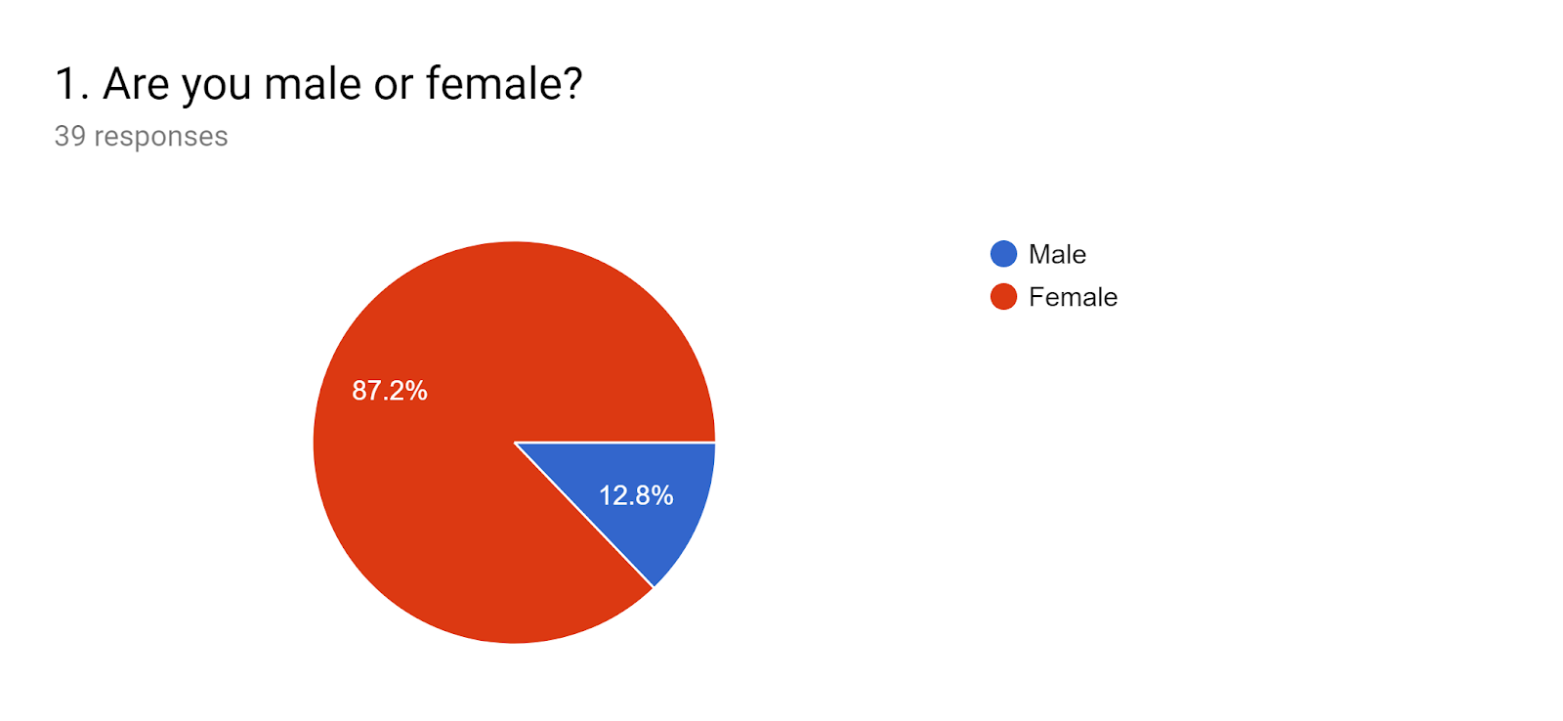
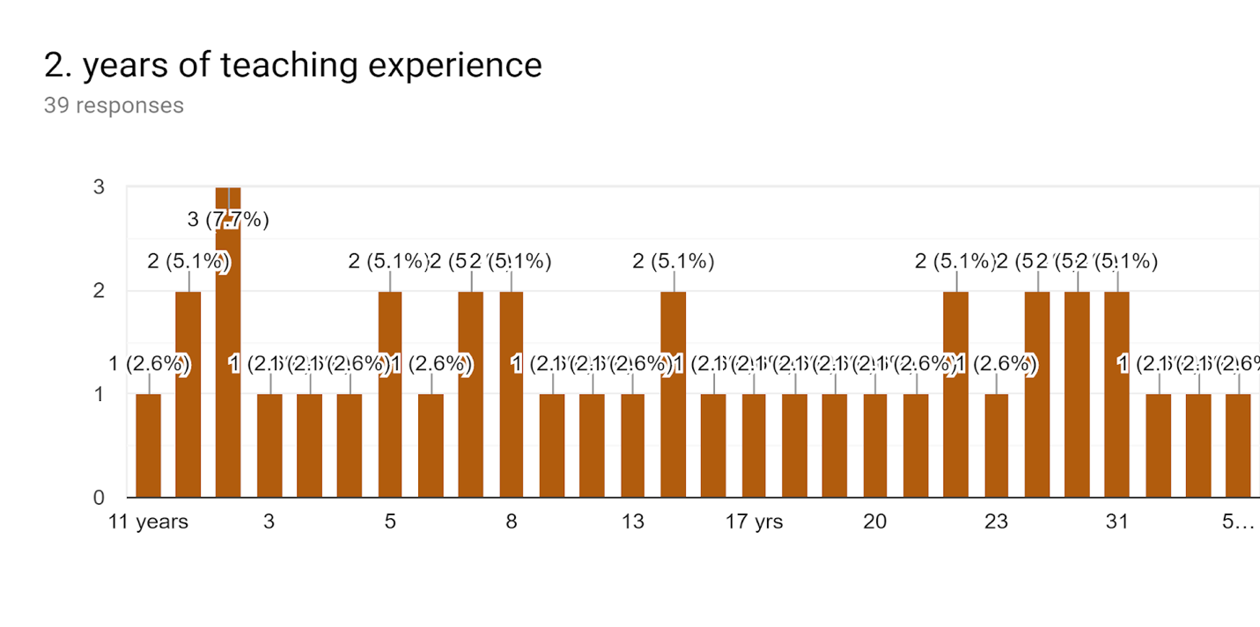
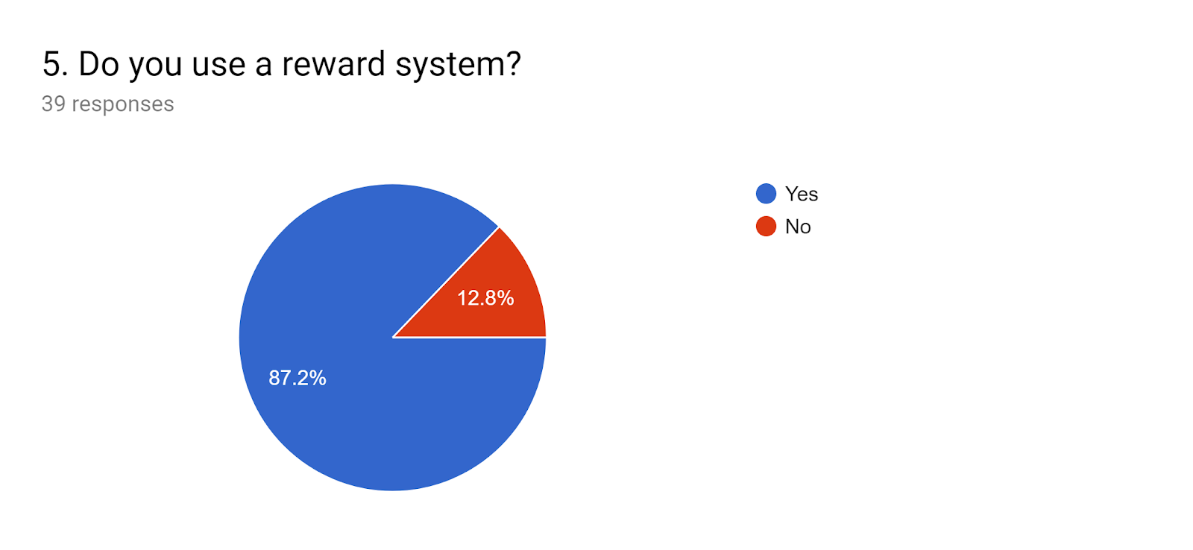
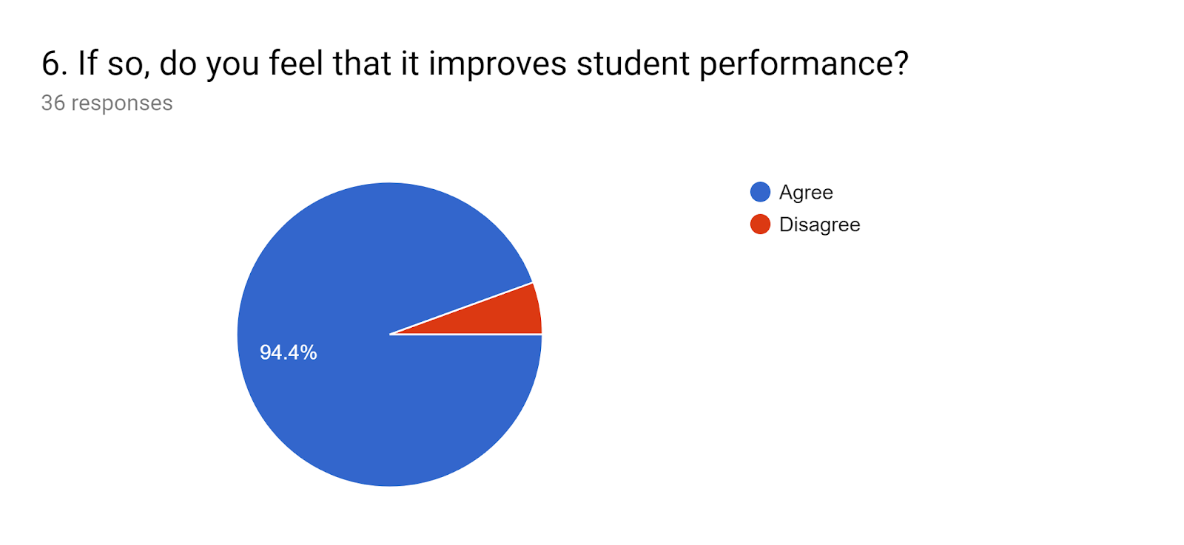

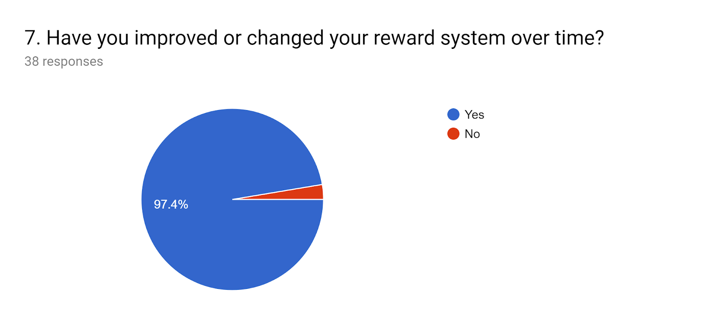
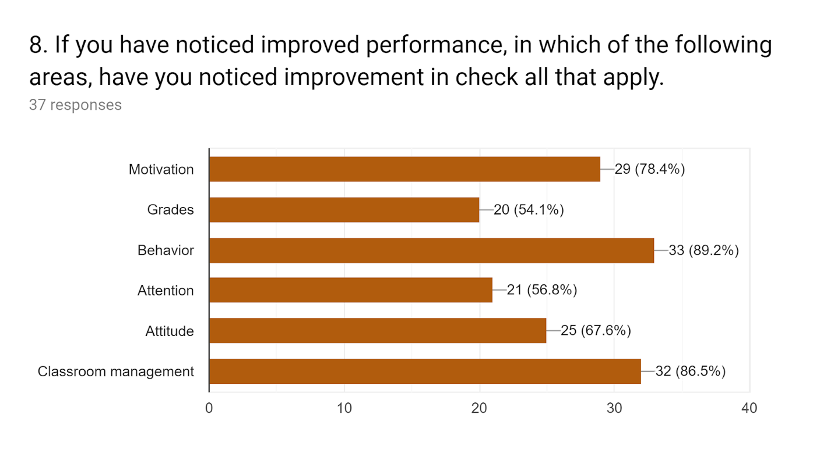
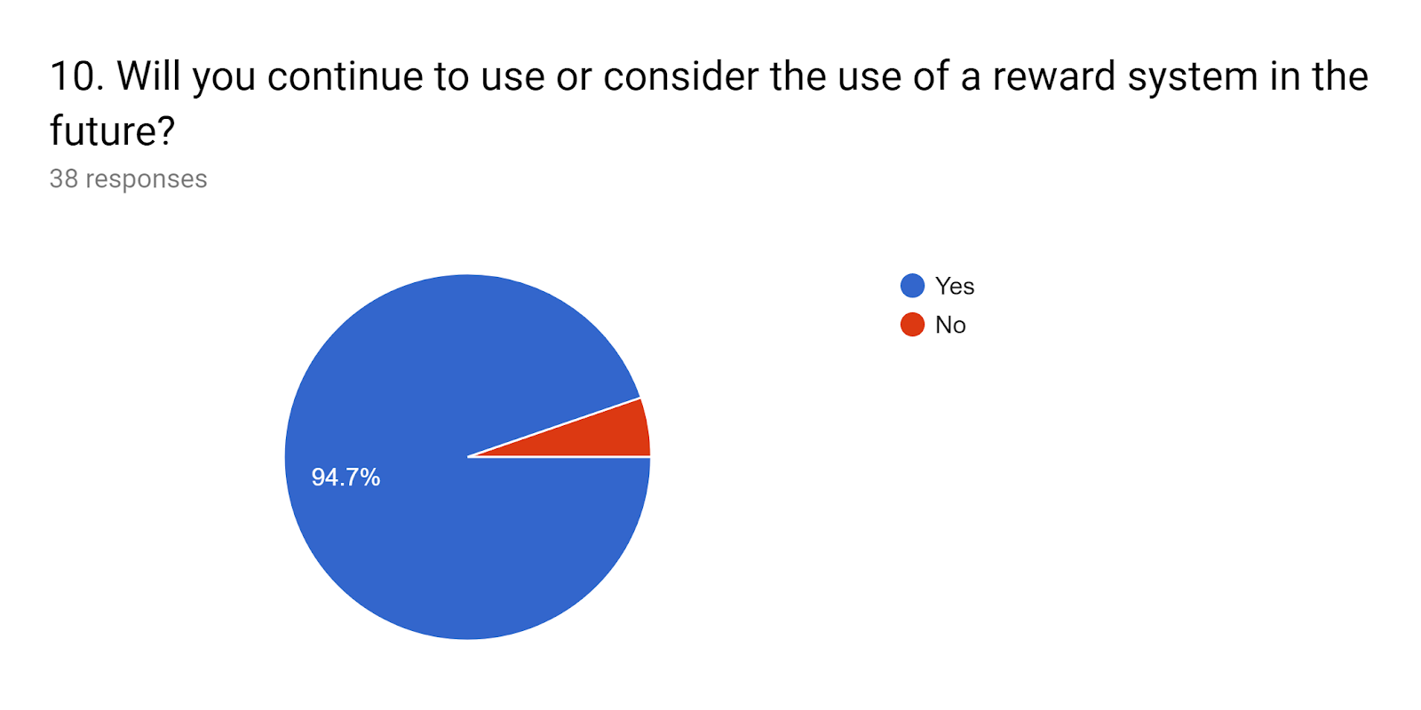

Appendix A
Survey of Research
1. Are you male or female?
Male
Female
2. years of teaching experience
Your answer
3. What grade/subject do you teach?
Your answer
4. Do you have any students with IEP's in your class?
Yes
No
5. Do you use a reward system?
Yes
No
6. If so, do you feel that it improves student performance?
Agree
Disagree
7. Have you improved or changed your reward system over time?
Yes
No
8. If you have noticed improved performance, in which of the following areas, have you noticed improvement in check all that apply.
Motivation
Grades
Behavior
Attention
Attitude
Classroom management
9. Which reward system , if any, do you use?
Your answer
10. Will you continue to use or consider the use of a reward system in the future?
Yes
No
SUBMI

