Running head: HEALTH PROGRAM ANALYSIS

An Analysis of the Components of a Coordinated Health Program:

*A Qualitative Study of a Local High School’s Health, Physical Fitness, and Dietary Programs and Curriculum*

By:

Briony Campbell, Elizabeth Portanova, James Neace, and Chris Herlihy

CSU: San Bernardino

EDUC-607: Dr. Murillo

**Abstract**

Most research produced regarding the correlation between diet, physical activity, and academic achievement, stress the importance of a structured, quality health program. “Physical Inactivity has a negative effect on Academic Performance. Physically active students do better academically than physically inactive students.”11 When students receive some level of nutrition on a consistent basis, and that is coupled with any amount of physical activity, the data suggests that students are typically prone to being more successful. The study conducted consisted of a four-step process, which included:

**Background:**

We conducted a cumulative analysis of the present information and research that exists today. Most articles tend to find a correlation, stressing that students with decreased overall diet quality were significantly more likely to perform poorly on…assessment(s),1 and that researchers have demonstrated that physical activity is related to improved cognitive performance2. This study will take a qualitative analysis of one high school’s current programs in order to locate exactly where the disconnect lies.

**Methods:**

In 2009, 35 high schools teachers, and 324 students (grades 9 – 12) were surveyed to determine and establish their opinion on their school’s compulsory health program, their school’s current dietary plan and options, and the achievement and participation in physical education classes. Once the data was gathered, follow-up interviews were conducted, as well as a cumulative analysis of data gathered.

**Results:**

Across the data, an association was confirmed between the lack of success within the school’s physical education program (measuring participation) and the school’s health program. Teachers generally expressed views of “total lack of organization,” to an overwhelming sense of “lowered expectations, and an increasing obesity plaguing our campus.” Overall, the programs were not correlated or aligned, nor was there any level of communication to ensure that these programs helped to build a sense of achievement. The majority of student’s interviewed and observed agreed that expectations within the physical education program were minimal to non-existent.

In regards to the compulsory health program, most teachers felt that the food was comparable to the students dietary intake within their homes, and cited that 31% (11 out of 35) of staff members purchase lunch equitable to what is sold at student lunch carts. Students were slightly less impressed with the lunch offerings, however out of the 350 students were surveyed, 288 ate a school provided lunch. Though the numbers seem staggering, most students commented that had they not received free or reduced lunch, they would not eat school provided food. Finally, we surveyed staff members for information regarding what type of quality program they would like to see.

**Conclusions:**

These findings represented a general, overarching theme; the students’ dietary consumption is adequate when comparable to home dietary patterns. However, staff members and students agreed that no health program existed, and the physical education program should be ratified in order to promote wellness and vigorous physical activity (for more than 30 minutes).

**General Statement of the Problem**

Students within a local high school are failing their core classes at an alarming rate in mathematics (82% in classes such as geometry and algebra 1) and English-language arts (63% in classes such as English 1, 2, 3, and 4). Despite overall disconnect and lack of motivation, what can be done by high school teachers to assist students in being successful? Regardless of what teachers cannot control (the issues and situations occurring outside of classrooms), there are several life altering ways teachers can make a difference. Recent studies have come up short in practical approaches, relying on consistent, time trusted measures; students with poor health, a lack of financial flexibility and parental involvement, are less likely to be successful within the modern school setting. Yet these studies continue to not address the glaring problem of providing any types of suggestions or guidelines to correct this ever growing issue.

At a local high school, we analyzed the growing disconnect and lack of systemic functionality between three components of students everyday life; physical activity (or inactivity), dietary consumption, and health instruction. After viewing and establishing the effectiveness of these three components, we attempted to create correlations between those and academic achievement, while providing necessary systemic changes.

**Review of Related Literature**

Once more, most studies only look at one component of health programs. They will only analyze health, physical activity, or dietary consumption, and its natural effects upon academic achievement. However, rather than provide specific examples of how a students’ progress or digression in one of the three areas effects achievement, the research merely makes generalizations for all students. Furthermore, most studies have been qualitative studies, to show large sums of students, and why they either are, or are not successful. Most of the research keyed on both physical activity and diet, and it’s correlation to achievement.

“Our findings contribute to a growing body of evidence indicating a significant relationship between students' academic achievement and physical fitness. Based on cross-sectional data gathered from a racially diverse urban school district, our results demonstrated a significant positive relationship between fitness and Math and English academic achievement.”4

However, despite the open acknowledgement of a correlation between physical fitness, wellness, and academic achievement, some factors have been unearthed. Much of the literature does not account for what factors cause an increase in academic achievement, and rarely do they attempt to combat the causes for academic achievement. Many researchers simply liken the higher achievement to physical fitness or diet, and disregard additional facts and analysis.

“While the research literature cannot yet fully explain why fit students may perform better on standardized tests, there are potential mechanisms that may help explain this relationship. First, a relationship between fitness and academic achievement may reflect the achievement orientation of motivated students. That is, motivated students may strive for achievement in both academics and physical fitness or athletics.”4 This seems to be the only constant precursor to academic achievement; self-motivated students, who strive for success, unlike the students who wait for it to be thrust upon their shoulders.

“Second, a student's physical fitness may reflect better overall health -- better nutrition, physical activity, and/or weight status -- and good health may contribute positively to academic achievement.” 4 Healthy people tend to be more successful then unhealthy people, which really has nothing to do with weight. It more closely correlates to the idea that people who are cognizant of what they eat, and what stressors they put their body through, are generally the type of people who pay attention to detail, and are generally more goal-oriented.

“Third, physical activity and fitness may enhance students' concentration and classroom behavior in school, which may contribute positively to academic achievement. Review papers report some evidence that physical activity helps students concentrate and focus, at least in the short term.” 4 The most important issue to focus on, is the idea that physical activity and fitness enhances concentration for the short term, and yet again it ultimately comes down to motivated students, and students who lack motivation. Improved concentration will help when taking notes, on trying to start a test, but motivation will be the driving force when the student is at home, with the television and video games on, trying to do their homework.

“Fourth, physical activity may improve mental health and self-esteem…regular exercise can also alleviate stress, anxiety, and depression -- problems that can affect school performance -- and can even boost self-esteem.” 4 For purposes of this study, we are looking at physical fitness programs within the school setting. Modern high school settings (particularly at the site we conducted the research at) don’t quite provide the necessary physical activity needed to boost self-esteem. In fact, one could argue that participating in the physical education program at this high school could *hurt* one’s self-esteem.

Many students do not participate, and huddle in groups in order to avoid doing any type of physical activity, and spend as much time with their friends as allowable. If a student gave their maximum effort in every physical activity task that may isolate them from their peer group, and have a negative effect on their social standing, which in turn could negatively impact their self-esteem. In regards to this study, the type of physical activity that could benefit a student’s self-esteem would be working out at a local gym, improving their self image, and then coming to school with higher self-esteem. We asked several students if they thought that their physical education program could improve their health. They all agreed that it doesn’t, but that it should.

“Finally, exercise and fitness may affect brain function and improve cognitive functioning. Studies on elderly adults show that exercise can help elders with cognitive functioning… [and that there is] an association between neurocognitive functioning and aerobic fitness in preadolescents.” 4 Once again there is a focus here on consistent, self reliant physical and aerobic fitness. This is all predicated on motivation and whether or not individuals will consistently do things on their own. Healthy, active lifestyles tend to lend themselves to healthy and active minds. The thought is, if individuals take the time out to exercise frequently, they are more than likely also exercising their minds.

Furthermore, many educational theorists have reported that meeting a student’s basic needs, will undoubtedly help them achieve more, and focus better on academic classes. Abraham Maslow created The Hierarchy of Needs Pyramid, which establishes “that the most basic needs, that are vital for success, are the physiological needs, which include; water, air, food, and sleep.”12 Although every individual will progress through the hierarchy at different paces, and will cyclically meet different phases of the pyramid, they will never achieve the upper echelon of need if they do not have their most basic physiological needs met. The foundation on which Maslow’s entire theory is based upon the physiological aspects, primarily focused on nutritional needs (Figure M).

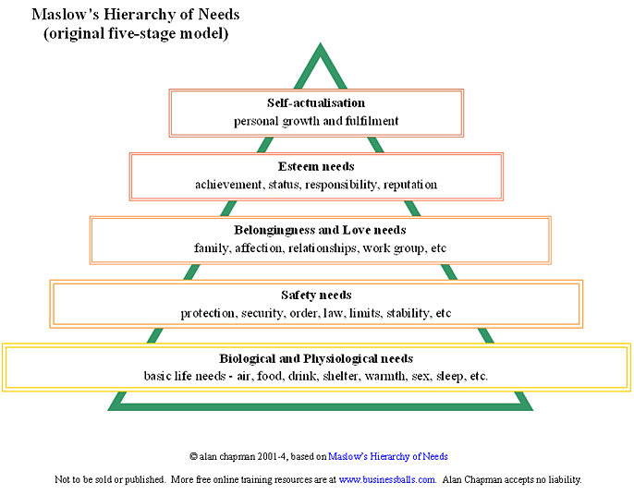

Based upon the preceding pyramid, in order for students to grow (both academically and socially), the basic needs must be met in order to sustain that growth. We took this same approach when surveying our students, particularly in regards to their dietary consumption; are their basic needs being met?

Perhaps the change we seek will not come from individuals at school sites, but rather from systemic change at home, possibly facilitated by the local public schools. “The programs that incorporate social skills training in a health education component along with parent training, teacher training, and school-wide climate change have demonstrated evidence for improving academic outcomes.”5 Obviously this is the ideal; change the home setting, in order to foster achievement and success in the school climate. However idealistic this may sound, there are ways that this can be successfully implemented; yet with current budget restraints, anything that is not standards based, is usually cut first.

There is not much we can do currently, in order to change our school climates, with such a high level of disconnect between parents and many of the students we interviewed. “However, in the interim, there is evidence that implementing school health programming incorporating social skills training in health education, breakfast programs, physical education, mental health services, health services, and parental and community involvement will improve students' chances for academic success.”5 Instead of attempting to ratify things we simply cannot control under this current regime of education, we can attempt to correct things that are in our current grasps. We as educators have control over the programs and services offered by credentialed staff, and nothing more. If we focus on a safe, active learning environment, hopefully the issues at home for students won’t seem as grim and macabre as they sometimes can seem.

With a continued focus on physical activity, it was imperative to research diet, and its positive effects on academic achievement. “A quality school lunch program means that schools provide lunch programs that offer a variety of healthy, tasty, and diverse choices, and students are encouraged to participate.”6 We surveyed the students to see whether or not this definition held true, and whether or not this particular site was offering diverse, healthy choices. According to the surveys (documented later), most students expressed mixed responses, with some agreeing with the above definition, and about the other half disagreeing.

According to the 2005 U.S. Dietary Guidelines, these are the conditions that must exist in order to have a positive impact on one’s physical fitness. If these teachers are to be the conveyors of this good message, what should they be doing? The guidelines are as follows, however the main goal is to “Engage in regular physical activity and reduce sedentary activities to promote health, psychological well-being, and a healthy body weight.”6

* + To reduce the risk of chronic disease in adulthood: Engage in at least 30 minutes of moderate-intensity physical activity, above usual activity, at work or home on most days of the week.
  + For most people, greater health benefits can be obtained by engaging in physical activity of more vigorous intensity or longer duration.
  + To help manage body weight and prevent gradual, unhealthy body weight gain in adulthood: Engage in approximately 60 minutes of moderate- to vigorous-intensity activity on most days of the week while not exceeding caloric intake requirements.
  + To sustain weight loss in adulthood: Participate in at least 60 to 90 minutes of daily moderate-intensity physical activity while not exceeding caloric intake requirements. Some people may need to consult with a healthcare provider before participating in this level of activity.
  + Achieve physical fitness by including cardiovascular conditioning, stretching exercises for flexibility, and resistance exercises or calisthenics for muscle strength and endurance.
* **Key Recommendations for Specific Population Groups** 
  + *Children and adolescents.* Engage in at least 60 minutes of physical activity on most, preferably all, days of the week.

The research suggested that the best way to implement such a plan is to define exactly what a quality nutrition education program is. Once defined, schools can then focus their efforts on creation and implementation. “A nutrition education program means that students receive nutrition education messages not just in health education classes and the cafeteria, but through their core curriculum and throughout the school. These messages should be interactive, consistent, and reinforce each other.”6 With standards based curriculum extremely limiting our ability to extend curriculum, it seemed difficult to implement something so lofty, within the routine of our schedule.

Once established however, what is our goal? Is it simply to correct what is occurring on our campuses, or are we as lifelong educators, attempting to ratify a person’s current state? According to research, “Importantly, antiobesity strategies have included policy and environmental changes. In addition, policy activity affecting the school environment has occurred at the federal, state, and local levels.”7 Environmental changes are things often out of the control and grasp of the modern educator. We searched within the school district of the local high school, and only saw information regarding only that the meals provided basic nutrients.

“For children, the program provides a nutritious meal that contains 1/3 of the Recommended Dietary Allowance of necessary nutrients. For parents, the program offers a convenient method of providing a nutritionally balanced lunch or breakfast at the lowest possible price. For schools, the program enhances children’s learning abilities by contributing to their physical and mental well being.”8 Nowhere in the entire policy was any mention of obesity, diet, or happier and healthier lives for our students. The focus seemed to only be on ensuring that students were offered the minimum amount required by Federal law.

After our extensive review of the literature, we decided what we needed to answer based upon both existing literature, and our time at the high school. If the majority of studies show that academic performance is so positively connected to good diet and an effective physical education program, than why are public schools implementing ineffective health programs at all? It seems, especially after reading the school districts Nutrition Mission Statement, that the district is merely doing the bare minimum for the students. If schools want to create positive change, they will ultimately have to put in the necessary work for systemic change. Thus our goal through the research is to analyze the areas of weaknesses, and then suggest both plans and implementation strategies, in order to successfully alter the school health programs.

**Assumptions**

There were many pre-established presumptions going in to this study, particularly when analyzing student achievement. 86% of our students were of Hispanic origin, and our school site was located in the Inland Empire, in a rather rural area. Most students expressed a level of comprehension when conversing in both English and Spanish. It was also assumed that students lived in the immediate area, and any communal issues expressed, would be coherently understood.

It was assumed that students were cognizant of their average dietary consumption (what they normally eat during a day, with specific types of meals described), and that students could adequately describe what kind of physical activity they participated in, and to what degree. It was also assumed that students could comprehend the connection and correlation between their current situations, and its possible effects on their future.

Once stated, students were given definitions of the three components (diet, exercise, health instruction), and were given further definitions in order to explain how they should all fit within the current school environment. Teachers were given information on the current physical education program, as well as the standards and what the State of California requires of standards based physical education classes. Staff was also given information on the dietary offerings available to both students and staff, and what health classes were offered by the particular school site. Unfortunately, there were no health classes offered; therefore the information was from the previous health class (over 8 years ago) was distributed. Finally, it was assumed that all academic achievement would be measured based off of 6-week benchmarks within the student’s general education classroom.

Literature presupposed ideas were that academic achievement can be measured by a standardized test, and that student effort and disposition played no role in academic achievement (the researchers only attempted to add something positive to the student’s life in order to positively affect their ability to succeed academically). We also attempted to disregard external modifiers in the academic process. Our attempt was simply to focus on what we could systematically change, not what was beyond our grasp on influence.

Our research was based on the presupposed idea that the compulsory health program at this particular local high school was insufficient and didn’t meet the needs nor expectations of the students. We were under the impression that students were not being encouraged or required to meet goals throughout the duration of their Physical Education classes. Even though healthy foods are offered on campus, we felt that students either weren’t informed about these options or there weren’t enough tasty options for them to even consider. As a result of numerous times of trying to use the vending machines on campus, we assumed that vending machines must always be empty and not in working order based on personal experience of staff members and students alike.

**Research Question(s), Hypothesis, or Foreshadowed Problems**

While beginning our qualitative project, we had many ideas that we wanted to address. After reviewing the literature, we decided that there had to be some correlation between academic success, and some quality of health (whether dietary, physical activity, or health instruction). We grew increasingly frustrated because the research constantly made the connection, but could not distinctively say how or why, nor did it ever make the connection that there may be additional factors involved with academic achievement. We decided then to research a local high school, and get student and teacher input in regards to our assessment. We wanted to know what both subgroups thought of the dietary and physical activity of the students was, and what it possibly should be.

The first, and most apparent issue that arose, was that based upon the literature reviewed, what is the local high school doing to promote physical activity and quality health in the lives of students? We found that there is a typical physical education setting (co-ed activity classes), a dietary plan implemented by the state, and that plan was certified at both the state and federal level. We also discovered that the only health service (instruction, support, communicaton) is provided through a health aid and a resident nurse on site. While this is advantageous for students with ailments, it does not change the climate at the site by promoting healthy lifestyles and choices. Furthermore, the emphasis of standards based instruction, limits the opportunities for implementation of any health based curriculum.

Our hypothesis is that school health programs are not effectively meeting the criteria of a well balanced, successful coordinated health program, which in turn is negatively effecting student academic achievement.

*Why is it a problem?*

An ineffective coordinated health program is a contributing factor to the decline in academic achievement. Many schools are mainly quoting state policy, in regards to offering students a nutritious meal, however if they are simply meeting the guidelines, it does not guarantee that they are implementing the program effectively.

*How do we correct the problem?*

Prior to completing our research, we found that in order to correct the problem, it would require a three-tiered approach. First, the local high school must ensure that all students are participating in vigorous physical activity, and that students are following a structured rigorous physical activity plan, that includes California State Standards. Any physical activity plan must include adequate expectations, guidelines, goals, and standards, as well as appropriate stretching, and cool down times, in addition to the actual activity. Upon entering the physical activity class, the instructor will require students to create workout plans, to meet their individual needs of staying in shape, and learning life lasting skills.

Students will not be merely graded by changing into P.E. clothes, and simply just “being there.” Students must make progress on their workout plan, in order to receive a passing grade. In order for instructors to note individual progression, and assist students in living more active lifestyles, class sizes must be reduced in order to focus on individual needs.11

The second tier consists of a health class that students are required to take (a graduation requirement). This class should be offered their freshman year, when students do not have to take a history class, and their schedule is not as full. This class would provide students with valuable insight such as the benefits of physical activity and proper dietary consumption. Identical to the plan highlighted in tier 1, students will be required to complete a healthy lifestyle plan, in order to show the connection between proper health at home and at school.

Finally, students will receive a ratified meal plan, including healthier choices rather than pizza, fries, and mini cheeseburgers. Students will then take the healthy lifestyle plan completed in their health class, and assist their decision making process when purchasing food at lunch.

*Foreshadowed problems and results of our research?*

Getting students to answer the questionnaires truthfully and diligently would be a definite problem with completing the research. Another issue is altering the climate of the school environment, to ensure that teachers “buy-in” to the new changes. It is easier for P.E. teachers, to be content with simply lettings students wander around, but rules and structure needs to be enforced and communicated to ensure that students receive proper instruction, and are kept out of harm’s way. Students also are not going to enjoy having food items such a chili cheese dogs and French fries and mini-hamburgers taken off their local menus.

*Foreshadowed critiques of our research?*

We understand that the scope of our research was very narrow, however we feel these generalizations can work for most, if not all schools. We consulted with other colleagues from other districts and at other school sites, and found that many of the ideas, comments, and suggestions that we received in regards to the ratification of our health program were consistent to what evidence our research unearthed; that most school sites minimally follow state dietary guidelines, students have minimal participation in physical activity classes, and that most health programs (classes and information dissemination) are either nonexistent, or underfunded. We understand that funds are extremely limited in many districts this year, and especially in the upcoming years. This generally means non-core classes (classes excluding English-Language Arts, Math, Science, History, and P.E.), are more likely to be cut. This definitely hinders our ability to instill a health class at each comprehensive high school, yet we still feel it is valid for the reasons outlined throughout this study.

Our sample study could have been much larger; however we pulled approximately 10% of the school to assist us with our study. We tried with much diligence, to ensure that each student properly understood each question, and gave an honest, valid opinion to our survey questions. However, some students may have simply copied from their peers, or simply circled the first thought that came to them, rather than fully reading and comprehending the questions.

**Definitions of Terms**

1. A **coordinated (or compulsory) health program** is a school district’s pledge to ensure that students have three quality components implemented throughout; quality health instruction, physical activity instruction, and nutritious meals on a daily basis.

2. **Academic achievement** is scoring basic or better on a benchmark exam. Examinations are given every 6-weeks, and students are scored with five possible grades; far below basic, below basic, basic, proficient, and advance.

3. **Physical activity** considers if the student is enrolled in a physical education (P.E.) class, whether or not they dress in school approved P.E. clothes, and if the students stretch, participate in weekly runs, and play the approve activity for the day. **Physical inactivity** is not fully participating in any of the areas. For instance some students might dress out, but won’t fully stretch, or will not run or participate in the required activity.

4. **Dietary consumption** refers to what students eat during the school day (the time students leave their house, to the time they arrive home). *See also* **Dietary Intake**.

5. **Health instruction** consists of information dissemination and the actual instruction that student would receive within a classroom with appropriate standards.

**Significance of the Proposed Study***Why is it important?*

Based upon the alignment of NCLB and the IDEA Reauthorization Act of 2004 (IDEIA) standards have increased, and now students are being evaluated in a more proactive manner (failure is not an option rather than waiting to fail). Student academic achievement is being assessed based on tests like the CST’s, and these assessments have a major impact on a school’s API and AYP scores. If a school is not meeting their API and AYP scores then they receive sanctions from the state due to being placed on the Program Improvement list. Since the students were scoring low on tests and having difficulties passing their classes, we felt this was the best time to assess the instilled program, and ultimately improve academic achievement.

*Why study it now?*

Furthermore, based upon students low academic placement tests for college, students are spending additional monies to enroll in remedial classes, putting them further behind. This coupled with the extreme failure rate currently happening at this site, it was imperative to begin the analysis. Additionally, despite home disconnect, schools need to find other avenues to improve student performance rather than “drill and practice.”

*How can this study lead to future research?*

Preferably, this study will lead to other researchers exploring additional alternatives to improving the three components of a coordinated health program. Also, we hoped that future studies will further explore the disconnect between the modern school setting and home life. Future studies could also explore motivational factors of students, and possible solutions to students and their lack of motivation for unwanted tasks (such as school). Even further, an exploration into the disconnect of schools being the gateway to future endeavors. Hopefully, anything that can be done will be done in order to improve academia in the modern school setting.

**Subjects and/or Case**

The local high school that was chosen has an ethnic demographic of approximately 86% Hispanic students, 6% Caucasian students, 6% African-American students, and 1% serving the remaining ethnicities. It is in a rural area nestled within the Inland Empire. The comprehensive high school serves students from grades 9 through 12, and its previous API score was (612) and in the AYP the school met only 4 of the 18 necessary criteria. Students, according to most teachers, are rather” lethargic and apathetic,” and approximately one out of every 4 students turns in homework on a consistent basis.

With that information firmly established, we felt the greatest need for this study was to attempt to ratify student’s opportunities at school, in order to allow for greater academic achievement. While exploring the current setting in place, three things were notated. First, the physical education classes (P.E.) were completely disorganized, and most lesson plans consisted of students standing on numbers for roll, and then walking the track or the basketball courts for the remainder of the period. P.E. classes were designed to meet State graduation requirements (two full years of P.E.), and most students enrolled in these classes were 9 – 11 grade.

There were no health classes on this campus, and any health information was given to the school nurse, who then distributed the information out to teachers, staff, and students. There were three components of the dietary program at the high school. First, there were two meals (breakfast and lunch). Breakfast is served from 6:45 am, and ceases at 7:15 am. Breakfast is stopped just before the school bell, in order to account for late buses (often times during our research, school buses arrived to school late, thus some students missed their initial opportunity for breakfast. Lunch is split up into separate shifts, based upon the geographic placement of a student’s 4th period classroom.

According to cafeteria personnel, the varieties of food does not diminish between one lunch or the next, however students who arrive towards the end of their lunch period, will have significantly less choices.17 The third component of student’s dietary options, are vending machines. The vending machines on campus offered water, flavored waters, PowerAde, and juice. There was an additional vending machine that sold ice creams (drumsticks, fruit bars, etc.), but there was only one on campus. When reviewing the options that student’s had an opportunity to access, we mainly focused on the lunch meal, provided by either the cafeteria or lunch carts.

Students are released for lunch, and then are free to eat from wherever they wish. Lunch carts provide al a carte options for students (pizza, chips, juice boxes, etc.), and the cafeteria provides full meals with an option of eating off the salad bar. If students choose not to eat, or students purchase an abundance of food, these types of things are not monitored, which substantiates our claims that students need to receive appropriate health education in order to make wiser decisions.

**Instrumentation/Data Collection**

With the problem clearly stated, it was imperative to get a baseline on student opinions, as well as follow up with teachers. We began by devising two types of surveys for students, one questioning a student’s involvement in the P.E. class, and one highlighting a student’s daily dietary consumption. We felt that a survey would be the quickest way to familiarize students with what topics were being covered. Once students were familiarized with the topic, we asked follow up questions to glean more insight. The two surveys we distributed to students were The Student Physical Education Survey (APPENDIX 1) and The Student Diet and Nutrition Survey (APPENDIX 2). Once completed, we followed up (often immediately following the surveys) with questions based on the student responses. If we observed a student laboring over a particular response, we delved further, attempting to glean more data and insight.

The division of labor was delegated evenly, with all research team members interviewing students, distributing surveys, and gathering observations and comments from teachers and students. Before we began our survey, we received permission from the Principal at the school, and sent out a recorded message to parents, describing the survey we were conducting.

Researchers made themselves available to clarify any survey questions, and ensure that student’s answers did not contradict themselves. We offered two surveys, which allowed students to pick from three options; yes, no, or sometimes. We made generalized statements, and asked the students to comment on the regularity that these things happen within their P.E. classes and in their meals from the school. Once students finished these two short surveys, the researchers asked follow up questions, to delve deeper and glean more detailed comments. These surveys were handed out during students lunch periods, as well as their second period classes. We chose second period, because students had a 20-minute period set aside for Sustained Silent Reading (SSR). This period was to be set aside for silent reading, however many teachers on the campus decided to use it as additional teaching time, or for assessing student’s progress in other classes.

Finally, teachers were given six short answer questions to answer in regards to the three components of a compulsory health program, titled Compulsory Health Program (APPENDIX 3). We tabulated the results from the surveys, and retyped the information and responses from their teacher questionnaires. The advantage of distributing the teacher questionnaires was that teachers could answer the questions at their own leisure, and provide quotable feedback. What was also beneficial was that we had verifiable data penned from their own hands, and if at any time we needed additional clarification or reactions, we could go to those teachers. The disadvantage of the teacher questionnaire, is that it did not allow us as researchers to gauge the teachers responses (such as body gestures, facial expressions, tone of voice – including sarcasm – and general impressions) while they were answering the questions.

We designed the surveys for students to be quick and efficient, but full student interviews and reviews of progress would have been more accurate in depicting the current state of the school’s compulsory health program. Furthermore, some of the wording of our statements were either confusing, or they were foundational (built upon previous questions). The issue with foundational questions is that if the person completing the survey did not fully understand the first question, they will be confused on the remainder of the survey (or on the questions that correlate with confusing question).

This last disadvantage from students is the general stigma that surrounds most high schools. Students have a negative view towards school, and any questions asking them to rank components of their school tend to result in negative views, often if they are not necessarily true. Furthermore, by not asking all students to justify their reasons, we are simply scratching the surface of the real reasons.

We followed a highly structured and organized set of steps to determine maximum efficiency and replication. First, we emailed teachers and asked them to participate in our study. Those that agreed, we handed them a copy of the teacher questionnaire (along with emailing them a copy and placing a copy in their teacher mailbox) and asked them to give their honest opinions. We then visited each teacher to collect the results. For the student surveys, we visited 10 math classrooms, during 2nd period, and had 260 students fill out the surveys for us. Our goal was at least 10% participation from the school, so we ventured out and set up a table in the quad area of the campus and asked for volunteers. We brought bite size Snickers, Twix, and Reese’s Peanut Butter cups to offer up as bribes to coerce the students into stopping at our table.

High school students won’t do much voluntarily, unless you bribe them. With that concept, we painted a large white banner with blue paint that read “FREE CANDY!” and plastered it on the front of our table. Once most students came to visit, we were able to get some of them to fill out our survey. In total, 64 students filled out our surveys during lunch, and provided us with additional responses based upon their answers to the surveys. We then returned to the math classes, and asked students the same follow-up questions we asked the students at lunch. With all of our information gathered, we transcribed the quotes and tabulated our data.

We frequented the school over a period of two weeks, constantly talking with teachers, students, and administrators. We maintained the role of observer-participant, in the sense that when we first arrived, we stayed in the background, observed our surroundings, and noted our findings. For the latter part of our stay, we took a more active approach, conversing with staff and students, and trying to get as close to the happenings as we could.

**Data Treatment Procedures**

Once gathered, we had two surveys, a questionnaire, and quotations written from our participants. We tabulated all the data from each survey from the students (Diet and Health and the Physical Education survey), and setup percentages for each option (i.e. answers of yes, no, or sometimes were categorically listed, and percentages were calculated). For the teacher questionnaires, we transcribed teacher notes, met with teachers for clarification (whether an extension of comments or to help decipher sloppy handwriting), and then followed up with additional questions based upon their responses.

While analyzing student surveys, we paid special attention to the types of responses we received (whether or not the answering was consistent with the questions asked). We attempted to catch nullifying responses (responses that negated each other when compared) while students were completing surveys, however we did not catch them all. Some questions were staggered so that, if one was answered with a response of yes, the following question needed the same response (periodically, a few of the surveys had such discrepancies).

**Presentation of Findings**

**Physical Education:**

In order to accurately assess the data, we compiled a statistical breakdown for each and every question on the surveys. Once compiled, we immediately began to question the student’s definition of “exercise.” Many students claimed to participate in daily, rigorous physical activity, when all that was observed was students dressing out. Another key component that many students failed to rationalize was the idea of being physically active. Most students claimed they were physically active, with some students claiming they “We run sometimes, but most people walk the whole time.”

Based upon observations, most 6th period P.E. classes dressed out, took roll, and sat in the gymnasium due to the “heat.” We were confused how students could consider this to be physically active behavior. A major systemic factor to consider was that most 11th and 12th graders are not required to have a P.E. class, so some of the data show a disproportionate number of upper grade students in those classes.

When in a P.E. class, the most basic need is proper stretching, in order to meet the physical demands on muscles. Many students during our surveying said that they stretched adequately prior to participating in the day’s activities (Figure 1.1). According to the results, over 100 9th grade students claimed to have stretched during the start of their P.E. class. Based upon observations of students, the research team did not see a correlation. Furthermore, students did not have to stretch if they were not going to run, as evidenced by many of the comments we received from students. Most students claimed that they had “only ran like a few times the whole year,” and that “P.E. teachers got a cool job, they take attendance and kick it all day.” This alarming comment was evidenced during some of our observations, particularly later in the day when teachers were leaning against large trees, as students were walking around the basketball courts.

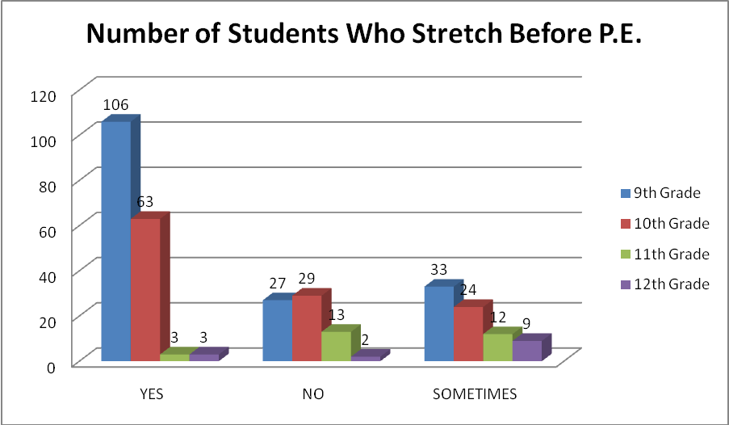

**Figure 1.1**

There seemed to be an apparent discrepancy between the student’s perception of their effort and participation in their P.E. class, and what actually transcribed. According to the records office at the high school, 36% of students fail their P.E. class. Based on the evidence in our surveys, this did not seem to be the case. We decided to further explore the relationship between what students actually perceived as occurring, and what was being documented by staff. We felt it was important to notate the following (Figures 1.2 and 1.3)

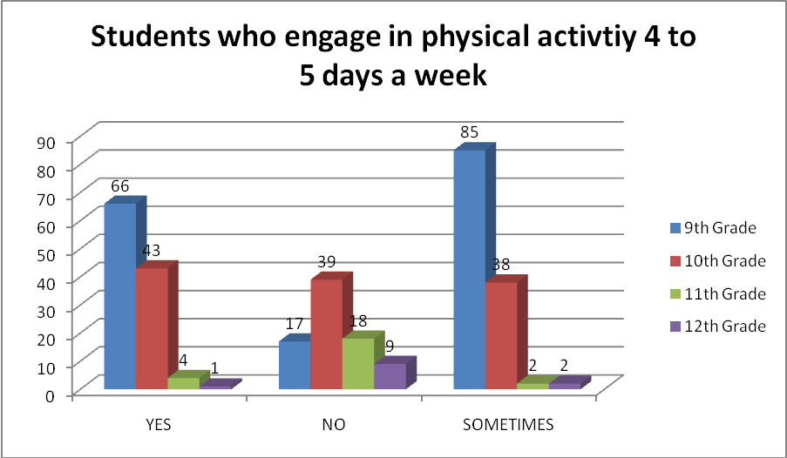

**Figure 1.2**

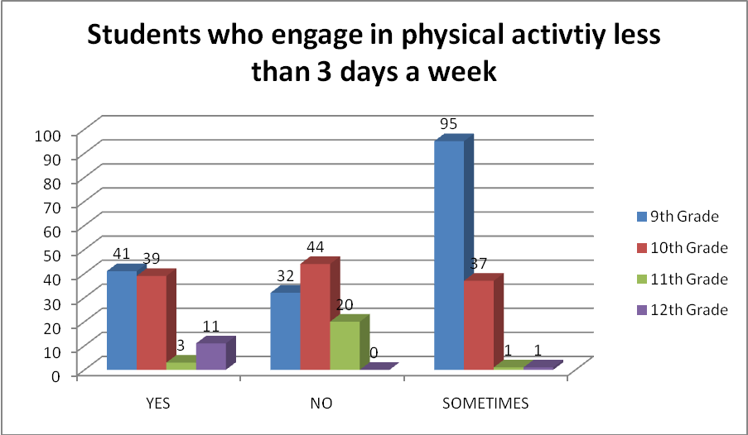

**Figure 1.3**

Nearly 66.6% of the students claimed that they were physically active at least four days a week. Going back to the statistic that 36% of students fail a P.E. class, we correlated that students who were actively participating at least 4 days (80% of the week) a week, were incredibly likely to not fail, thus the fail rate should have been closer to 20%. The fact that students were only “sometimes” participating in physical activity four times a week, shows that that students may not be actually active in the P.E. program at all, because they are not being required to meets standards and expectations on a daily basis. During many observations, only 3 out of 50 students were actually performing the stretches.

In one such instance, the teacher, after seeing two out of 47 students completing arm circles, stated, “Ok, and reverse!” It was completely ignored by the remainder of the class. It raised many doubts in our minds, that students were physically active in class, when only 4% of the students are engaging in appropriate warm-up activities. We then matched this fact with the grade expectations of students (Figure 1.4).

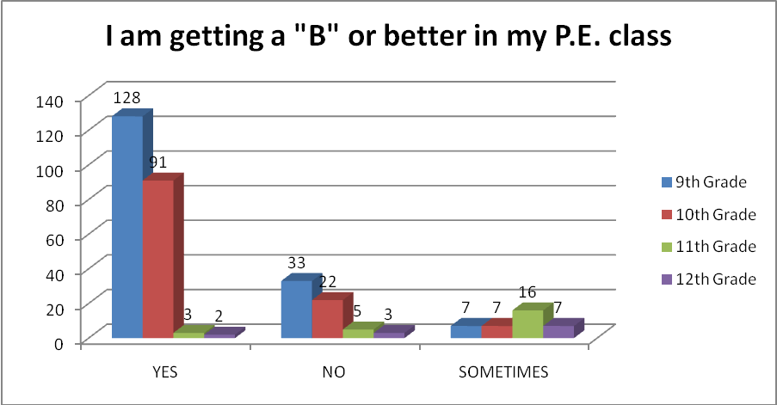

**Figure 1.4**

According to the Figure 1.4, 79% of the students surveyed felt that they were going to receive a “B” or better from their P.E. teacher. This data contradicted the earlier figures gathered from the records office. The contradiction for the research team was that students openly admitted that they participate, but that their participation consists of standing around and talking to friends. The question posed in Figure 1.4 was coupled with the question which asked students if they were aware of the Physical Education Teachers expectations. Data showed that most students felt that they knew the teacher’s expectations, and there was only a minor discrepancy between the students who knew their grades and the students who supposedly knew the teacher’s expectations.

When interviewed, one such student was asked if he knew what the Physical Education teacher’s expectations were and if he knew his grade. This student responded by saying, “I don’t know why my grade is a D, because we never do anything. There have only been a couple times that I haven’t dressed out.” Therefore, this student understood that he was expected to dress out for P.E., but wasn’t to a very good understanding of why he was receiving a poor grade. Another student under the same line of questioning stated, “I know what the coaches expect, but a lot of other kids just mess around the whole time, they get bad grades and they blame the coaches.”

This response brings into question whether students take P.E. seriously or not. Do students expect just to get a passing grade for merely showing up and dressing out? This is one of the sad realities that we seemed to be facing throughout the study. When wondering whether or not students were taking P.E. seriously we also pondered the fact that maybe the coaches aren’t motivating students to want to be involved and take the class seriously. One student informed us, “All we do is play basketball, and most people just walk around the courts” (Figure 1.5). If students just come to class, get dressed, and grab a basketball for a leisurely hour is this much incentive to perform well daily in P.E?

However, when discussing grading most students felt that the “Coaches are fair with our grades,” and if they are not fair the general consensus seemed to be that the “coaches are cool they stay off our back.” One student was so pleased with his teacher’s classroom, that he stated, “P.E. is my favorite class! I’d rather be outside than sitting in a boring classroom.”

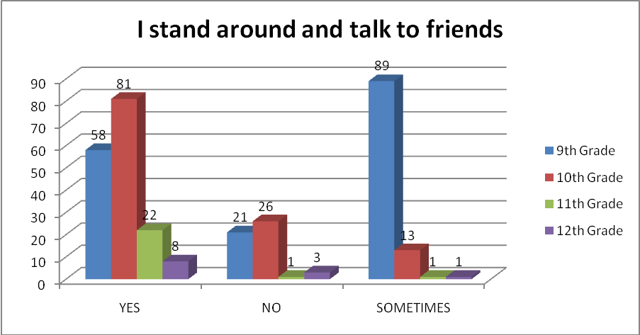

**Figure 1.5**

Are difficulties with analyzing the data, were that students claimed to participate more than 80% of the time (Figure 1.2), stated they are receiving a “B” or better (Figure 1.4), yet they are standing around and socializing. We felt if these components were true, then the standards and expectations that the students were being held accountable were either non-existent, or simply not being enforced. 9th graders seemed to be inconsistently receiving proper expectations, however 10th grade students emphatically understood what was being required of them. Furthermore, most students responded to questioning by stating that ““P.E. is cool, I get to chill and kick it with my friends all period.”

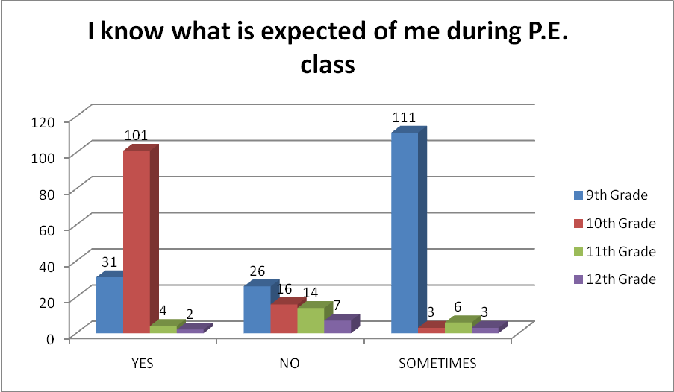

**Figure 1.6**

It was interesting to note that students felt the P.E. program was adequate, and that they were rarely out of energy (Figure 1.7), or that it met their expectations (Figure 1.8). All in all, the student perspectives seemed to be more focused on perceptions, rather than substantial statistics, or substantive standards. If students are rarely out of energy, and the class meets their expectations, the research team that we needed to raise the expectations and requirements within the P.E. program, and challenge the students. Physical activity (and subsequent physical progression) only occurs when students are consistently being challenged. If students are never out of energy, no such challenge is being offered, and the situation needs to be rectified.

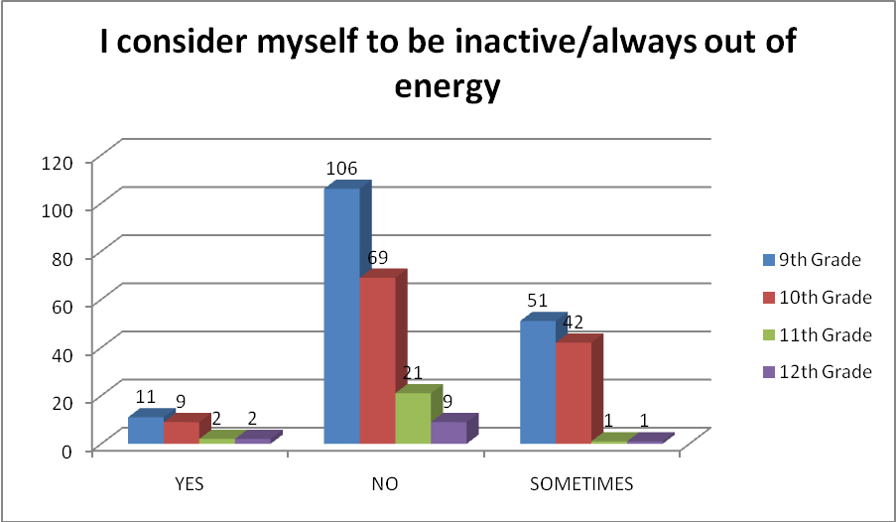

**Figure 1.7**

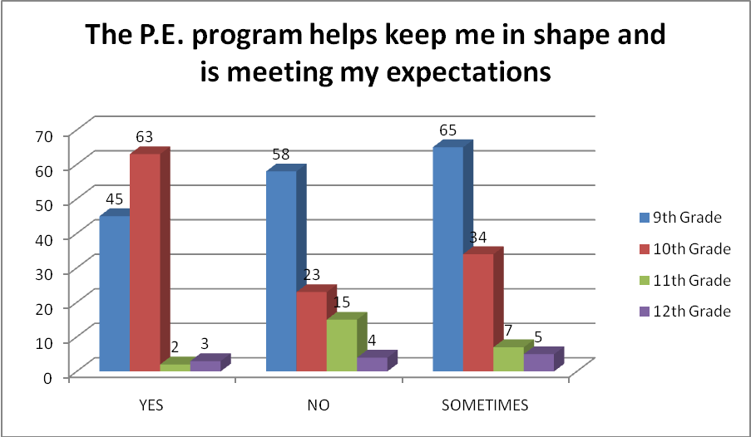

**Figure 1.8**

Students who participate 80% of the time and who are never out of energy are somehow missing a major component of a P.E. program. Students were also asked if they participated and dressed out, and a large majority consented that they did in fact complete both aspects of the class. This coupled with our findings, cemented the idea that there is a missing component somewhere, and that if student expectations were raised, and teacher requirements were more stringent, they overall level of the physical education program would improve.

**Diet and Nutrition:**

The diet and nutrition aspect of our study was only based off of what students ate, based off of what was available, and did not mention the aspects related to health classes (due to the site not offering any). It was important to note that most students did not bring lunch from home, therefore the only source of dietary intake or consumption is being provided by the school. This does not account for whether or not students eat.

**Figure 2.1**

We omitted this fact because we can’t control if students eat or not, nor can we monitor and report on each and every facet of a student’s life, including the reasons why they do not eat lunch. Most students reported they bring no lunch from home or any type of additional snacks (Figure 2.1), yet a staggering number said that they do not eat lunch at school (Figure 2.2). 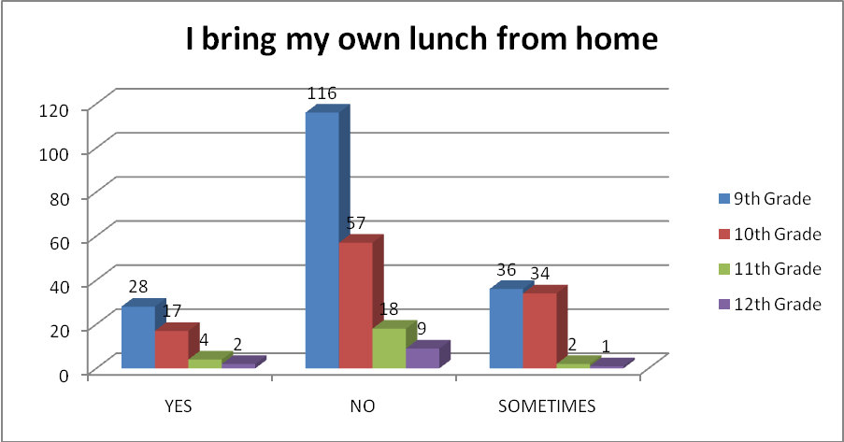

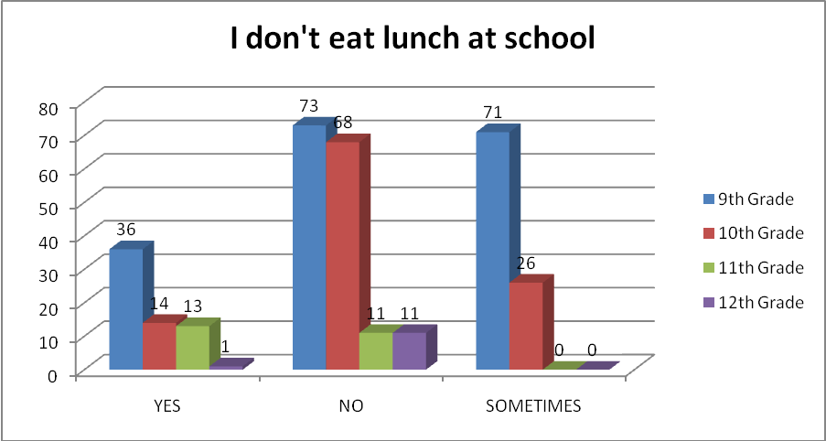

**Figure 2.2**

Once established, we realized at least two out of every three students did not eat lunch. What the cause of this was is unknown (a later study), but by understanding that such a large percentage of students do not eat lunch of any kind on campus, we wanted to gather student perceptions on what types of available options the site we visited were offering (Figure 2.3).

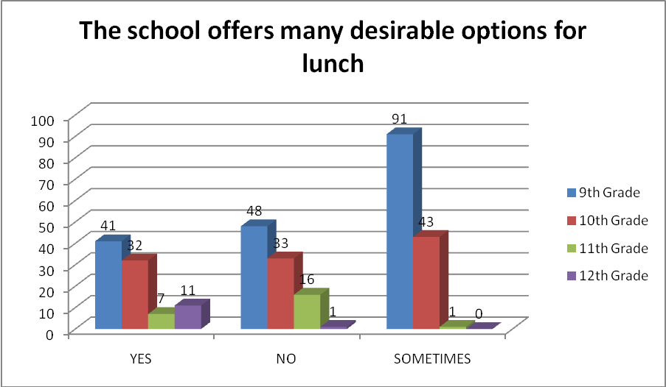

**Figure 2.3**

If students have no desire to eat the available food, and are not even eating, how can students be expected to get the recharge of energy that happens from eating? Most students seemed indifferent to what the site was offering for meals, yet they tended to more enjoy the meals that were less processed, as opposed to fresher ingredients. Most students commented that they wanted more salad bar options, rather than Chinese food from PickUp Stix and chili dogs from Weinerschnitzel. “There is diet coke, baked chips, salad, granola bars, and sometimes rice bowls.”

Not only are students not finding options that they want to eat, but many of the sides accompanying these options are incredibly unhealthy (Figure 2.4). From Tater Tots (that were nearly impossible to bite), to French fries and chips, students were not only limited in their options, but had no healthy alternatives apart from celery and carrot sticks. A few students noted, “There are vegetables and fruit, but nobody eats it.”

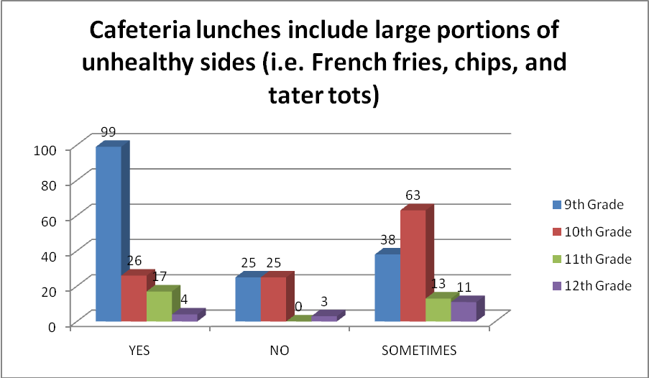

**Figure 2.4**

Though this question seemed biased (assuming all meal alternatives apart from vegetable sticks were unhealthy), many students felt it accurately assessed the meal components. “I only eat in the cafeteria because they give a lot of fries.” Many students claimed to have minimal dietary options, yet when asked about the availability of dietary information (specifically from lunch carts), students reported no access. Our question then became, if students have no FDA approved assessment of the meals and snacks provided (Figure 2.6), what deems something unhealthy (Figure 2.5)? Once again, similar to the P.E. program, student perception is serving as the main determinate for all information gathered.

One student was very specific with why they eat lunch at school. “The cafeteria food is good sometimes, but my favorite is the Chinese food (rice bowls).” Once we began to get an understanding of what student’s looked for, we decided to aim our questioning towards opinions on healthier options. We asked if students knew of healthier options present during lunch, and most students agreed that “There are some healthy foods but they are gross.” According to another student, “They got healthy stuff here, but I doesn’t matter if you drink a diet coke or eat a bag of baked chips, the pizza and fries you also ate does the damage.”

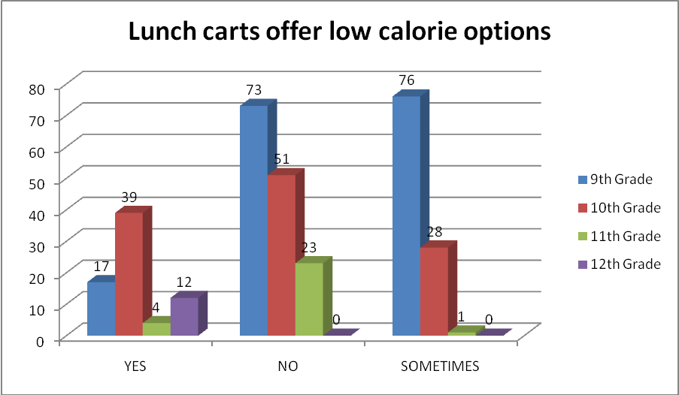

**Figure 2.5**

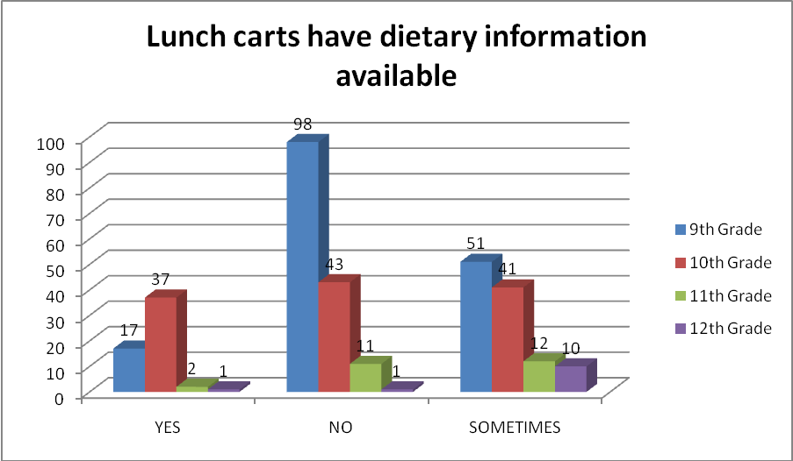

**Figure 2.6**

We immediately began to question, why did students feel certain items were low calorie? Furthermore, did students purchase those healthier alternatives? Our next step was to determine if they had adequate healthy items to eat, and possibly was that the reason they were not eating. Many students agreed, that lunch lines were not too long (Figure 2.7), and the choice not to eat was primarily based upon not being hungry, or wanting to hang out with friends.

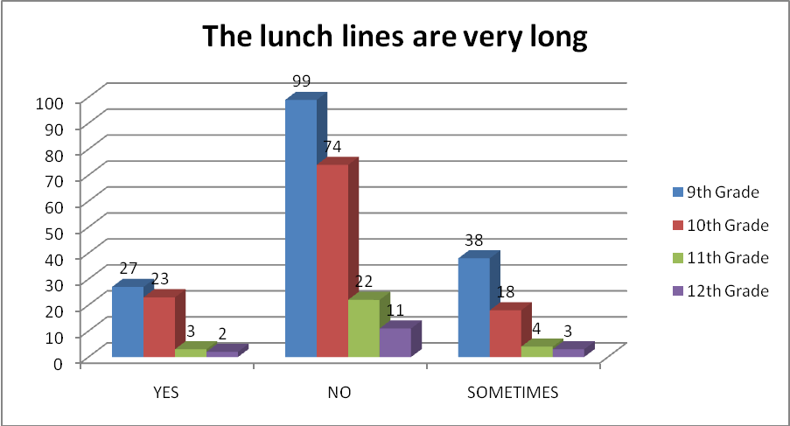

**Figure 2.7**

Furthermore, we analyzed whether students stated a discrepancy between lunch and merely snacking. We questioned students to see if they visited vending machines and lunch carts to grab a bag of chips, or just to get a water bottle. We asked students if the vending machines were well stocked (Figure 2.8), and recorded their answers below.

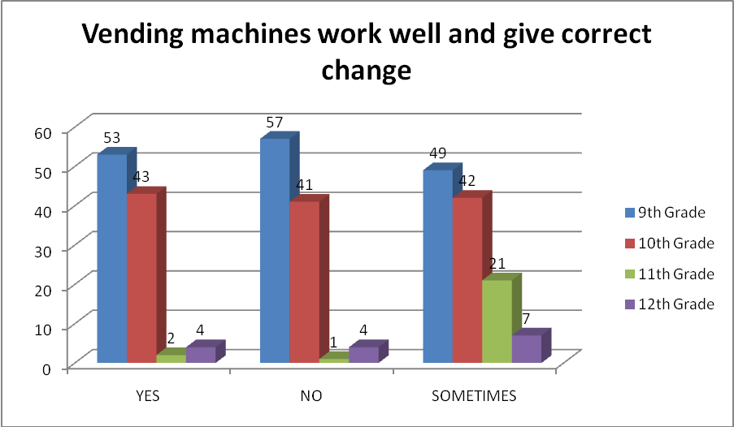

Based upon the data, students expressed mixed responses towards the vending machines, and it tended to be solely based on personal experience, and past incidences. Some students were absolutely emphatic with their descriptions of losing change; “The vending machines always steal my money, where can I go to get my money back?” Some students went as far as to say that they were receiving warm drinks. It should also be noted, that the vending machines only offer water, PowerAde, flavored water, and Minute Maid juice. “We can’t even get diet sodas from the vending machines.” All we can get is water, PowerAde and flavored water.”

There was also an ice cream vending machine (one on the entire campus), and most students said it worked well, but was rarely stocked. “I like getting ice creams from the vending machines during P.E.” One student put it poignantly, “If you want anything good to drink you will have to bring it to school yourself.” This was further echoed by student’s complaining of the lack of options, when they said “At lunch or passing period I try and get a drink, but almost every time I put my money in, they don’t have what I want.” Students also felt that “To get something to drink here you have to stand in the long lunch cart lines because the vending machines have nothing.” Overall, it felt that students were being taken advantage of, and that the vending machines were not functioning properly, nor were they stocked with items the students were actually interested in.

**Staff Section:**

Many of the comments that we received from staff, tended to align with our previous assumptions. The P.E. department in particular felt that members of their own department did not sufficiently hold their students to high standards. However, “many teachers expect nothing from their students, and that is exactly what they receive in turn. But it’s hard to expect teachers with more than 45 students to hold them to standards, when others are not doing the same.”

The teacher went on to add that many times it seems like P.E. classes have upwards of 65 to 70 students. “All the students talk. They know the easiest place to hang out during class is the P.E. area. So when students are kicked out of their classes with referrals, instead of walking to the office, they wander around the gym. It is hard to maintain any type of structure or control, especially when 10 to 20 of the students, aren’t even enrolled in your classroom.” With this feeling of being overwhelmed, many teachers felt that raising the bar, with disrupt the entire educational process at the site. With this small bit of knowledge, we decided to limit our questioning to just six questions. We had many more that arose, but we did not want to overburden the teachers anymore than they already were.

The first question we asked was, “**Do you know of a coordinated health program currently employed on your campus?”** We decided to focus our efforts on counselors (nine in all), to attempt to acquire the true reason behind our lack of adequate health classes, and overall views on the P.E. program. According to one counselor, “unfortunately we are not currently offering any health education classes and the nurse’s office cannot and should not be the only source to deal with all the topics relevant to teenagers and the health, sexual education, mental and emotional health, nutrition, substance use and abuse, etc.”

In fact, when we questioned the head counselor, as to when the last time a health class was offered she said, “With the current budget constraints plaguing our school we haven’t been able to offer health classes. It has been years since we last offered classes that addressed important health issues.” There was a definite need for qualified teachers to teach health classes on the campus, but if there were no sections offered, what good would it do to higher such teachers?

Teachers were then asked, “**Are healthier student’s higher achievers (in terms of academics?**” Most teachers stated the obvious, that “healthy students are more well-rounded, and they have support systems in place [home support] to make academics a priority and have a desire to do well in school.” It is important to note that the term “healthy,” is multifaceted, implying that students have good nutrition, health services, family/community involvement, and they have adequate social interaction.

When we attempt to make this correlation, we felt that the data would backup our claims. A student’s health generally is an indicator of several factors, rather than just one. However, for the purpose of the study, we were working towards finding a solution for the coordinated health program at school, so we confined our research to that topic alone. Our next question on the teacher questionnaire was, “**Is there a problem with obesity on this campus?**” Most staff agreed that like any comprehensive high school, there are obesity problems. Many commented that there wasn’t an overall issue with obesity, but many students lacked proper diet and exercise. Staff comments ranged from “obesity is present on any campus,” to “it isn’t a noticeable abnormal number” to the thought that there “are students with weight problems, but I don’t see it as a problem on our campus,” and finally teachers did not think it would “hinder students from their everyday activities.”

One staff member felt that “Food is moderate. There are attempts to make and serve more healthy foods,” and another staff member added that “Food is of average nutritional quality.” There was no basis for the comments, just random musings from some of the teachers, with one teacher cracking that “I heard the cafeteria was able to clear the rat problem this year.” Another staff member boldly complained that “I’m surprised that students would even eat the cafeteria food, because I sure as heck wouldn’t.” Despite the overall negative views, some staff stated “I eat in the cafeteria everyday and contrary to what most people believe, the food is actually quite tasty.” Our main focus for asking the preceding question was that there has been a “rising obesity rate,” over recent years, and we were looking for any correlation we could find.

With obesity not seen as an overwhelming, site absorbing issue, we decided to ask staff if they felt, “**Students had access to healthy choices for all meals?**” Most teachers only saw students with cheese pizza, tater tots, curly fries, mini microwaveable cheeseburgers, and chili dogs (from Weinerschnitzel). However, a few staff members defended the meal plan saying, “Our cafeteria provides a variety of healthy meal choices that follow set guidelines and regulations. The students usually aren’t thrilled about the ‘healthy’ food, but will eat it since they were hungry.”

Yet other staff argued that “most students bring lunch from home, yet still participate in the free or reduced lunch program.” Many staff felt that this was the issue; we are spending millions on students, who are getting quality lunches from home. However, the most established thoughts seemed to be that the cafeteria tries their best to offer appeasing food that is somewhat healthy, and without being trained chefs, and receiving frozen foods, there is not much under their control. Furthermore, one teacher noted that “If you want healthy foods the cafeteria has them, but I haven’t seen too many teachers eating here who are too health minded,” in regards to some staff members loading up their plates so full, that the Styrofoam trays almost snap due to the sheer weight of the lunches.

We questioned the teacher in question, and he summated it very honestly for us. “My salads include, and are not by any means limited to; extra cheese, extra ranch, croutons, bacon bits (when they have them), cottage cheese sometimes, and you can’t order the salad bar without piling some macaroni salad or potato salad on the side.” Based on the staff lunch responses, it is clear that the lunch available to staff seems to correlate with the lunches offered to the students. We also analyzed the non-cafeteria options available to staff, and one teacher in particular, shared this story with us.

“During testing I tried to get a malnourished student a drink from one of the vending machines and I went to a total of four vending machines without being successful until the last. The first vending machine was sold out, the second vending machine wasn’t even plugged in and upon plugging it in it was broken, the third vending machine was sold out also and when I tried to retrieve my change I didn’t get anything back, and the fourth machine was the one in the staff lounge where I had to resort to buying a student a soda because of the mismanagement of the supposed healthy options machines on campus.” This staff member had suffered such an ordeal, but when we followed up with most staff, they completely avoided the vending machine because previously it had taken their money. Finally, one staff member had this to say about the meals offered in the cafeteria. “I wouldn’t eat in the cafeteria if they offered free lunch for staff.”

When asked, “**If students have a quality physical education program,”** most teachers (who did not observe the physical education cohorts) felt that the P.E. instructors follow their curriculum and students are graded “on participation” in the planned physical activities. Most P.E. teachers stated that budgetary constraints (lack of equipment), limited their ability to implement a successful program, however the researchers felt that this lack of equipment had no bearing on their ability to hold students to higher standards, and hold them accountable for their success. One staff member stated that there was “Poor structure for P.E. classes, and there aren’t goals set for students to achieve.” This became a focus because once students leave high school, many do not diet or exercise regularly, and “Physically inactive students have increased risk of health problems.”

Finally, we asked if “**students actively participate within our current physical education program?”** there was no established dominant position during questioning, the numbers were split (12-12-11 respectively) in regards to the responses. 12 teachers felt that students “enjoy P.E. and extracurricular sports programs on campus.” Which covered all sports teams, and regular P.E. classes, and excluded advanced P.E. classes such as advanced Police Training (a P.E. class based around basic training for induction into the Police Explorers program). However, 12 separate teachers felt that some “students merely participate and pass P.E.” Yet still, some teachers felt that there are “students who refuse to participate and fail P.E.”

One systemic difficulty with the P.E. classes, are that “Many PE classes are too big, exceeding 45 students, which translates into less real activity per student.” Even more so, “P.E. teachers are often insufficiently trained and their equipment inadequate, especially in less affluent communities.”11 This coupled with the percentage of students not participating in vigorous to moderate physical activity increased steadily from grades 9 to 12, and the number of students physically active for 60 minutes or more per day on five or more of the past seven days decreased steadily from grades 9 to 12, raised a serious red flag during our analysis of the school’s program.

Despite the differences found in our final question, teachers generally had a negative view in one way or another, on the dietary plan and on the P.E. programs offered at our school. Most teachers had no comments on the health class offerings, because most weren’t present when they were last offered. We genuinely wanted more time with the staff; however it was difficult not to overwhelm them with additional tasks during their prep periods.

**Limitations of the Design**

* **Take more time**: Above all else, we wanted more time at our site. More time to systematically observe components, and determine what the real cause of disconnect truly is. More time observing students in individual P.E. classes, and more time observing and notating dietary patterns of the students. There was no health class within the curriculum, so it made it easy to focus on those two attributes. Rather than using a small scale research project, this could have been a larger project, with multiple comparisons.
* **Larger Sample**: Comparing multiple schools, across multiple districts, and differing socioeconomic areas. By using such a heterogeneous sample, we felt we limited the outreaching effects of our data. By using more students, across geographic boundaries, our data would be more valid.
* **Individual Questioning**: We would have rather asked students individual questions, and list detailed responses, as opposed to surveys in order to create a baseline of data. Sitting down with individual participants would have take more time, however it would have improved the quality of the research conducted.

**Conclusion** Research gathered expressed a correlation between diet, physical activity, and academic achievement. Yet when working seamlessly, do these components ensure academic success? Furthermore, how can educators, at a site level, influence such success throughout a high school campus? Based upon the data gathered, we found that it would be most beneficial to implement the following changes, omit the following programs and procedures, and institute the appropriate goals and systemic implementation of curriculum.

After surveying and interviewing 35 high school teachers and 324 students (grades 9 – 12), we attempted to prove that the academic achievement could be substantially improved with a quality dietary and physical activity program. When students receive some level of nutrition on a consistent basis, and that is coupled with any amount of physical activity, the data suggests that students are typically prone to being more successful. This coupled with high standards and expectations, students had a much greater opportunity for success.

These findings represented a general, overarching theme; the students’ dietary consumption is adequate when comparable to home dietary patterns. However, staff members and students agreed that no health program existed, and the physical education program should be ratified in order to promote wellness and vigorous physical activity (for more than 15 minutes). We were genuinely concerned with the lack of physical activity observed because it can lead to a higher risk of disease due to decreased immunity, increased levels of stress, obesity, lower levels of Self-Esteem, and an academic performance lower compared to physically active students.

**Recommendations:**

We felt that the physical education program could be altered so that it includes the full inclusion of all students, and does not segregate students, and immediately attempt to remove them from their class based on behavior. We also felt that at least 50 percent of instructional time (within the P.E.) should be spent on moderate-to-vigorous physical activity, with maximum participation and ample practice opportunities for class activities. This would be facilitated by well-designed lessons that facilitate student learning and possibly offer out-of-school assignments that support learning and the practice of learned skills. All of this is then predicated off of appropriate discipline and class management.

We felt this could benefit students because it would provide fitness education and assessment to help students understand, improve, and/or maintain their physical well-being. In order to see this fulfilled, all schools need policies that allow for the maximum amount of physical activity possible. Unfortunately, most physical education students are spending less time engaging in physical activity during PE classes, and more time socializing. This again harkens back to students having structure within the class, and being required to participate in physical activity on a daily, consistent basis. This could be further enhances by parents and communities joining in on the efforts of schools to increase the amount of physical activity taking place.

There is a definite need because high school aged students are engaging in less activities that make them sweat or breath hard. In order for this to be successful, the school should encourage a healthy diet and physical fitness plan, and help students set realistic fitness goals. Educators can encourage students to join sports teams by professionally modeling healthy lifestyles and by encouraging students to purchase healthy foods. Educators could further increase their ability to indirectly influence students by discouraging students from “eating out” and going to get fast food. From an administrative perspective, we must regularly scheduled recesses for elementary school students, and offer a variety of intramural activities and physical activity clubs.

**Recommendations for Further Research**

**More Administrative Focus**: We did not focus on the attitudes and opinions of administration, because we felt they do not influence classroom instruction within the subgroup, and are bound by district protocol in regards to answers of some of our questions.

**More State Research**: We wanted to take our research to a State level, and determine why most comprehensive high schools do not contain health classes imbedded into the curriculum.

**Why do students not choose to eat**: We wanted to answer more qualitative questions but the lack of time hindered our opportunity to question the students.

**Jamie Oliver’s School Dinners Program**: Jamie Oliver, a renowned British chef, began a formal campaign to ban unhealthy food in British schools and get children eating fresh, tasty, nutritious food instead. Oliver's efforts to bring radical change to the school meals system challenged the junk food culture by showing schools they could serve healthy, cost-efficient meals that kids enjoyed eating. Jamie's efforts brought the subject of school dinners to the political forefront and changed the types of food served in schools. He even proposed a 10-year plan that suggested the following recommendations:

* + In schools: make cooking and life skills classes compulsory for all kids so they learn about food and good eating habits while they're young.
  + For teachers: recruit and train new cooking teachers, otherwise the new opportunity that kids have to cooking lessons just isn’t going to happen.
  + For administration: empower districts to make every school a junk food free zone.
  + For parents: educate parents and help them to understand the basics of family cooking and responsible nutrition
  + For cafeteria worker: invest in proper training and enough paid hours to cook their food with fresh ingredients
  + Commit to a ten-year strategic plan and fund a long-term public campaign to get people back on to a proper diet and empower/persuade (and possibly scare, if needed) the public to make better choices.

The results were hard to argue with. The findings, from a report by the Institute for Social and Economic Research (ISER) at Essex University, focused on schools in Greenwich, southeast London, where Oliver launched his healthy eating campaign with Channel 4 in 2004 stated that “Pupil exams in 2006-7 [who] were on the new diet for at least 12 months, researchers found the number of pupils reaching levels four or five [on English standardized tests] had risen by up to 8 percent in science, and 6 percent in English. There was also a slight improvement in math results.”

Oliver hired nutritionists who found most school meals contained less than half the daily recommended amount of iron - known to improve children's development and concentration. Oliver's new menus, adopted by 81 out of 88 primary and secondary schools in Greenwich, banned processed foods such as “Turkey Twizzlers” and introduced iron-rich foods such as red meat and green vegetables. According to Oliver, “the children aren't being stuffed with additives, they're much less hyper in the afternoons now."

Oliver went on to comment, “Even while doing the program we could see the benefits to children's health: it made them calmer and therefore able to learn. The results are fantastic - it's the first time a proper study has been done into the positive effects of the Feed Me Better campaign. It strongly suggests we were right all along."

Researchers found that children who follow the healthy diet were less likely to stay away from school, and that absenteeism also fell by 15 percent. In regards to our study, the average cost per pupil would translate into approximately $2.65 secondary and $2.52 for primary lunches, respectively (dollar amounts based off of conversion from British Pounds to USD).

**REFERENCES**

References

Carmichael, M. (2008). Phys. Ed. Is Not Dead Yet. *Newsweek, 151* 18-18.

Cho H., & Zbell Nadow M. (2004). Understanding Barriers to Implementing Quality Lunch and Nutritional Education.  *Journal of Community Health*, *29*, 421-435.

Chepko, S., Coughlin, M., Couturier, L. (2007). Whose Gym Is It? Gendered Perspectives on Middle and Secondary School Physical Education. *Physical Educator, 64*, 152-158.

Chomitz V. R., Slining M. M., McGowan R., Mitchell S. E, Dawson G., & Hacker K. (2009). Is There a Relationship Between Physical Fitness and Academic Achievement? Positive Results from Public School Children in the Northeastern United States. *The Journal of School Health, 79*, 30-37.

Florence M.D., Asbridge M., & Veugelers P.J. (2008). Diet quality and academic performance. *The Journal of School Health, 78*, 209-215.

Hall, E. M. (2007). Integration: Helping to Get Our Kids Moving and Learning. *The Journal of School Health, 68*, 109-110.

Kramer R.A., Allen L., & Gergen P.J. (1995). Health and social characteristics and children’s cognitive functioning: results from a national cohort. *American Journal Public* Health, 60, 719-745.

LaFee, S. (2008). Let's Get Physical! P.E. Struggles to Make the Grade. *Education Digest, 73*, 49-52.

Maslow Hierarchy of Needs.

Moag-Stahlberg, A., Howley, N., & Luscri, L., (2008). A National Snapshot of Local School Wellness Policies. *The Journal of School Health, 78,* 562-568.

Winterfeld, A. (2007). PE Makes a Comeback. *State Legislatures, 33*, 36-37.

Zinczenko, D. (2007). Gym-Class Heroes. *Men's Health, 22*, 28.

**Appendices**  
**Student Physical Education Survey**

1. *Exercise for 30 minutes or more*

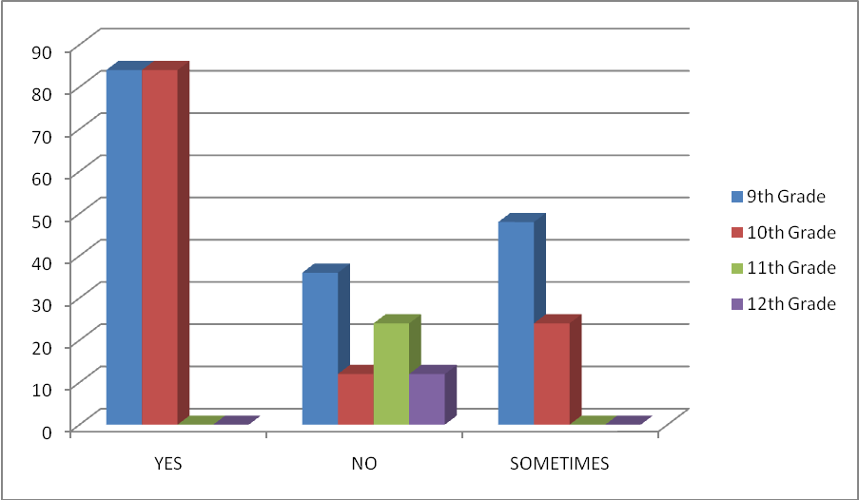

1. *Exercise for less than 30 minutes*

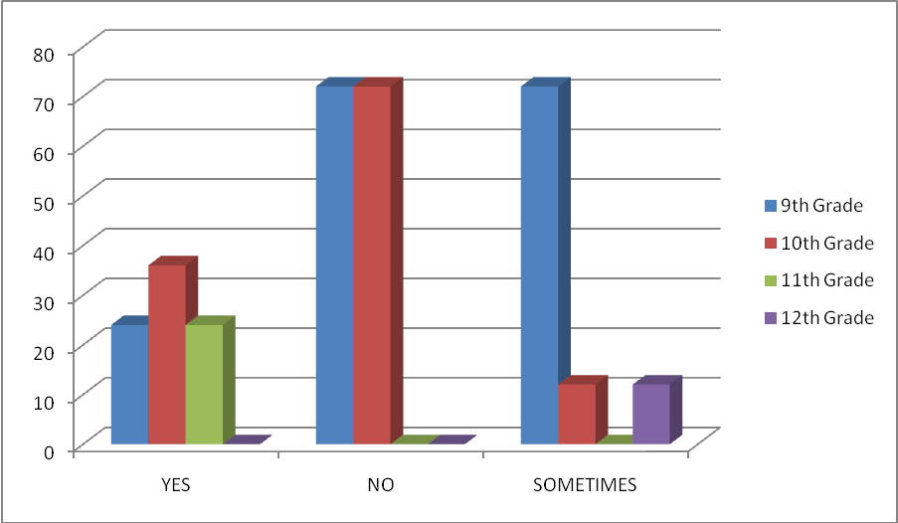

1. *We stretch before taking part in physical activity*

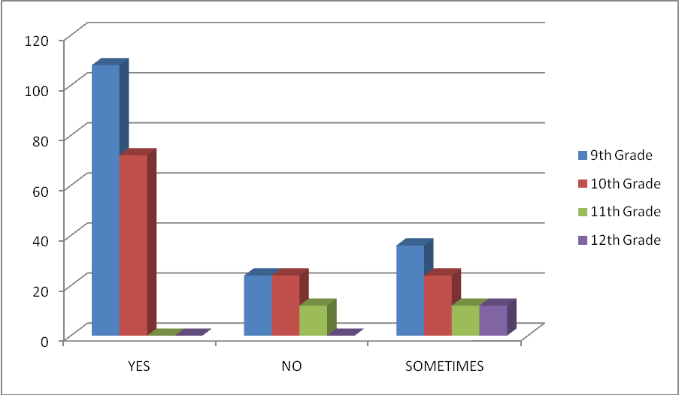

1. *I engage in physical activity that makes me sweat/raises my heart rate, 4 to 5 days a week*

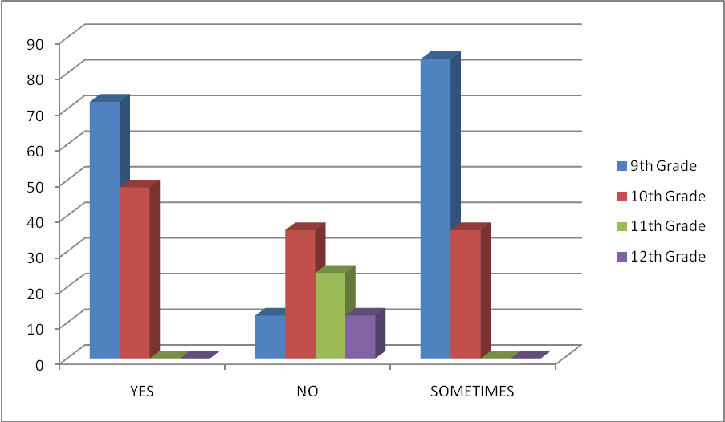

1. *I engage in physical activity that makes me sweat/raises my heart rate, at least 3 days or less a week*

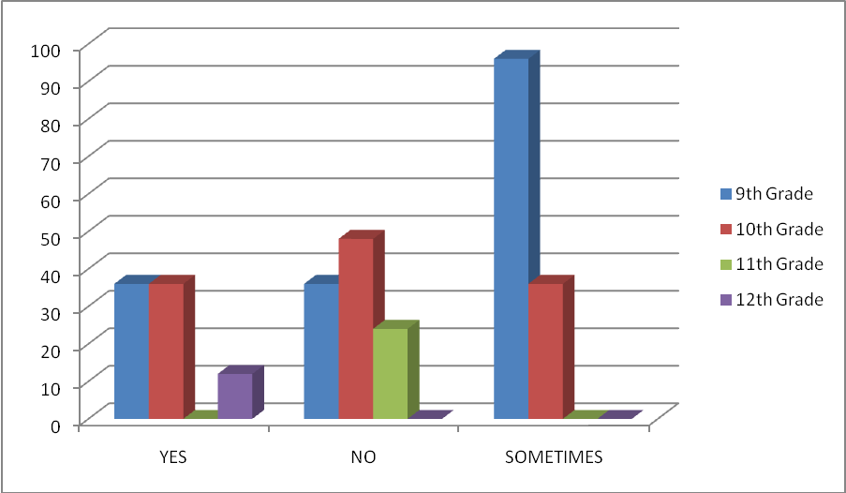

1. *I usually dress out for 4 or 5 days a week*

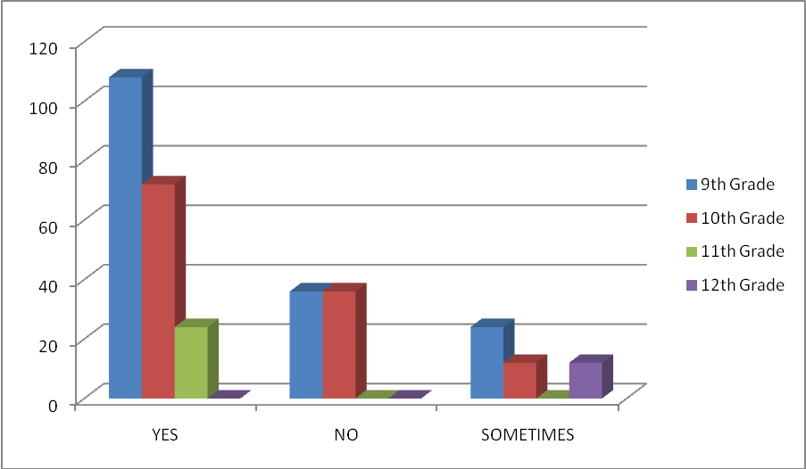

1. *I usually dress out 3 days or less a week*

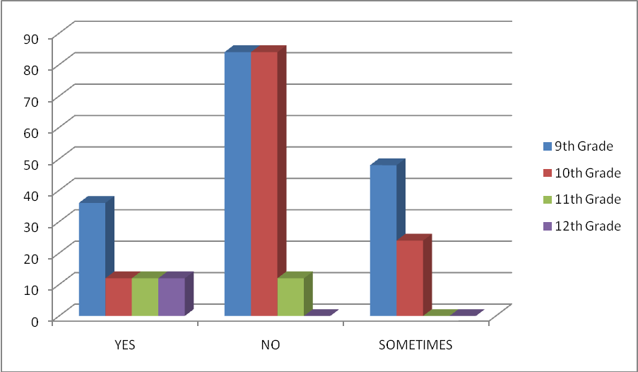

1. *I participate in daily activities*

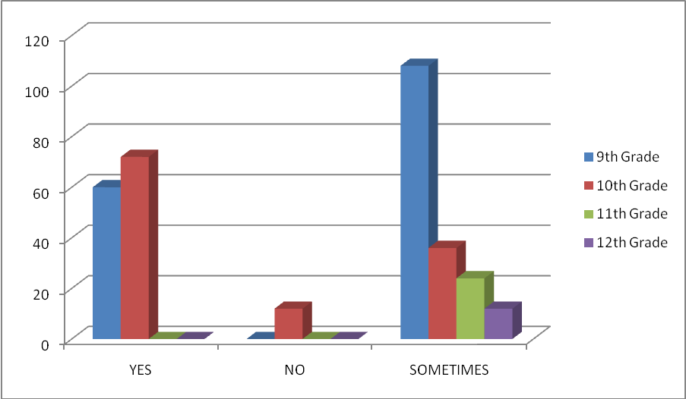

1. *I walk around the basketball courts and/or track*

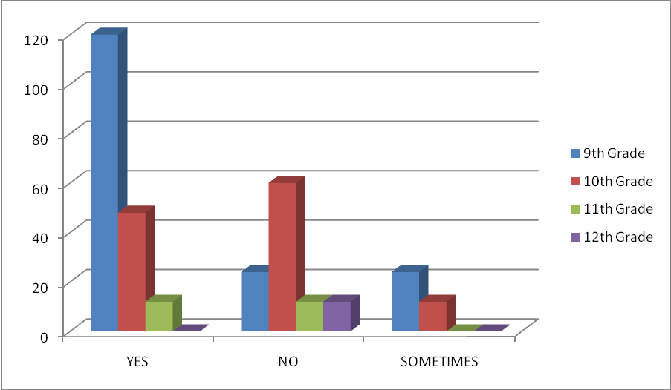

1. *I sit around and talk to friends*

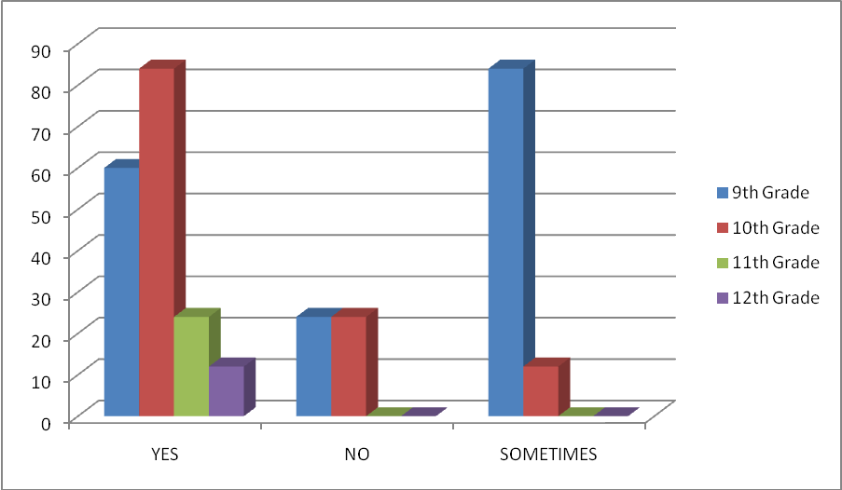

1. *The sports and/or activities are fun and/or interesting*

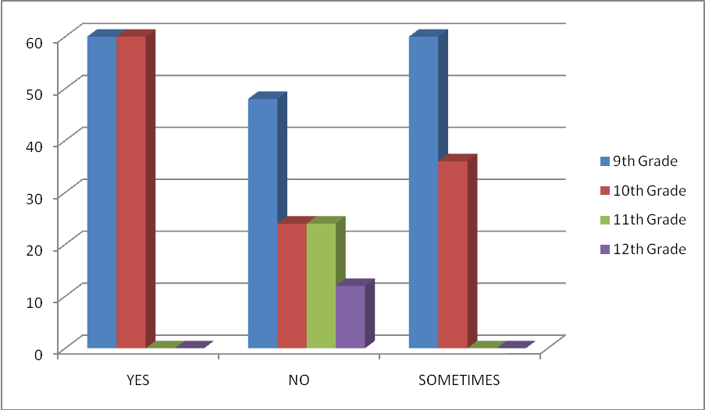

1. *The sports and/or activities are always the same and boring*

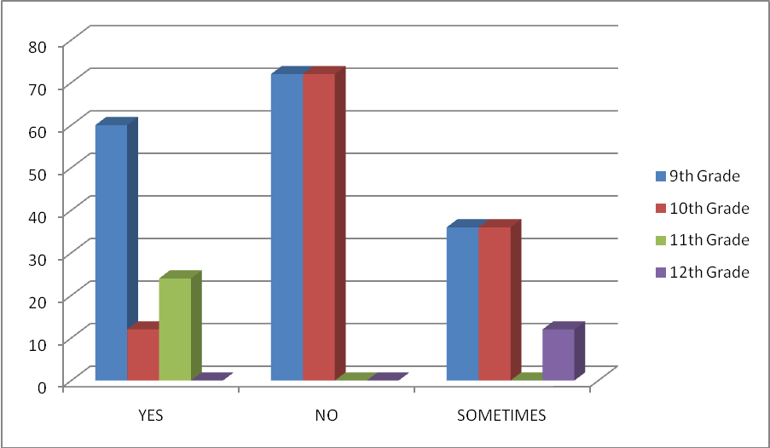

1. *My coach encourages me to be involved in daily sports and/or activities*

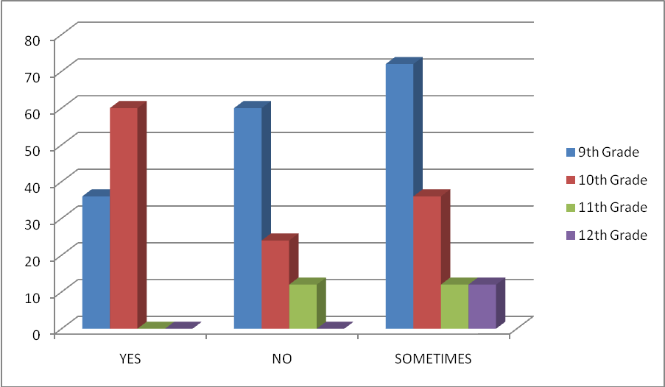

1. *I consider myself to be an active/athletic person*

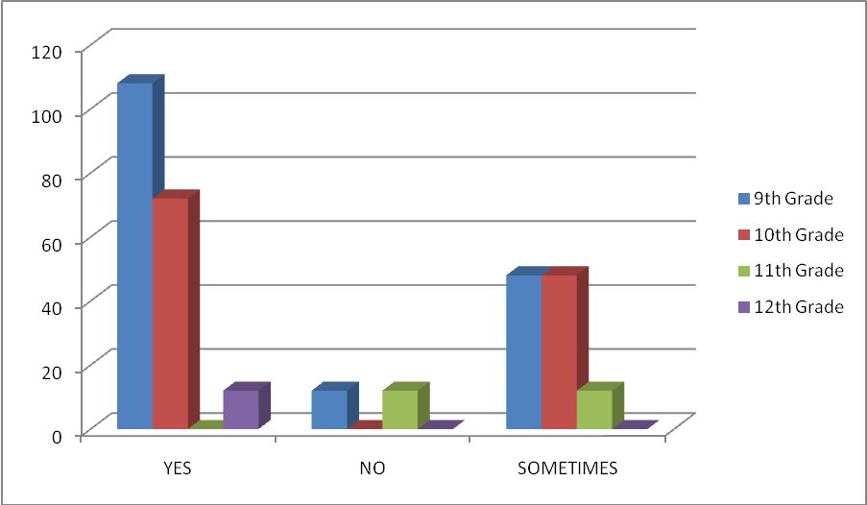

1. *I consider myself to be inactive/always out of energy*

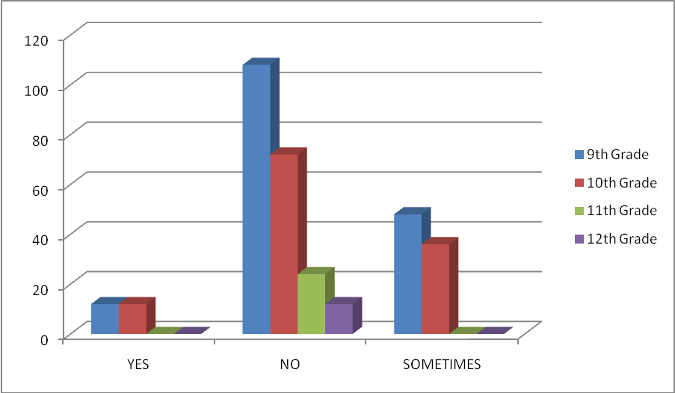

1. *We complete timed runs*

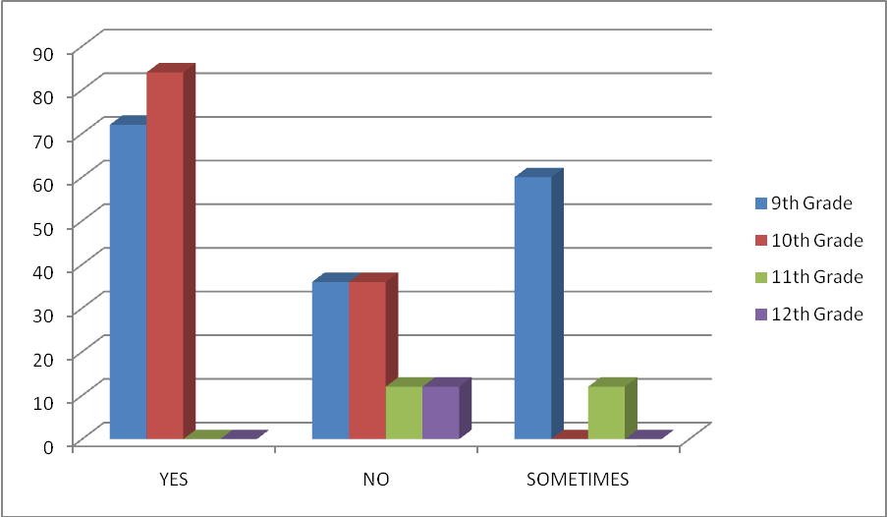

1. *I know what is expected of me during P.E. class*

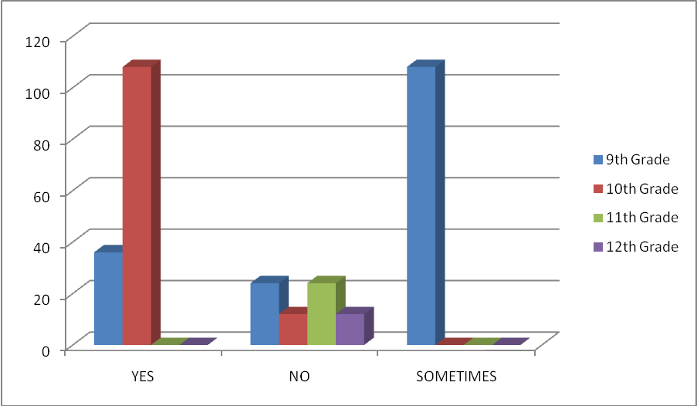

1. *The P.E. program at BHS helps me keep in shape and is meeting my expectations*

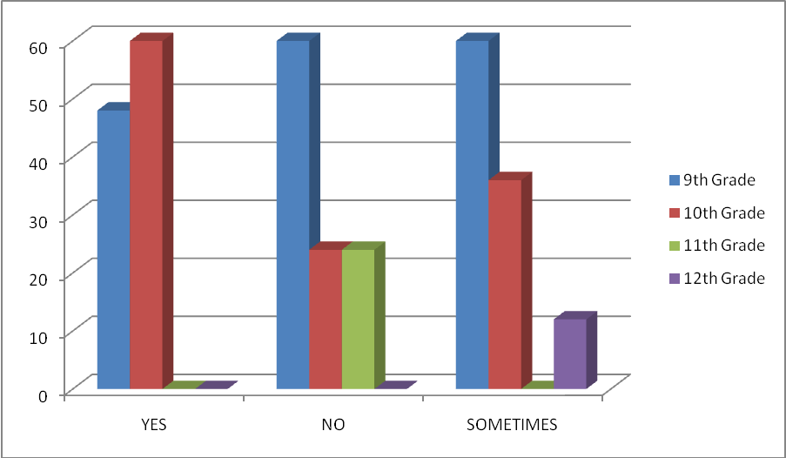

1. *I would like more information on how to become involved on a sports team*

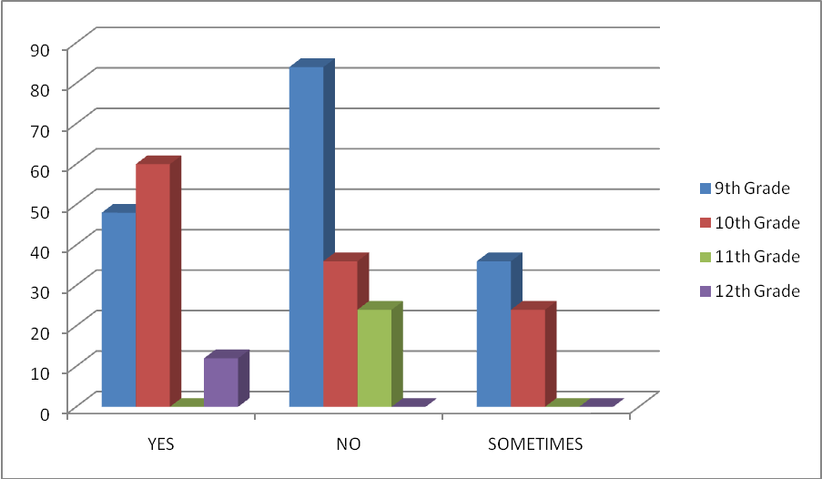

1. *I attend P.E. on a regular basis*

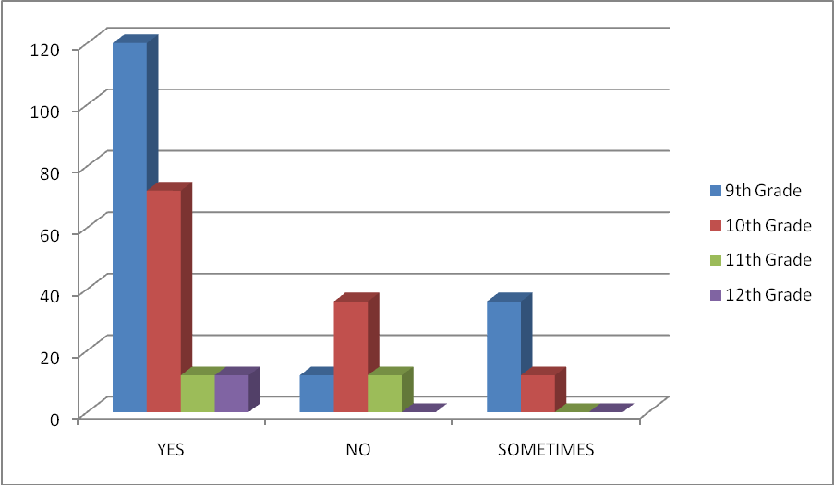

1. *I dress out for P.E. on a regular basis*

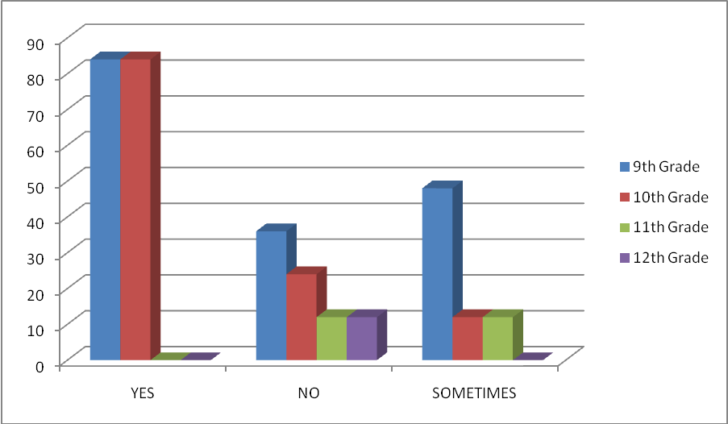

1. *As far as I know, I am getting a “B” or better in my P.E. class*

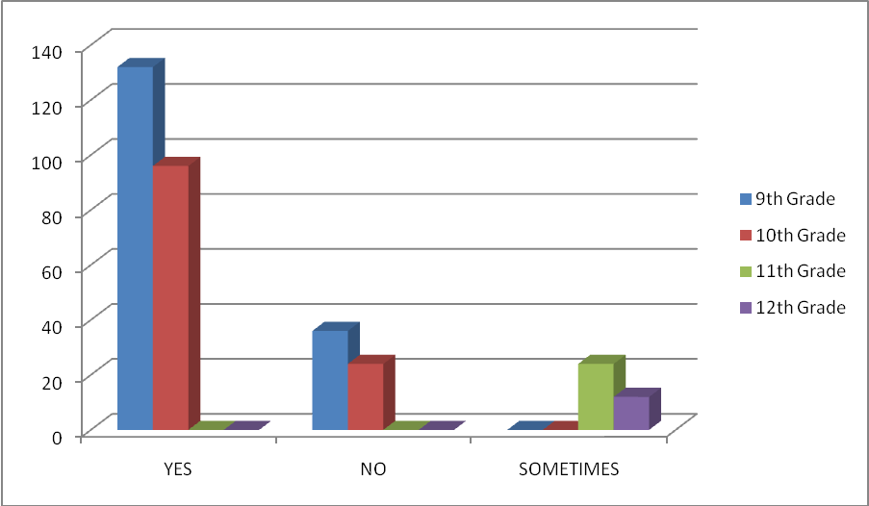

**Student Diet and Nutrition Survey**

1. *I bring my own lunch from home*

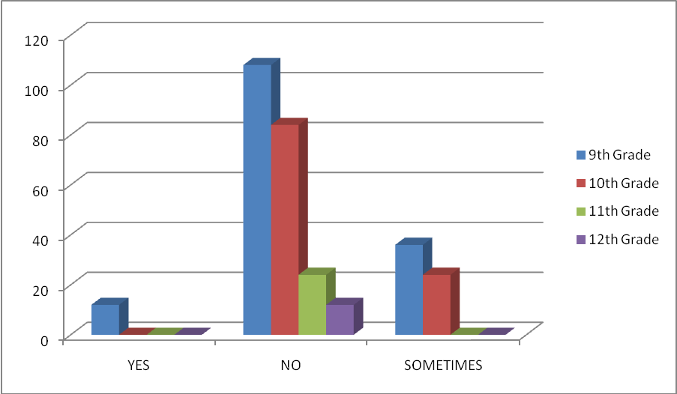

1. *I don’t eat lunch at school*

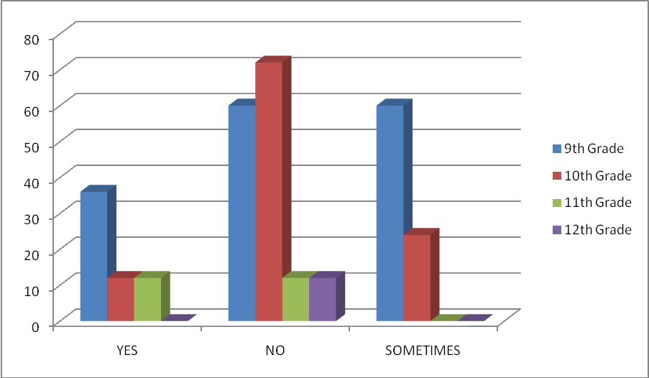

1. *The school offers many desirable options for lunch*

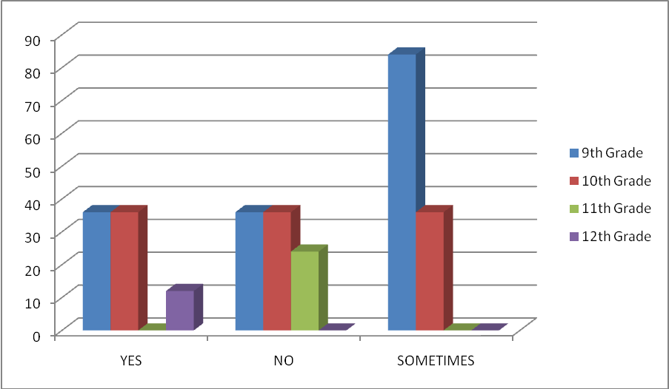

1. *There are many healthy foods to choose from at lunch*

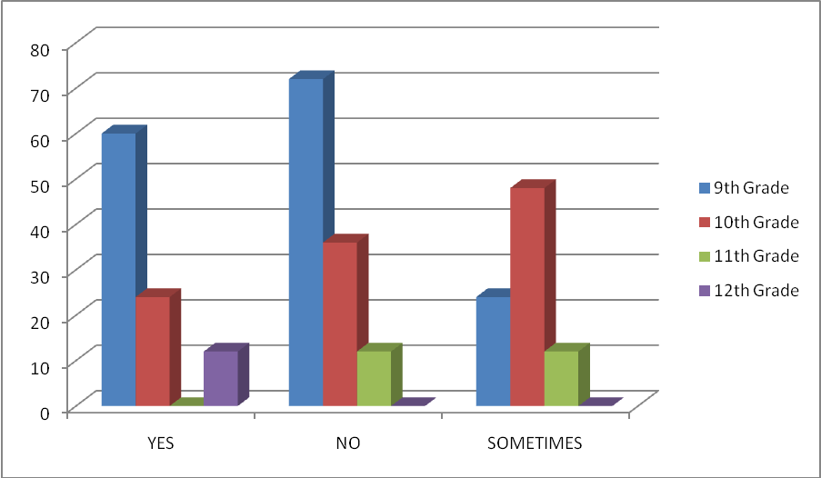

1. *Vending machines offer tasty, nutritious snacks and drinks*

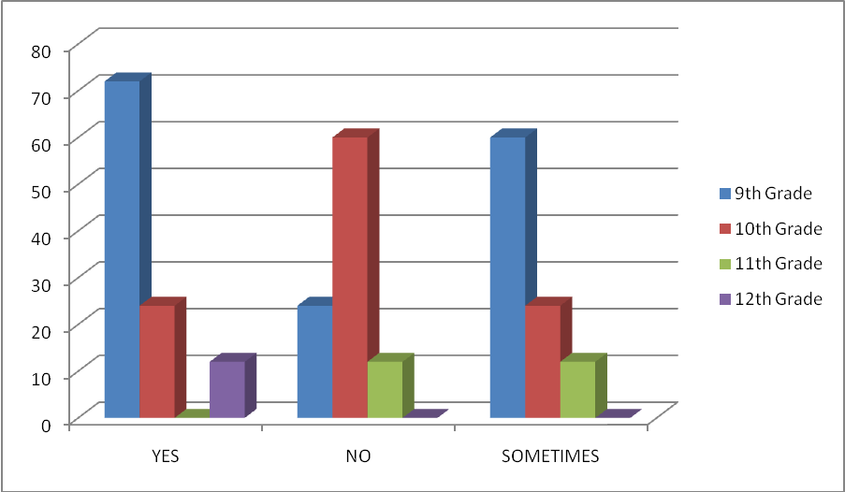

1. *Vending machines are always well stocked*

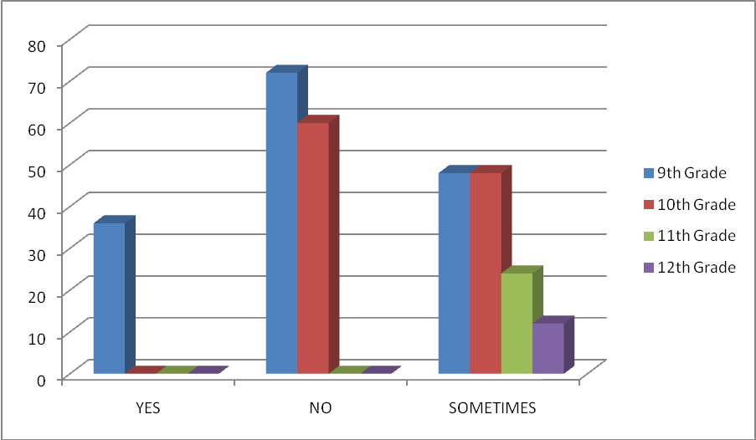

1. *Vending machines work well and give correct change*

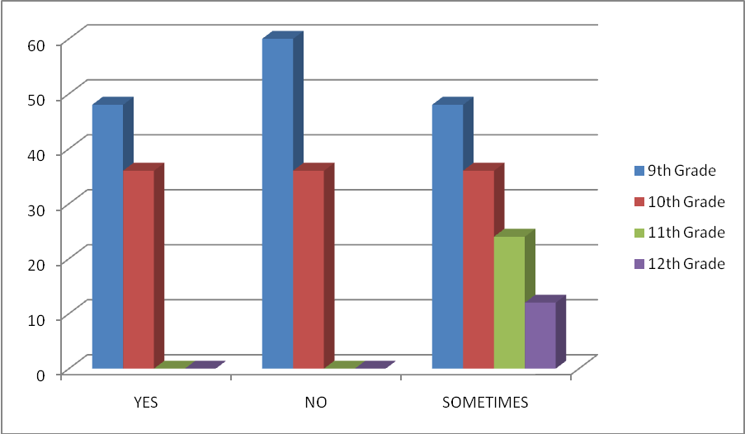

1. *Cafeteria lunches include large portions of unhealthy sides (i.e. French fries, chips, and tater tots)*

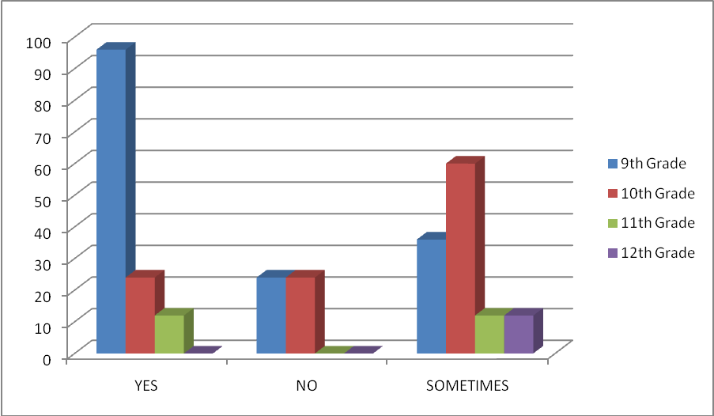

1. *The cafeteria has a salad bar option*

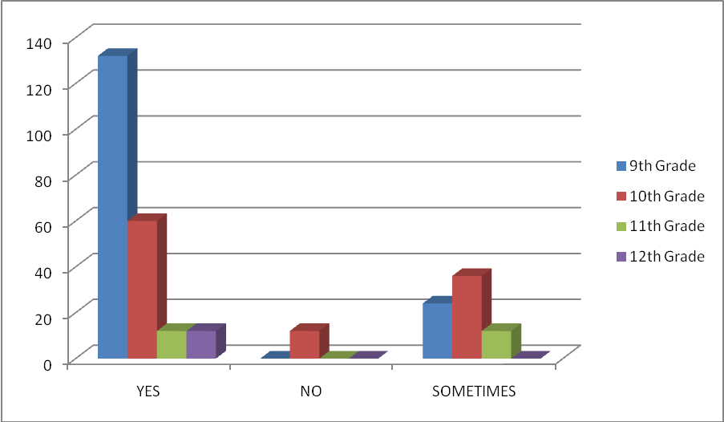

1. *Cafeteria workers limit the amounts sides included with salads*

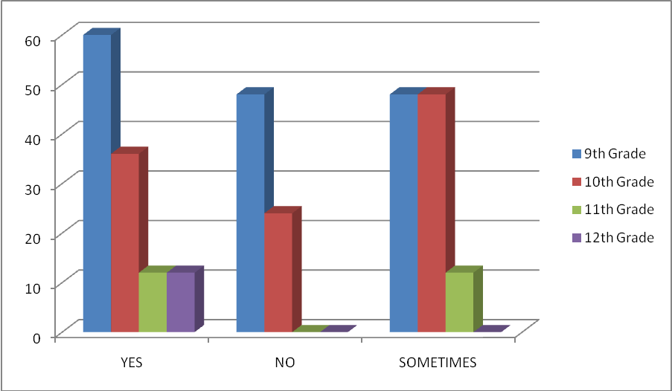

1. *When eating from the salad bar, do you use more vegetables and lettuce, or does your plate contain more cheese, croutons, and dressing*

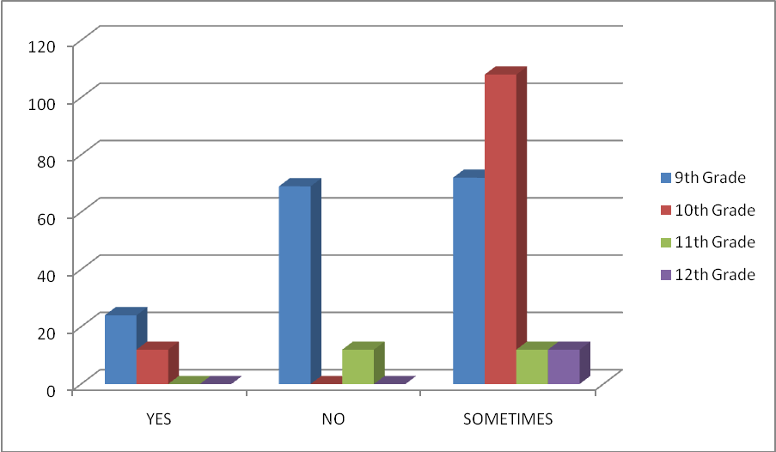

1. *Lunch carts offer low calorie options*

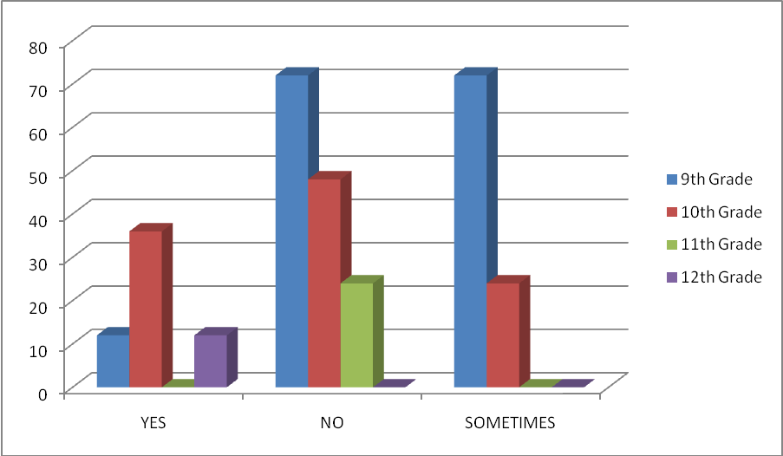

1. *Lunch carts have dietary information available*

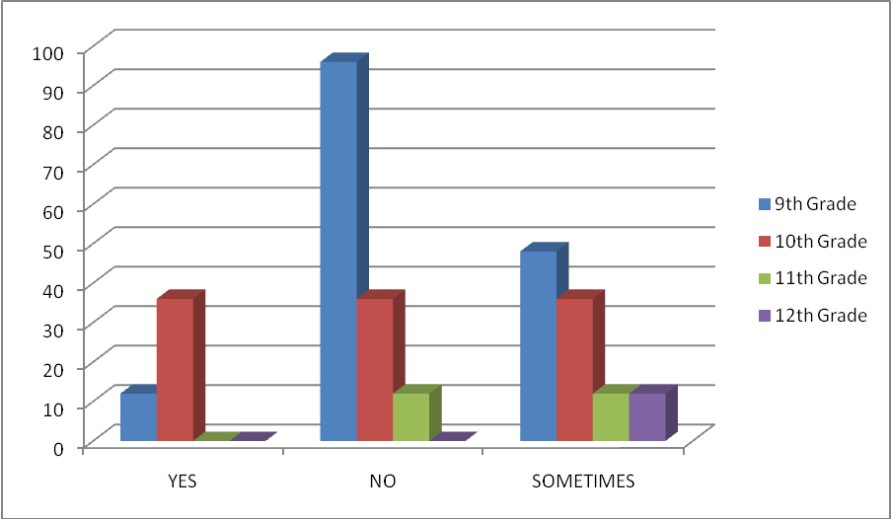

1. *The food is well stocked at the lunch carts*

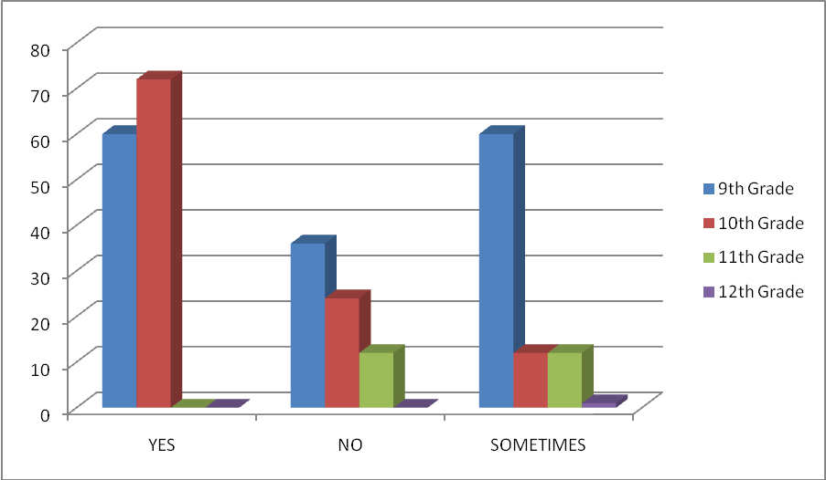

1. *The lunch lines are very long*

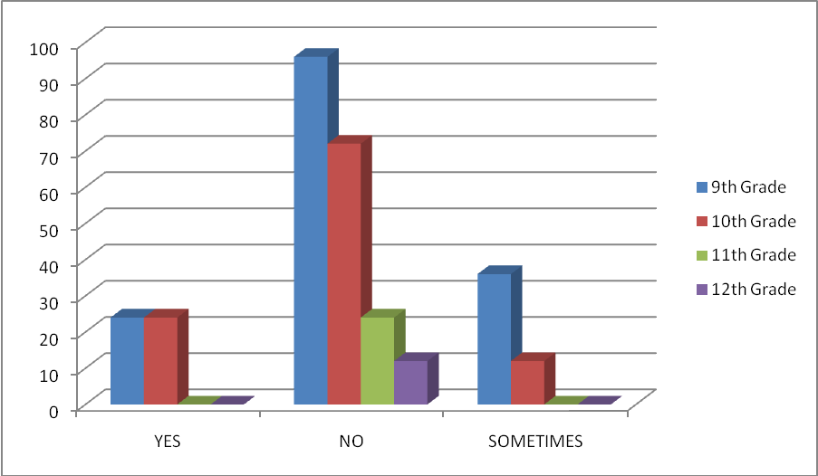

1. *Is there enough time before school to eat breakfast*

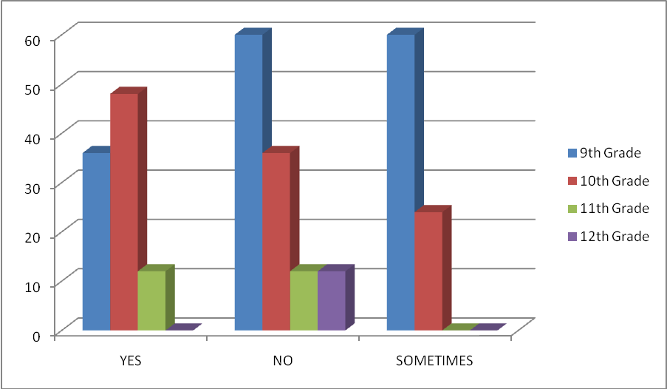

1. *Is there enough time during the lunch period to each lunch*

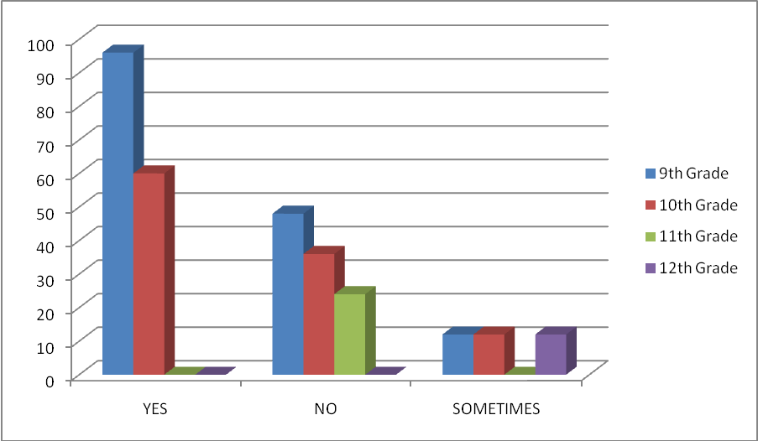

1. *Do you eat three meals per day, throughout the week*

